History Focus – Threshold Concepts | Year 3 – Toms Midnight Garden | Curriculum
History– Our Local Area  In this unit, the children will investigate their local area, and consider which buildings are of significance and should be preserved. They will conduct their own research, using sources including recommended websites, history books, street directories and census returns. They will also have the opportunity to visit and study local listed buildings and make links to historical events from the time of the building’s construction, as well as to their prior learning. There is the possibility of inviting a panel of guests to take part in a question and answer session about local buildings, leading into the children planning and running a campaign to save a particular building  Science  Physics – Light.  During this unit of work, children will recognise that they need light in order to see things and that dark is the absence of light. They will learn to identify light sources; explore what happens when light reflects o- mirrors or other reflective materials and think of ways to protect themselves from the Sun. They will investigate which materials make the best/worst shadows and conduct an  experiment to find out about the relationship between the height of a light source and the length of  a shadow. Children will also experience a range of activities to discover how mirrors work. | 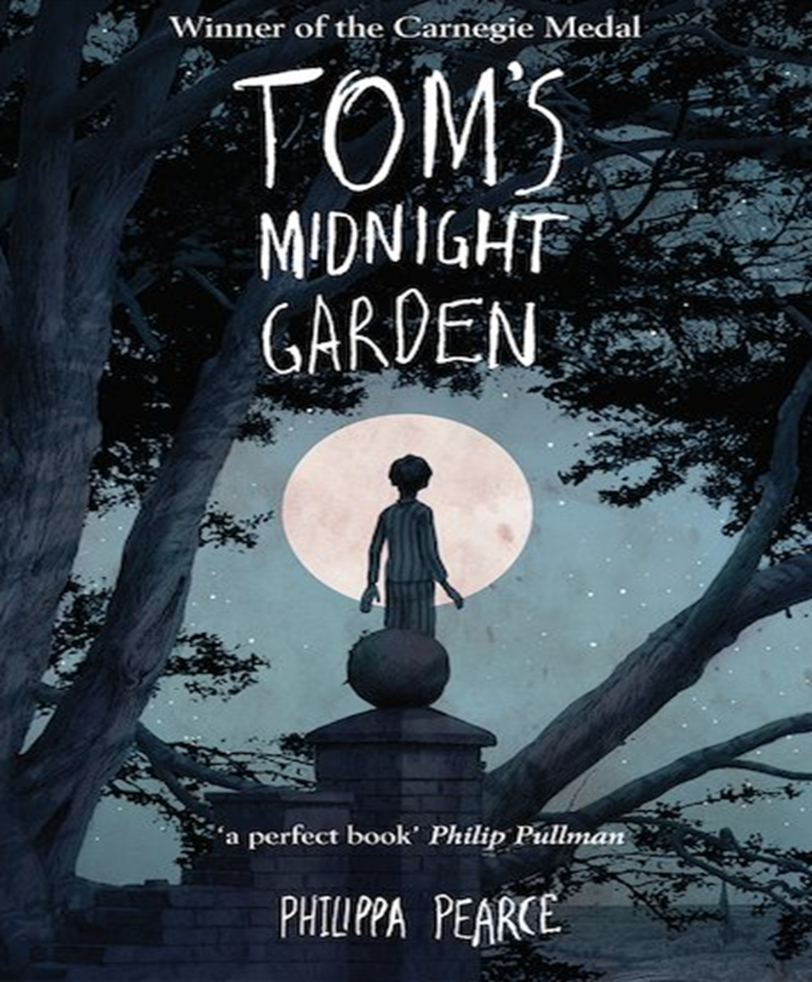  English focus text: Toms Midnight Garden  Writing outcomes: Narrative text  Mini process: Non Chronological Report  Purpose: To write for different purposes.  Inspired by author Philippa Pearce’s’ Toms Midnight Garden. The Children will first focus on using their inference skills to make predictions about the narrative and the genre of the text.  The children will then write accurate character descriptions before engaging with a research project into Grandfather clocks.  The Children will finish this unit by writing an alternative chapter ending in line with the style of the author and her characters.  Shorter writing outcomes:  -Note taking. Taking down and making notes for topic specific research.  Supporting Texts:  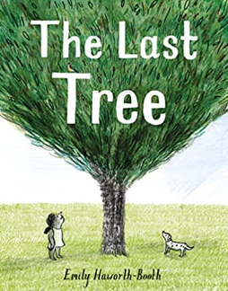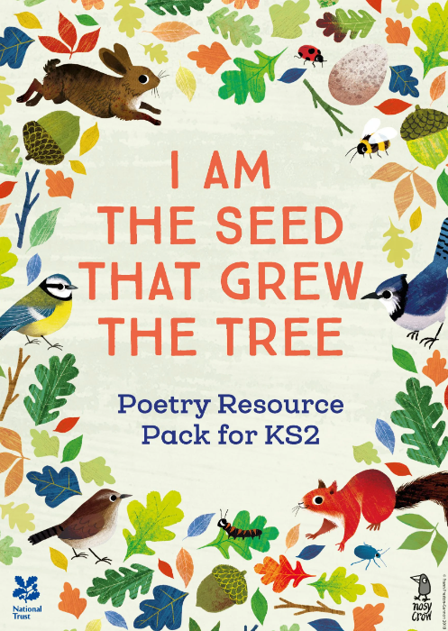 | Maths : White Rose – Fractions  Access art: Summer term 1  Making Animated Drawings  DT: 2D Shape to 3D Shape  RE: Discovery R.E- Hinduism Sharing and Community Sikhism.  Computing: Computer Science – Tynker – If Statements. HTML App-Coding  P.E: Striver. Tag Rugby  MFL: Spanish – Fruit  Music: Communication - Human Body  The children will learn to make to sing in French for this module.  PSHE: Jigsaw – Relationships  Children will learn about relationships and explore how to be good friend and support others.

