History Focus – Threshold Concepts | Year 3 – Toms Midnight Garden | Curriculum
  History– Our Local Area  In this unit, the children will investigate their local area, and consider which buildings are of significance and should be preserved. They will conduct their own research, using sources including recommended websites, history books, street directories and census returns. They will also have the opportunity to visit and study local listed buildings and make links to historical events from the time of the building’s construction, as well as to their prior learning. There is the possibility of inviting a panel of guests to take part in a question and answer session about local buildings, leading into the children planning and running a campaign to save a particular building  Science  Physics – Light.  During this unit of work, children will recognise that they need light in order to see things and that dark is the absence of light. They will learn to identify light sources; explore what happens when light reflects o- mirrors or other reflective materials and think of ways to protect themselves from the Sun. They will investigate which materials make the best/worst shadows and conduct an  experiment to find out about the relationship between the height of a light source and the length of  a shadow. Children will also experience a range of activities to discover how mirrors work.     | 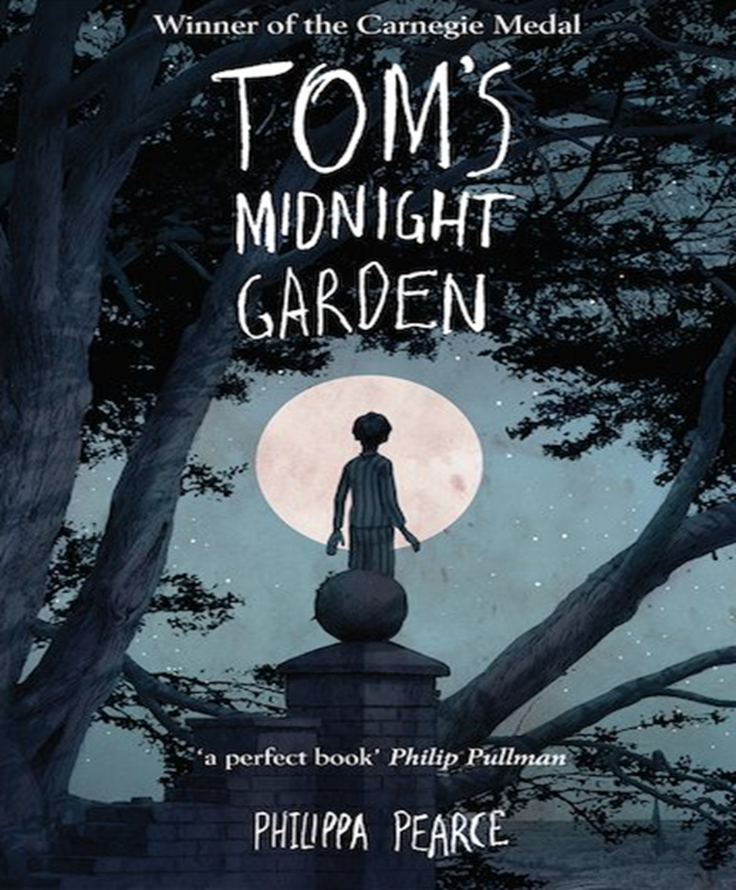  English focus text: Toms Midnight Garden  Writing outcomes: formal or informal letter  Mini process: Diary style entry  Purpose: To write for different purposes.  Inspired by author Philippa Pearce’s’ Toms Midnight Garden. The Children will first focus on using their inference skills to make predictions about the narrative and the genre of the text.  The children will then a letter as the character Tom around the events unfolding in the narrative.  Throughout the writing process the children will have opportunity to write a diary style entry and practice their note taking for topic specific research.  Supporting Texts:  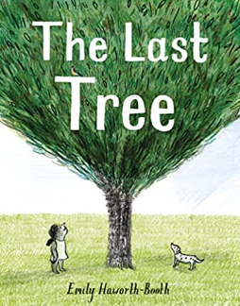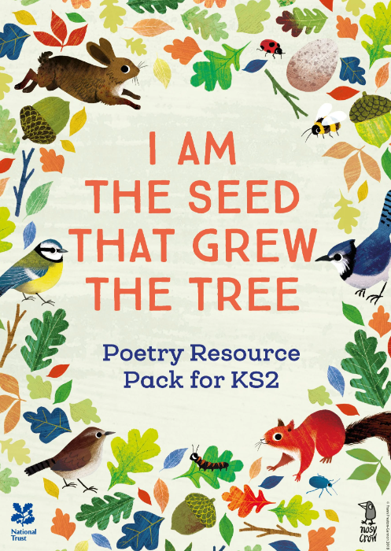 |   Maths : White Rose – Fractions, Money and Time.  Access art: Summer term 1 -Making Animated Drawings.  DT: 2D Shape to 3D Shape.  RE: NATRE Unit 23 - What do many Christians learn from the Creation story?  Computing: Computer Science – Tynker – If Statements. HTML App-Coding  P.E: Striver. Athletics and further sports day preparation.  MFL: Spanish – Goldilocks and the three bears. By the end of this unit we will be able to:  • Listen attentively to a whole familiar fairy tale in Spanish.  • Remembering new language using picture, word and phrases cards.  • Improve gist reading and gist listening skills.  • Attempt to re-tell a familiar fairy tale in Spanish using a mini book for support.  Music : Recorder – Whole class ensemble, underpinned by elemental music development.  PSHE: Jigsaw – Relationships  Children will learn about relationships and explore how to be good friend and support others.

