Geography Focus – The Americas  Enquiry Question: Can you come on the Great American road trip? | Year 4 – Jemmy Button | The Curriculum – Threshold Concepts
Geography  Communicate geographically:  • human geography, including: settlements and land use.  • Use the eight points of a compass, four-figure grid references, symbols and key to communicate knowledge of the United Kingdom and the wider world.  Enquire Geographically:  • Ask and answer geographical questions about the physical and human characteristics of a location.  • Explain own views about locations, giving reasons.  Study Location:  • Describe geographical similarities and differences between countries.  Mapping:  • Use maps, atlases, globes and digital/computer mapping to locate countries and describe features.  Science  Physics – Electricity  • A source of electricity (mains of battery) is needed for electrical devices to work.  • Electricity sources push electricity round a circuit.  • More batteries will push the electricity round the circuit faster.  • Devices work harder when more electricity goes through them.  • A complete circuit is needed for electricity to flow and devices to work.  • Some materials allow electricity to flow easily and these are called conductors. Materials that don’t allow electricity to flow easily are called insulators. | 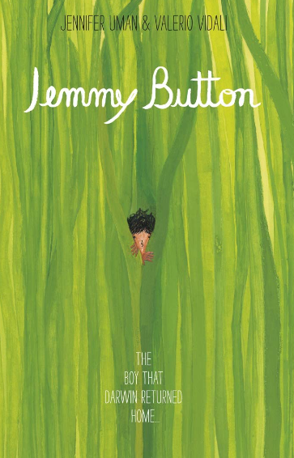  English focus text: Jemmy Button by Valerio Vidali  Extended writing outcomes:  -Diary entry for the return voyage home Jemmy Button takes, describing his experiences in England, what he learnt and what he saw while being taught how to be an English Gentlemen.  Short writing outcomes:  -Character description of Jemmy Button based on the illustrations from the story and the contextual information we learn about him.  Link Reading:  Mapping South America – Paul Rockett (Non-Fiction)  Blue Sky, White Stars  - Sarvinder Naberhaus (Narrative)  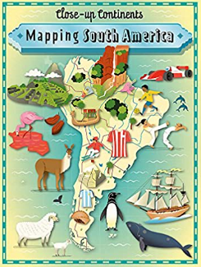  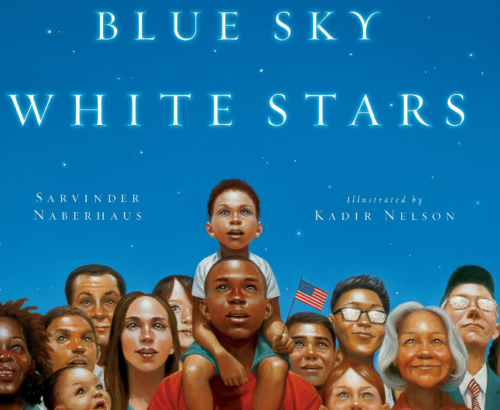  Mathematics – White Rose  Place Value  Addition and Subtraction | P.E: Basketball.  • Throw and catch with control and accuracy  • Follow the rules of the game and play fairly.  • Pass to team mates at appropriate times.  • Lead others and act as a respectful team member  I.C.T: Digital Literacy  - Use technology safely, respectfully and responsibly; recognise acceptable/unacceptable behaviour; identify a range of ways to report concerns about content and contact.  RE: Religion: Judaism  Theme: Beliefs and Practices  Key Question: How special is the relationship Jews have with God?  • Present the key teachings and beliefs of a religion.  • Refer to religious figures and holy books to explain answers  PSHE: Jigsaw Being Me In My World.  Music: Music Express.  Poetry – Musical Focus: Performance.  Environment - Musical Focus: Composition.  MFL: Spanish  Phonetics 1 & 2  I am learning Spanish module.
The Curriculum:
Art and Design: Storytelling through drawing.
We are going to explore how artists create sequenced drawings to share and tell stories. We will create accordion books or comic strips to retell poetry or prose through drawing.
DT: Mechanical Systems
Levers and Linkages.

