  Geography Focus – The Americas  Enquiry Question: Can you come on the Great American road trip? | Year 4 – Jemmy Button | The Curriculum – Threshold Concepts
  Geography  Communicate geographically:  • human geography, including settlements and land use.  • Use the eight points of a compass, four-figure grid references, symbols and key to communicate knowledge of the United Kingdom and the wider world.  Enquire Geographically:    • Ask and answer geographical questions about the physical and human characteristics of a location.    • Explain own views about locations, giving reasons.  Study Location:  • Describe geographical similarities and differences between countries.    Mapping:  • Use maps, atlases, globes and digital/computer mapping to locate countries and describe features.  Science  Physics – Electricity  - Identify common appliances that run on electricity.  - Construct a simple series electrical circuit, identifying and naming its basic parts, including cells, wires, bulbs, switches and buzzers.  - Identify whether a lamp will light in a simple series circuit, based on whether the lamp is part of a complete loop with a battery.  - Recognise that a switch opens and closes the circuit and associate this with whether a lamp lights in a simple series circuit. Recognise some common conductors and insulators, and associate metals with being good conductors.  - Know the difference between a conductor and an insulator, giving examples of each.  - Safety when using electricity.            Art and Design:  Storytelling Through Drawing.  Key Concepts:  -That we can tell stories through drawing.  -That we can use text within our drawings to add meaning.  -That we can sequence drawings to help viewers respond to our story.  -That we can use line, shape, colour and composition to develop evocative and characterful imagery. | 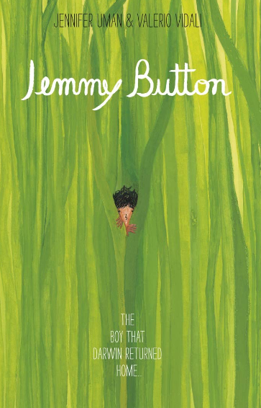  English focus text: Jemmy Button by Valerio Vidali  Extended writing outcomes:  -Diary entry for the return voyage home Jemmy Button takes, describing his experiences in England, what he learnt and what he saw while being taught how to be an English Gentlemen.  Short writing outcomes:  -Character description of Jemmy Button based on the illustrations from the story and the contextual information we learn about him.  Link Reading:  Mapping South America – Paul Rockett (Non-Fiction)  Blue Sky, White Stars  - Sarvinder Naberhaus (Narrative)  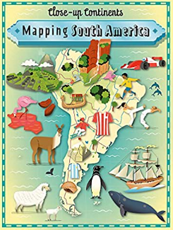      Mathematics – White Rose  Place Value  Addition and Subtraction | P.E:  Gymnastics.  • Plan, perform and repeat sequences.  • Refine movements into sequences.  • Show changes of direction, speed and level during a performance.  • Travel in a variety of ways, including flight, by transferring weight to generate power in movements.  I.C.T:  Digital Literacy:  -Use technology safely, respectfully and responsibly; recognise acceptable/unacceptable behaviour; identify a range of ways to report concerns about content and contact.  Multimedia:  -Use sequence, selection, and repetition in programs, work with variables and various forms of input and output  RE:  Religion: Christianity.  Theme: Beliefs and Practices  Key Question: What kind of world did Jesus want?  -To learn about the concept of ‘Gospel’* which tells the story of the life and teaching of Jesus. They will learn about the calling of the first disciples and how Christians today try to follow Jesus.  PSHE: Jigsaw Being Me In My World.  Music: Violins.  • Play notes on an instrument with care so that they are clear.  • Perform with control and awareness of others.  MFL: Spanish  Phonetics 2 (XT)  Vegetables (E)
DT: Mechanical Systems Levers and Linkages.
• Use research and develop design criteria to inform the design of innovative, functional, appealing products that are fit for purpose, aimed at particular individuals or groups • Understand how key events and individuals in design and technology have helped shape the world • Apply their understanding of how to strengthen, stiffen and reinforce more complex structures • Understand and use mechanical systems in their products (for example, gears, pulleys, cams, levers and linkages) • Evaluate their ideas and products against their own design criteria and consider the views of others to improve their work.

