History Focus – The Ancient Egyptians  Enquiry Question: How much did the Ancient Egyptians achieve? | Year 4 – Secrets of a Sun King | The Curriculum – Threshold Concepts
History:  Communicate historically:  • Develop the use of historical terms.  • Construct informed responses that involve thoughtful selection and organisation or relevant historical information.  Historical enquiry:  • Understand how our knowledge of the past is constructed from a range of sources.  • Address and devise historically valid questions about similarity, difference and significance.  Understanding chronology:  • Develop a chronologically secure knowledge and understanding of British, local and world history.  Interpret historically:  • Study the achievements of the earliest civilisations.  • Note connections, contrasts and trends over time.  Science  Biology – Living things and their habitats  • Recognise that living things can be grouped in a variety of ways.  • Explore and use classification keys to help group, identify and name a variety of living things in their local and wider environment.  •Recognise that environments can change and that this can sometimes pose danger to living things. | 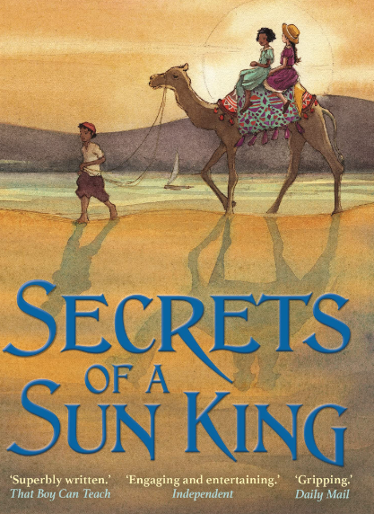  English focus text: Secrets of a Sun King by Emma Carroll  Extended writing outcomes:  -Creating a Non-Chronological Report based on Howard carter and his discovery of Tutankhamun focusing on the structural layout of a non-chronological report and using grammatical features most appropriate for this text type:  -bullet points, colons, and commas  -factual information from the story or research  -headings and subheadings  -themed, cohesive paragraphs  Link Reading:  Everything Ancient Egypt – National Geographic non-fiction text  The Eye of Ra – fiction text.  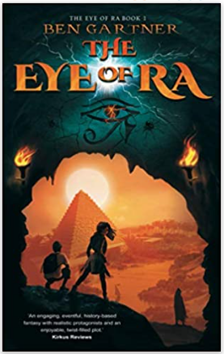  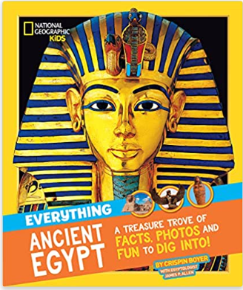  Mathematics – White Rose  Measurement - Area  Multiplication and Division A | P.E: Handball  • Throw and catch with control and accuracy.  • Follow the rules of the game and play fairly.  • Maintain possession of a ball (with, e.g. feet, a hockey stick or hands).  • Pass to team mates at appropriate times.  I.C.T: Computer Science  Communicate  • Use some of the advanced features of applications and devices in order to communicate ideas, work or messages professionally.  RE: Religion: Christianity  Theme: Christmas  Key Question: What is the most significant part of the Nativity story for Christians today?  • Present the key teachings and beliefs of a religion.  • Refer to religious figures and holy books to explain answers  PSHE: Jigsaw Celebrating Difference.  Music: Music Express.  Sounds – Musical Focus: Exploring sounds.  Recycling - Musical Focus: Structure.  Languages: Spanish.  Presenting Myself.  • Ask and answer simple questions and talk about interests.  • Take part in discussions and tasks.  • Demonstrate a growing vocabulary.
The Curriculum:
Art and Design: Exploring Pattern.
Exploring how we can use colour, line and shape to create patterns, including repeating patterns.
DT: Mechanical Systems
Levers and Linkages.
• Use scientific knowledge of the transference of forces to choose appropriate mechanisms for a product (such as levers, winding mechanisms, pulleys and gears).

