History Focus – The Ancient Egyptians  Enquiry Question: How much did the Ancient Egyptians achieve? | Year 4 – Secrets of a Sun King | The Curriculum – Threshold Concepts
History:  Communicate historically:  • Develop the use of historical terms.  • Construct informed responses that involve thoughtful selection and organisation or relevant historical information.  Historical enquiry:  • Understand how our knowledge of the past is constructed from a range of sources.  • Address and devise historically valid questions about similarity, difference and significance.  Understanding chronology:  • Develop a chronologically secure knowledge and understanding of British, local and world history.  Interpret historically:  • Study the achievements of the earliest civilisations.  • Note connections, contrasts and trends over time.  Science  Biology – Living things and their habitats  • Recognise that living things can be grouped in a variety of ways.  • Explore and use classification keys to help group, identify and name a variety of living things in their local and wider environment.  •Recognise that environments can change and that this can sometimes pose danger to living things. | 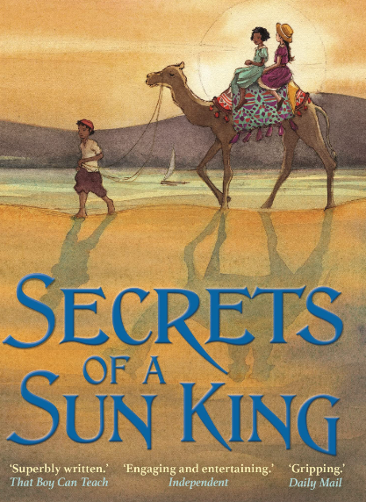  English focus text: Secrets of a Sun King by Emma Carroll  Extended writing outcomes:  -Creating a creative piece of historical fiction narrative story based on an ancient secret of either a God or a Pharaoh. Using extracts from the short novel as a guide to the structure of our writing including grammatical and language features we are studying:  -Fronted adverbials, expanded noun phrases  -Figurative language  -Conjunctions to create complex sentences.  Link Reading:  Everything Ancient Egypt – National Geographic non-fiction text  The Eye of Ra – fiction text.  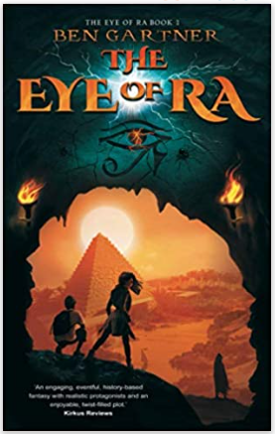  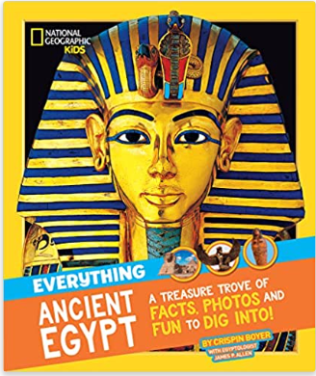  Mathematics – White Rose  Measurement - Area  Multiplication and Division A | P.E: Dance.  • Plan, perform and repeat sequences.  • Move in a clear, fluent and expressive manner.  • Refine movements into sequences.  • Create dances and movements that convey a definite idea.  • Change speed and levels within a performance.  • Develop physical strength and suppleness by practising moves and stretching.  I.C.T: Computer Science  • Use some of the advanced features of applications and devices in order to communicate ideas, work or messages professionally.  RE: Religion: Christianity  Theme: Christmas  Key Question: What is the most significant part of the Nativity story for Christians today?  • Present the key teachings and beliefs of a religion.  • Refer to religious figures and holy books to explain answers  PSHE: Jigsaw Celebrating Difference.  Music: Music Express.  Sounds – Musical Focus: Exploring sounds.  Recycling - Musical Focus: Structure.  MFL: Spanish  Musical Instruments.
The Curriculum:
Art and Design: Exploring Pattern.
Exploring how we can use colour, line and shape to create patterns, including repeating patterns
DT: Mechanical Systems
Levers and Linkages.

