  History Focus – The Ancient Egyptians  Enquiry Question: How much did the Ancient Egyptians achieve? | Year 4 – Secrets of a Sun King | The Curriculum – Threshold Concepts
  History:  Communicate historically:  • Develop the use of historical terms.  • Construct informed responses that involve thoughtful selection and organisation or relevant historical information.    Historical enquiry:  • Understand how our knowledge of the past is constructed from a range of sources.  • Address and devise historically valid questions about similarity, difference and significance.    Understanding chronology:  • Develop a chronologically secure knowledge and understanding of British, local and world history.    Interpret historically:  • Study the achievements of the earliest civilisations.  • Note connections, contrasts and trends over time.  Science  Biology – Living things and their habitats  • Recognise that living things can be grouped in a variety of ways.  • Explore and use classification keys to help group, identify and name a variety of living things in their local and wider environment.  •Recognise that environments can change and that this can sometimes pose danger to living things.           | 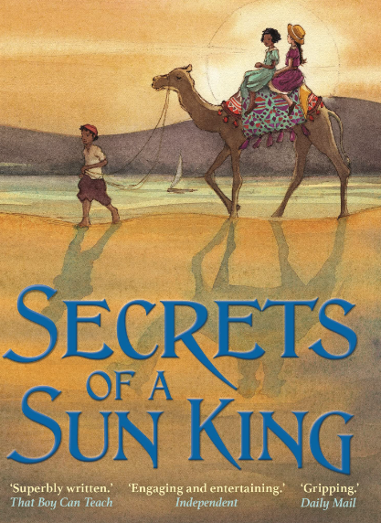  English focus text: Secrets of a Sun King by Emma Carroll  Extended writing outcomes:  -Creating a letter written as the main character to her friend, detailing the key events in the story regarding the curse in chronological order and writing informally as her friend to resolve the issue of the misplaced canopic jar.  Link Reading:  Meet The Egyptians - non-fiction text  The Eye of Ra – fiction text.  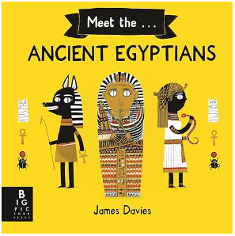  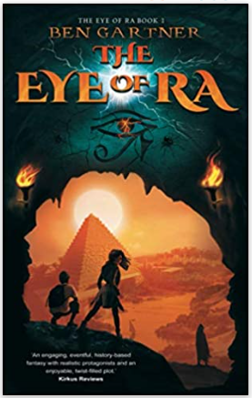    Mathematics – White Rose  Measurement - Area  Multiplication and Division A | 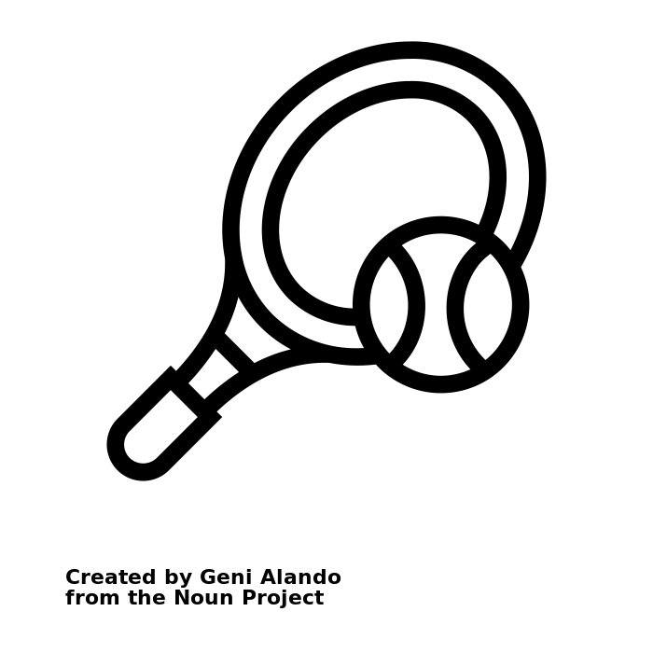  P.E: Tennis  • Use forehand and backhand when playing racket games.  • Choose appropriate tactics to cause problems for the opposition.  • Follow the rules of the game and play fairly.  I.C.T: Information Technology  - • Use search technologies effectively, appreciate how results are selected and ranked, and be discerning in evaluating digital content  - Select, use and combine a variety of software (including internet services) on a range of digital devices to design and create a range of programs, systems and content that accomplish given goals, including collecting, analysing, evaluating and presenting data and information. (Information Technology)  RE: Religion: Christianity  Key Question: For Christians, when Jesus left; what was the impact of Pentecost?  In this unit, pupils will find out about the events of Pentecost found in the Bible, considering which events would be needed to retell the story for someone else.  PSHE: Jigsaw Celebrating Difference.  Music: Violins.  • Play notes on an instrument with care so that they are clear.  • Perform with control and awareness of others.  Languages: Spanish.  Presenting Myself.  • Ask and answer simple questions and talk about interests.  • Take part in discussions and tasks.  • Demonstrate a growing vocabulary.
Art and Design: Exploring Pattern.
Exploring how we can use colour, line and shape to create patterns, including repeat patterns.
DT: Mechanical Systems
Levers and Linkages.
• Use scientific knowledge of the transference of forces to choose appropriate mechanisms for a product (such as levers, winding mechanisms, pulleys and gears).

