Geography Focus - Threshold Concepts | Y4 Rivers and the Water Cycle | Art and Design - Threshold Concepts
Geography:  Investigate Places:  - Ask and answer geographical questions about the physical and human characteristics of a location.  - Use a range of resources to identify the key physical and human features of a location.  - Identify and describe how the physical features affect human activity within a location.  - Use a range of resources to give detailed descriptions and opinions of the characteristics features of a location.  Communicate Geographically:  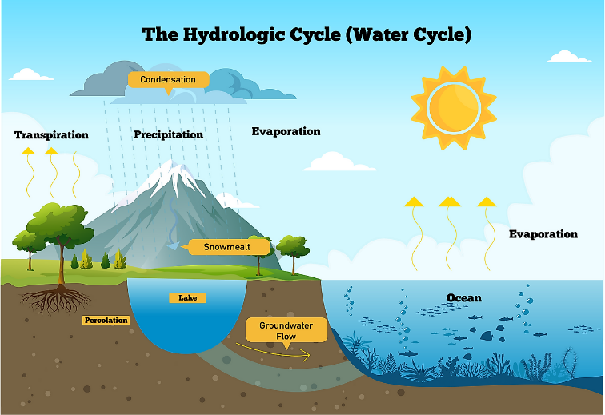  - Describe Key aspects of physical geography including rivers and the water cycle. | Enquiry Question:  How does the water go round and round?  Class Text  Themes: Based on a true story with an ecological message. The story starts with an exciting discovery of a whale in the River Thames. Michael can’t quite believe what he is seeing but then discovers a more serious message about our rivers and oceans when he befriends the stranded whale.  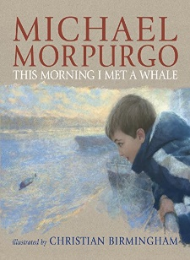  Extended Written Piece: Imagery Poem  - write with purpose.  - use imaginative description.  - use similes, metaphors, personification,  onomatopoeia and alliteration.  Supporting Text  Themes: The pollution of our seas, lakes and rivers. Lucy wants to save her town from total devastation by the Iron Woman. The Iron Woman wants to avenge the creatures in the rivers, lakes and seas. Can they work together and understand each other to prevent a catastrophe? And who is coming to help them…  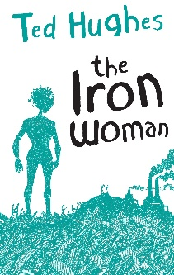  Supporting Written Piece: A persuasive letter  - write with purpose  - organise writing appropriately  - use paragraphs  - use sentences appropriately  R.E  Focus 1 : Buddhism - The life of the Buddha. Key Question: is it possible for everyone to be happy?  Focus 2: Judaism - Passover. Key Question: How important is it for Jewish people to do what God asks them to do?  ICT  Information Technology - using email.  SMSC and PSHE:  Focus: Celebration Difference - Respect for similarity and difference. Anti-bullying and being unique  D&T Focus: Electrical systems – Programming and control. Control and monitor models using software designed for this purpose. | Exploring Symbolism  Develop Ideas  - Collect information, sketches and resources..  - Comment on artworks using visual language.  Master Techniques  - Use a number of brush techniques using thick  and thin brushes to produce shapes, textures,  patterns and lines.  - Use watercolour paint to produce washes for  backgrounds then add detail.  - Mix colours effectively.  - Experiment with creating mood with colour  - Take inspiration from the greats  Artist Spotlight: Edvard Munch  - Replicate some of the techniques used by notable artists, artisans and designers.  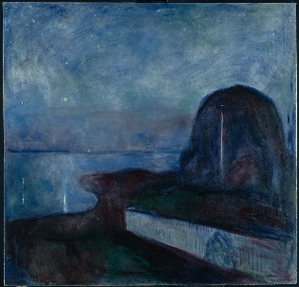  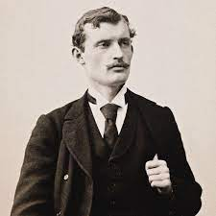
Science  Investigate Living Things:  - Recognise that living things can be grouped in a variety of ways.  - Explore and use classification keys.  - Recognise that environments can change and that this can sometimes pose dangers to specific habitats.  - Identify how plants and animals, including humans, resemble their parents in many features.  - Recognise that living things have changed over time and that fossils provide information about living things that inhabited the Earth millions of years ago.  - Identify how animals and plants are suited to and adapt to their environment in different ways. |  | Cross Curricular Opportunities  English: speaking and listening; poetry; performance, prepare poems and plays to read aloud with expression, volume, tone and intonation.  Maths: data, measurement, coordinates.  Computing: Programming, algorithms, data input, software.  History: Prehistoric England – Stone, Bronze and Iron age.

