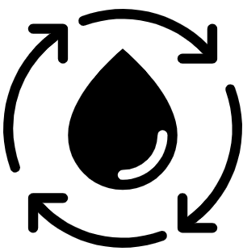  Geography Focus – Rivers and the Water Cycle  Enquiry Question: How does the water go round and round? | Year 4 – Why The Whales Came | The Curriculum – Threshold Concepts
Geography  Communicate geographically:  • To be able to explain different processes of how rivers and mountains are formed using Geographical vocabulary.  Enquire Geographically:  • To lean how rivers and mountains are formed.  • Identify some of the processes associated with rivers.  Study Location:  • To learn about the features of the River Thames in the United Kingdom, from source to mouth.  Mapping:  • To name and locate some of the United Kingdom’s and the world’s most significant rivers and mountain environments.  Science  Physics – Biology  • Recognise that living things can be grouped in a variety of ways.  • Explore and use classification keys to help group, identify and name a variety of living things in their local and wider environment.  • Recognise that environments can change and that this can sometimes pose dangers to living things.  • Living things can be divided into groups based upon their characteristics.  • Environmental changes affects different habitats differently.  • Different organisms are affected differently by environmental change.  • Different food chains occur in different habitats.  •Human activity significantly affects the environment. | 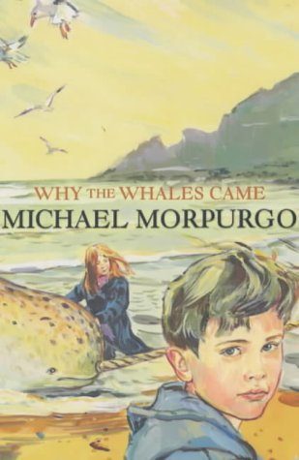  English focus text: Why the Whales Came by Michael Morpurgo  Extended writing outcomes:  - Non-Chronological reports focusing on the narwhal looking at the features of a non-chronological report and setting it out correctly.  - The legend of the Birdman. Creating a legend, using information taken from the text.  Link Reading:  This Morning I Met a Whale – Michael Morpurgo (Fiction Text by the same author)  The Wind in the Willows – Kennth Grahame (Classic Text)  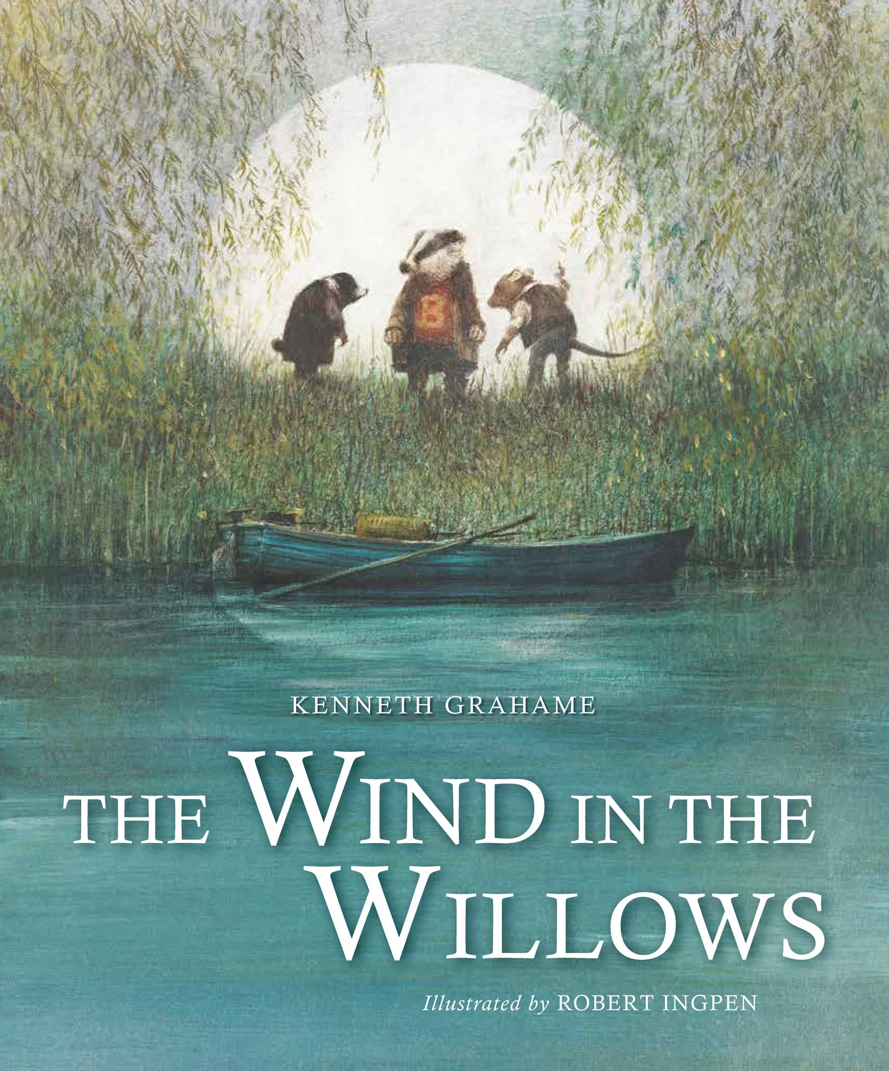  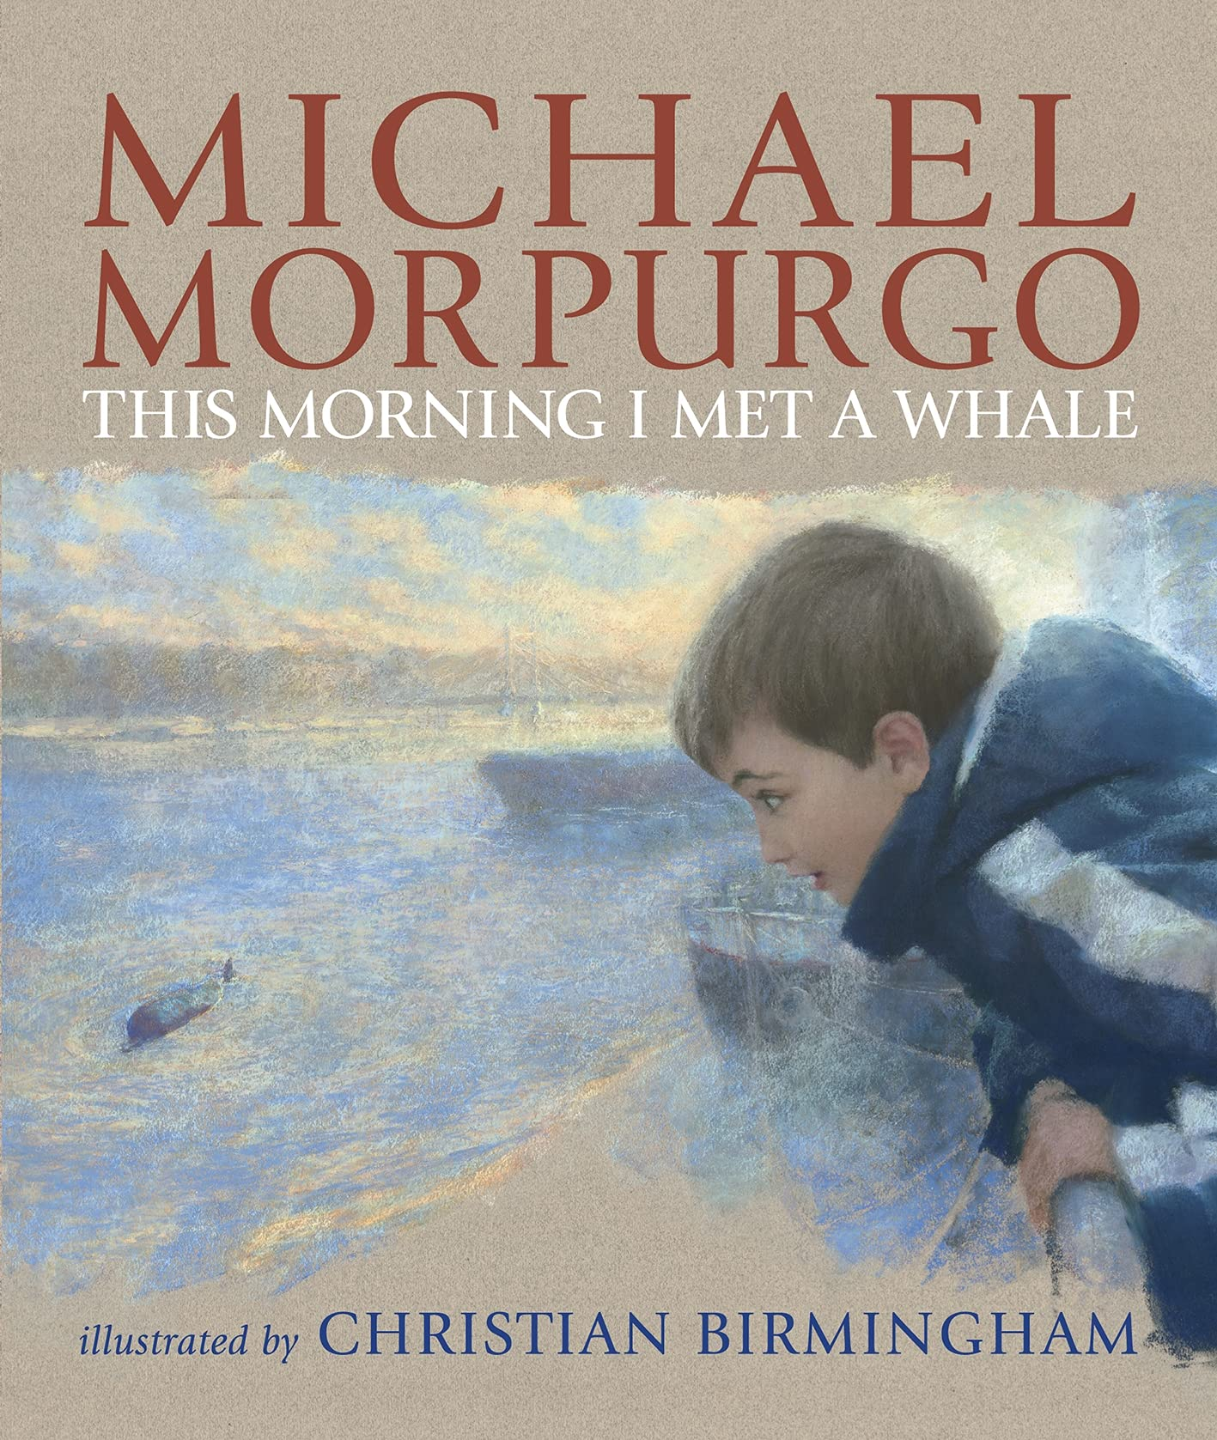  Mathematics – White Rose  Number – Multiplication and Division B  Measurement – Lenth and Perimeter | P.E: Dance  • Plan, perform and repeat sequences.  • Move in a clear, fluent and expressive manner.  • Refine movements into sequences.  • Create dances and movements that convey a definite idea.  • Change speed and levels within a performance.  I.C.T: Information Technology.  -Word processing: creating a document​​​​​​.  -PowerPoint: Design and transition.  -Paint.net - Design a Name Plate.  RE: Religion: Judaism  Theme: Passover.  Key Question: How important is it for Jewish people to do what God asks them to do?  PSHE: Jigsaw Dreams and Goals.  Music: Music Express.  Building – Musical Focus: Beat.  Around the World - Musical Focus: Pitch.  Languages: Spanish  Ancient Britain.  -To Understand the culture of the countries in which the language is spoken.  - To speak confidently.  - To read fluently.
Art and Design: Pathway – The Art of Display.
Key Concepts:
- That artists think carefully not just about what they make, but also how they present what they make.
- That when we view sculpture (or other art), the context (way it is presented) affects how we react to it.
- That how something will be seen can help us shape what is made.
- That we can give thought to how we display the art we make, to help us understand how people will view our work.
DT: Electrical Systems
Programming and Control. Stem Project – designing and creating a working electric powered vehicle.

