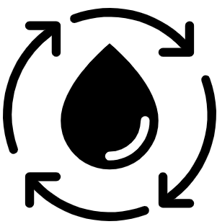  Geography Focus – Rivers and the Water Cycle  Enquiry Question: How does the water go round and round? | Year 4 – Why The Whales Came | The Curriculum – Threshold Concepts
  Geography  Communicate geographically:  • To be able to explain different processes of how rivers and mountains are formed using Geographical vocabulary.    Enquire Geographically:  • To lean how rivers and mountains are formed.  • Identify some of the processes associated with rivers.    Study Location:  • To learn about the features of the River Thames in the United Kingdom, from source to mouth.    Mapping:  • To name and locate some of the United Kingdom’s and the world’s most significant rivers and mountain environments.  Science  Biology -  • Recognise that living things can be grouped in a variety of ways.  • Explore and use classification keys to help group, identify and name a variety of living things in their local and wider environment.  • Recognise that environments can change and that this can sometimes pose dangers to living things.  • Living things can be divided into groups based upon their characteristics.  • Environmental changes affects different habitats differently.  • Different organisms are affected differently by environmental change.  • Different food chains occur in different habitats.  •Human activity significantly affects the environment.           | 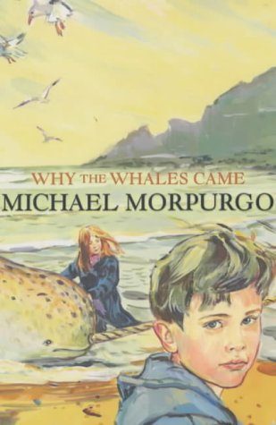  English focus text: Why the Whales Came by Michael Morpurgo  Extended writing outcomes:  - Narrative writing of ‘The legend of the Birdman’. Creating a legend, using information taken from the text to describe a character and setting, creating a narrative around ‘The Birdman’.  Link Reading:  This Morning I Met a Whale – Michael Morpurgo (Fiction Text by the same author)  The Wind in the Willows – Kennth Grahame (Classic Text)  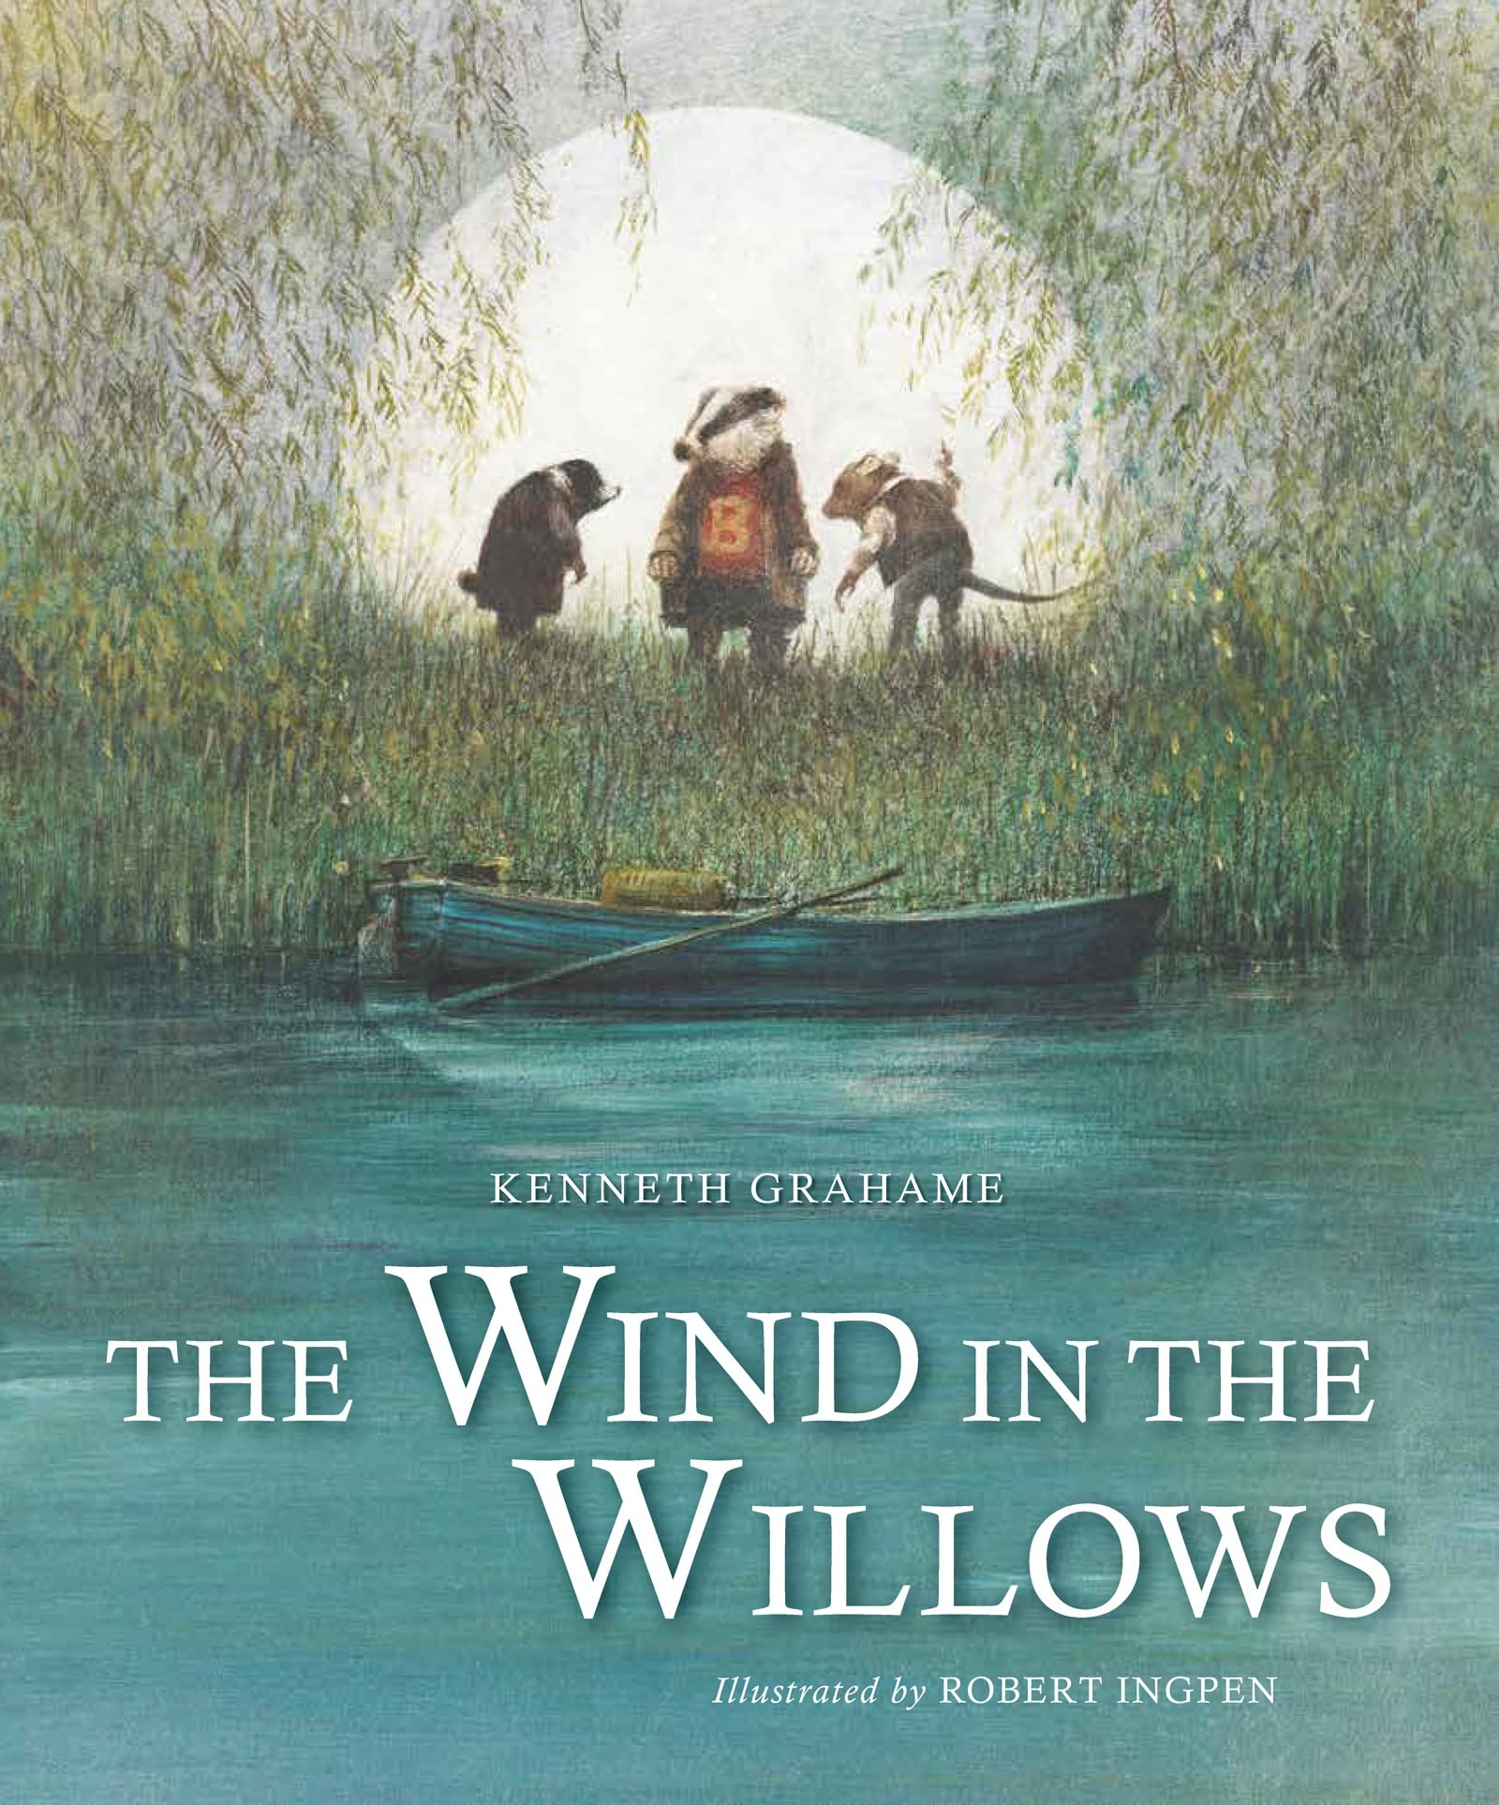  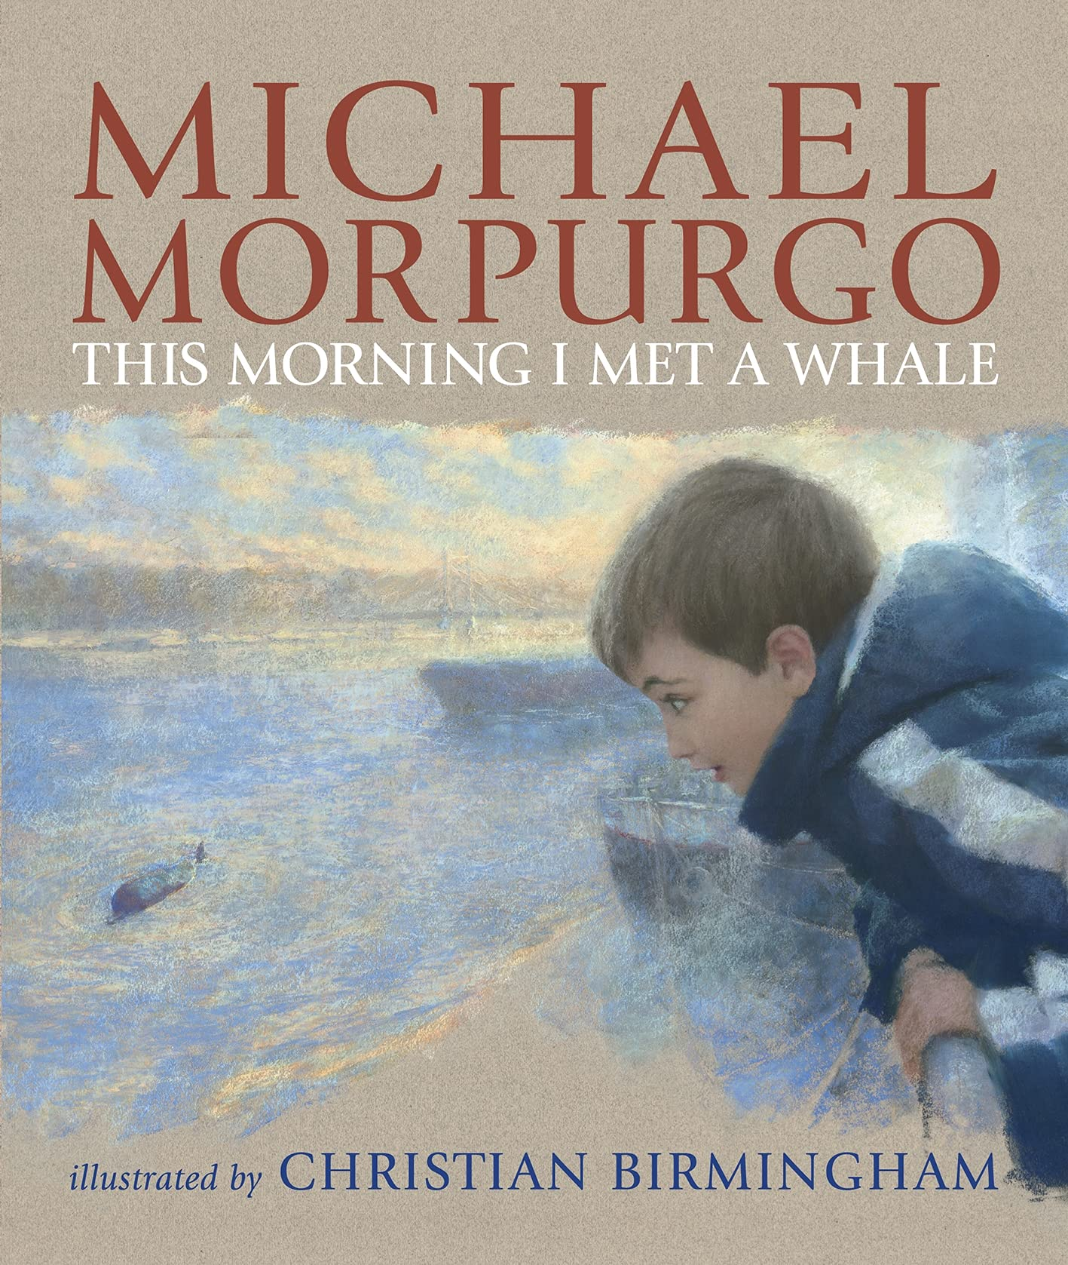    Mathematics – White Rose  Number – Multiplication and Division B  Measurement – Lenth and Perimeter | P.E: Dance  • Plan, perform and repeat sequences.  • Move in a clear, fluent and expressive manner.  • Refine movements into sequences.  • Create dances and movements that convey a definite idea.  • Change speed and levels within a performance.  I.C.T: Information Technology.  -Word processing: creating a document​​​​​​.  -PowerPoint: Design and transition.  -Paint.net - Design a Name Plate.  RE: Religion: Hinduism.  This unit begins to introduce Hindu Dharma to pupils, building on EYFS and Key Stage One. In this unit pupils act as philosophers considering how Hindus might see the world. They look at the concepts of Brahman to build up understanding. They use some stories, examine some Hindu texts and consider how deities exemplify qualities of Brahman  PSHE: Jigsaw Dreams and Goals.  Music: Learning the violin.  Languages: Spanish  Mi Familia – My Family.  By the end of this unit pupils will have the knowledge and skills to make a presentation about their own/a fictitious family in both spoken and written form in Spanish.
Art and Design: Pathway – The Art of Display.
Key Concepts:
- That artists think carefully not just about what they make, but also how they present what they make.
- That when we view sculpture (or other art), the context (way it is presented) affects how we react to it.
- That how something will be seen can help us shape what is made.
- That we can give thought to how we display the art we make, to help us understand how people will view our work.
DT: Electrical Systems
Programming and Control. Designing and creating a working electric powered vehicle.

