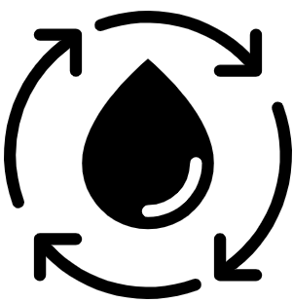  Geography Focus – Rivers and the Water Cycle  Enquiry Question: How does the water go round and round? | Year 4 – Why The Whales Came | The Curriculum – Threshold Concepts
Geography  Communicate geographically:  • To be able to explain different processes of how rivers and mountains are formed using Geographical vocabulary.  Enquire Geographically:  • To lean how rivers and mountains are formed.  • Identify some of the processes associated with rivers.  Study Location:  • To learn about the features of the River Thames in the United Kingdom, from source to mouth.  Mapping:  • To name and locate some of the United Kingdom’s and the world’s most significant rivers and mountain environments.  Science  Physics – Biology  • Recognise that living things can be grouped in a variety of ways.  • Explore and use classification keys to help group, identify and name a variety of living things in their local and wider environment.  • Recognise that environments can change and that this can sometimes pose dangers to living things.  • Living things can be divided into groups based upon their characteristics.  • Environmental changes affects different habitats differently.  • Different organisms are affected differently by environmental change.  • Different food chains occur in different habitats.  •Human activity significantly affects the environment. | 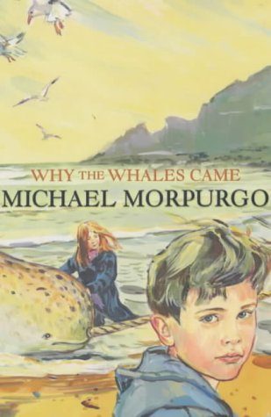  English focus text: Why the Whales Came by Michael Morpurgo  Extended writing outcomes:  - Non-Chronological reports focusing on the whales that are native to the waters around the United Kingdom looking at the features of a non-chronological report and setting it out correctly.  - The legend of the Birdman. Creating a legend, using information taken from the text.  Link Reading:  This Morning I Met a Whale – Michael Morpurgo (Fiction Text by the same author)  The Wind in the Willows – Kennth Grahame (Classic Text)  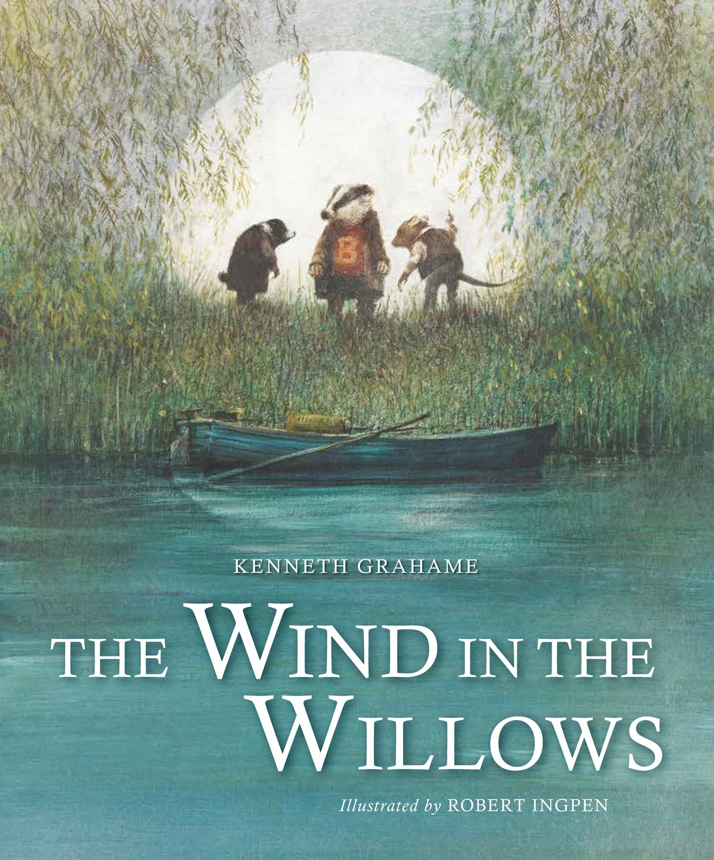  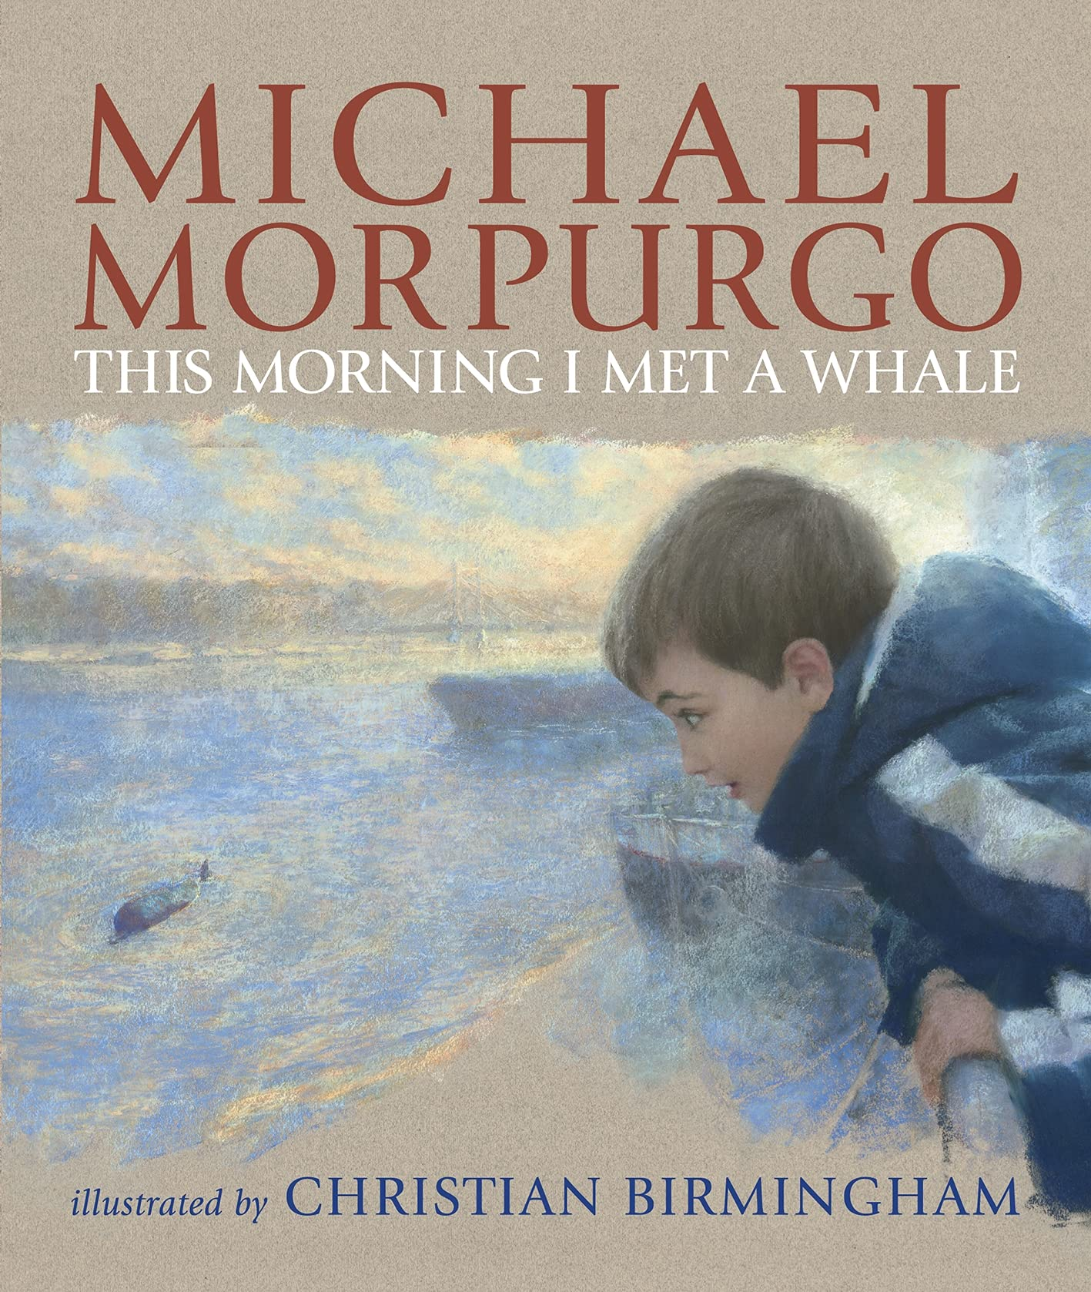  Mathematics – White Rose  Number – Multiplication and Division B  Measurement – Lenth and Perimetre | P.E: Gymnastics.  • Plan, perform and repeat sequences.  • Move in a clear, fluent and expressive manner.  • Refine movements into sequences.  • Show changes of direction, speed and level during a performance.  • Travel in a variety of ways, including flight, by transferring weight to generate power in movements.  • Show a kinesthetic sense in order to improve the placement and alignment of body parts (e.g. in balances experiment to find out how to get the centre of gravity successfully over base and organise body parts to create an interesting body shape).  • Swing and hang from equipment safely (using hands).  I.C.T: Information Technology.  -Word processing: creating a document​​​​​​.  -PowerPoint: Design and transition.  -Paint.net - Design a Name Plate.  RE: Religion: Judaism  Theme: Passover.  Key Question: How important is it for Jewish people to do what God asks them to do?  PSHE: Jigsaw Being Me In My World.  Music: Music Express.  Building – Musical Focus: Beat.  Around the World - Musical Focus: Pitch.  MFL: Spanish  Ancient Britain.
Art and Design: Pathway – The Art of Display.
Key Concepts:
- That artists think carefully not just about what they make, but also how they present what they make.
- That when we view sculpture (or other art), the context (way it is presented) affects how we react to it.
- That how something will be seen can help us shape what is made.
- That we can give thought to how we display the art we make, to help us understand how people will view our work.
DT: Electrical Systems
Programming and Control.

