History Focus – Roman Britain. What happened when the Romans came to Britain? | Year 4 – The Thieves of Ostia | The Curriculum – Threshold Concepts
History:  Communicate historically:  • Note connections, contrasts and trends over time and develop the appropriate use of historical terms.  • Construct informed responses that involve thoughtful selection and organisation or relevant historical information.  Historical enquiry:  • Address historically valid questions about change, cause and significance.  • Address and devise historically valid questions about similarity and difference.  Understanding chronology:  • Develop a chronologically secure knowledge and understanding of British history.  Interpret historically:  • Construct informed responses that involve the thoughtful selection and organisation of historical information.  • Understand how our knowledge of the past is constructed from a range of sources.  Science Animals including humans  Physics – Energy of Sound.  • Know how sound is made associating some of them with vibrating.  • Know what happens to a sound as it travels from its source to our ears.  • Know the correlation between the volume of a sound and the strength of the vibrations that produced it.  • Know how sound travels from a source to our ears.  • Know the correlation between pitch and the object producing a sound. | 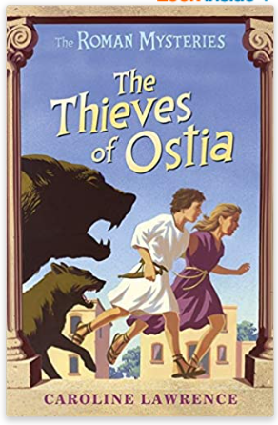  English focus text: The Thieves of Ostia by Caroline Lawrence.  Extended writing outcomes: To create a non-chronological report about what life was like during the Roman Empire living in Rome. We will take information and facts from our focus story, as well as use our Historical learning to help build up our report. We will also use our link text to create a short setting description using our knowledge of what Italian cities were like to build up our description.  Link Reading:  Meet the Ancient Romans – James Davies (non-fiction book)  Escape from Pompeii – Christina Balit (picture book)  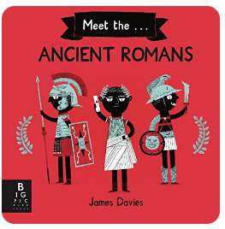  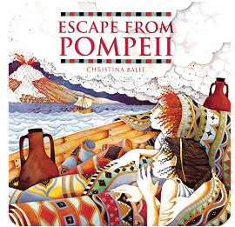  Mathematics – White Rose  Measurement: Length and Perimeter.  Number: Fractions.  Number: Decimals A | 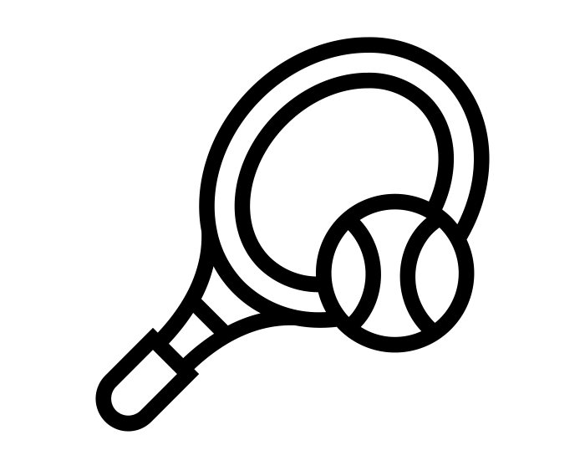  P.E: Tennis  • Use forehand and backhand when playing racket games.  • Choose appropriate tactics to cause problems for the opposition.  • Follow the rules of the game and play fairly.  Swimming  • Swim between 25 and 50 metres unaided.  • Use more than one stroke and coordinate breathing as appropriate for the stroke being used.  • Coordinate leg and arm movements.  • Swim at the surface and below the water.  I.C.T: Computer Science  Understand and identify algorithms.  Identify bugs and how to approach fixing them  RE: Christianity  Theme: Easter.  Key Question: Is forgiveness always possible for Christians?  Concept: Salvation.  • Present the key teachings and beliefs of a religion.  • Refer to religious figures and holy books to explain answers.  PSHE: Jigsaw. Healthy Me.  Puzzle Outcome: Healthy Friendships.  Music: Violins.  • Play notes on an instrument with care so that they are clear.  • Perform with control and awareness of others.  MFL: Spanish  Language Angels Unit: The Classroom.
Art and Design: Pathway – Exploring Still Life
Key Concepts:
- That when artists make work in response to static objects around them it is called still life.
- That still life has been a genre for many hundreds of years, and is it still relevant today.
- That when artists work with still life, they bring their own comments and meaning to the objects they portray.
- That we can make a still life creative response in many media: drawing, painting, collage, relief…
- That we can use line, shape, colour, texture, and form to help us give meaning to our work, and explore composition, foreground, background, and negative space.

