History Focus – Roman Britain. What happened when the Romans came to Britain? | Year 4 – The Thieves of Ostia | The Curriculum – Threshold Concepts
History:  Communicate historically:  • Note connections, contrasts and trends over time and develop the appropriate use of historical terms.  • Construct informed responses that involve thoughtful selection and organisation or relevant historical information.  Historical enquiry:  • Address historically valid questions about change, cause and significance.  • Address and devise historically valid questions about similarity and difference.  Understanding chronology:  • Develop a chronologically secure knowledge and understanding of British history.  Interpret historically:  • Construct informed responses that involve the thoughtful selection and organisation of historical information.  • Understand how our knowledge of the past is constructed from a range of sources.  Science  Physics – Energy of Sound.  • Know how sound is made associating some of them with vibrating.  • Know what happens to a sound as it travels from its source to our ears.  • Know the correlation between the volume of a sound and the strength of the vibrations that produced it.  • Know how sound travels from a source to our ears.  • Know the correlation between pitch and the object producing a sound. | 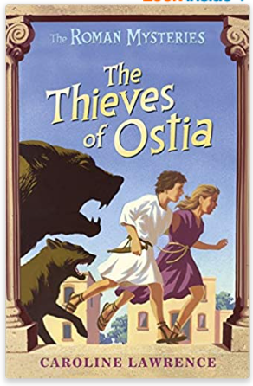  English focus text: The Thieves of Ostia by Caroline Lawrence.  Extended writing outcomes:  Narrative Writing – Mystery Story  Using the same character basis, we will plan, draft and write a creative narrative story involving a mystery that the main characters have to solve. Our story will be set in Ancient Roman times but with the characters and mystery being changed using our contextual knowledge learnt about this time period in history.  Link Reading:  Meet the Ancient Romans – James Davies (non-fiction book)  Escape from Pompeii – Christina Balit (picture book)  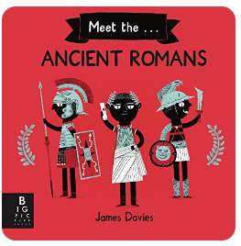  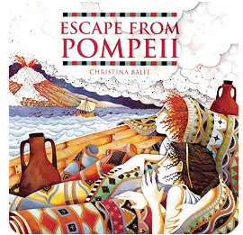  Mathematics – White Rose  Measurement: Length and Perimeter.  Number: Fractions.  Number: Decimals A | P.E: Handball  • Choose appropriate tactics to cause problems for the opposition.  • Follow the rules of the game and play fairly.  • Maintain possession of a ball (with, e.g. feet, a hockey stick or hands).  • Pass to team mates at appropriate times.  • Lead others and act as a respectful team member.  • Throw and catch with control and accuracy.  Swimming  • Swim between 25 and 50 metres unaided.  • Use more than one stroke and coordinate breathing as appropriate for the stroke being used.  • Coordinate leg and arm movements.  • Swim at the surface and below the water.  I.C.T: Computer Science  Understand and identify algorithms.  Identify bugs and how to approach fixing them  RE: Christianity  Theme: Easter.  Key Question: IS forgiveness always possible for Christians?  Concept: Salvation.  PSHE: Jigsaw. Healthy Me.  Puzzle Outcome: Healthy Friendships.  Music: Ancient Worlds  Musical Focus: Structure.  MFL: Spanish  Language Angels Unit: Vegetables.
Art and Design: Pathway – Exploring Still Life
Key Concepts:
- That when artists make work in response to static objects around them it is called still life.
- That still life has been a genre for many hundreds of years, and is it still relevant today.
- That when artists work with still life, they bring their own comments and meaning to the objects they portray.
- That we can make a still life creative response in many media: drawing, painting, collage, relief…
- That we can use line, shape, colour, texture, and form to help us give meaning to our work, and explore composition, foreground, background, and negative space.

