  History Focus – Roman Britain. What happened when the Romans came to Britain? | Year 4 – The Roman Invasion | The Curriculum – Threshold Concepts
  History:  Communicate historically:  • Note connections, contrasts and trends over time and develop the appropriate use of historical terms.  • Construct informed responses that involve thoughtful selection and organisation or relevant historical information.    Historical enquiry:  • Address historically valid questions about change, cause and significance.  • Address and devise historically valid questions about similarity and difference.    Understanding chronology:  • Develop a chronologically secure knowledge and understanding of British history.    Interpret historically:  • Construct informed responses that involve the thoughtful selection and organisation of historical information.  • Understand how our knowledge of the past is constructed from a range of sources.  Science Sound  Physics – Energy of Sound.  • Know how sound is made associating some of them with vibrating.  • Know what happens to a sound as it travels from its source to our ears.  • Know the correlation between the volume of a sound and the strength of the vibrations that produced it.  • Know how sound travels from a source to our ears.  • Know the correlation between pitch and the object producing a sound.           | 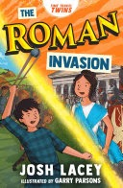  English focus text: The Roman Invasion. By Josh Lacey  Extended writing outcomes: To create a non-chronological report about the famous Roman Army. Our story is set during the Roman invasion of Britain, seeing our two main characters transported back in time to opposite sides of the conflict, through our story and non-fiction link texts we will create a detailed and accurate non-chronological report.  Link Reading:  Meet the Ancient Romans – James Davies (non-fiction book)  Escape from Pompeii – Christina Balit (picture book)  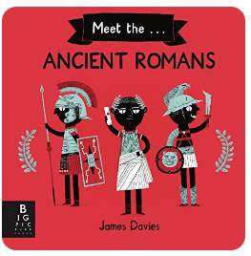  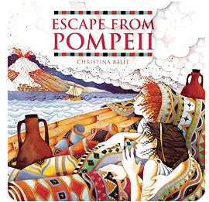    Mathematics – White Rose  Number: Fractions.  Number: Decimals A |   P.E: Gymnastics  • Plan, perform and repeat sequences.  • Move in a clear, fluent and expressive manner.  • Refine movements into sequences.  • Show changes of direction, speed and level during a performance.    Swimming  • Swim between 25 and 50 metres unaided.  • Use more than one stroke and coordinate breathing as appropriate for the stroke being used.  • Coordinate leg and arm movements.  • Swim at the surface and below the water.  I.C.T: Computer Science  Understand and identify algorithms.  -I can use variables in my programs.  -I can use selection in my programs.  -I can write programs that accomplish specific goals.  RE: Christianity  Enquiry Question: Why do Christians call the day that Jesus died ‘Good Friday’?  Within this unit, pupils will learn about how the Christian Salvation story fits into the big story of the Bible. They will find out about the main events of holy week and offer suggestions about how people at the time might have felt and responded to these key events  PSHE: Jigsaw. Healthy Me.  Puzzle Outcome: Healthy Friendships.  Music: Violins.  • Play notes on an instrument with care so that they are clear.  • Perform with control and awareness of others.  MFL: Spanish  Language Angels Unit: The Classroom.
Art and Design: Pathway – Exploring Still Life
Key Concepts:
- That when artists make work in response to static objects around them it is called still life.
- That still life has been a genre for many hundreds of years, and is it still relevant today.
- That when artists work with still life, they bring their own comments and meaning to the objects they portray.
- That we can make a still life creative response in many media: drawing, painting, collage, relief…
- That we can use line, shape, colour, texture, and form to help us give meaning to our work, and explore composition, foreground, background, and negative space.
Design and Technology.
Creating a motorised vehicle.
• Design with purpose by identifying opportunities to design.
• Create series and parallel circuits

