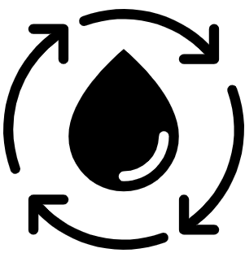  Geography Focus – How does the Earth shake, rattle and roll? | Year 4 – King of the Cloud Forests | The Curriculum – Threshold Concepts
Geography  Communicate geographically:  • To be able to describe and understand the key aspects of volcanoes and earthquakes.  • To know that earthquakes mostly occur at or near plate tectonic boundaries.  • To know the three major layers of the Earth.  Enquire Geographically:  • To understand that the distribution of earthquakes and volcanoes follows a pattern.  • To know there is an interdependence of the location of earthquakes and volcanoes and the boundaries of tectonic plates.  Study Location:  •To learn about the ‘Pacific Ring of Fire’  • To know that the Pacific Ring of Fire is a ring of plate boundaries circling the pacific ocean that is tectonically very active.  Mapping:  •To be introduced to plate tectonics.  • To understand the layers of the Earth and how plate tectonics move.  Science Sound  Chemistry – States of Matter  • Compare and group materials together, according to whether they are solids, liquids or gases.  • Observe that some materials change state when heated or cooled, and measure and research the temperature at which this happens in degrees Celsius.  • Identify the part played by evaporation and condensation in the water cycle and associate the rate of evaporation with temperature. | 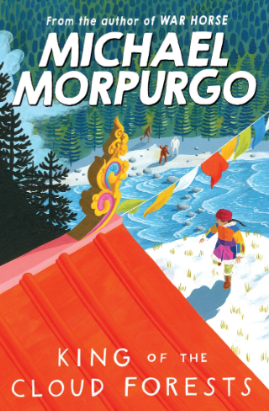  English focus text: King of the Cloud Forests by Michael Morpurgo  Extended writing outcomes:  Autobiography  Creating an autobiographical narrative story, writing as the main character Ashley, about his struggles and journey crossing the Himalayas whilst escaping China following Japan’s invasion leading up to Ashley’s capture and finding the cloud forest.  Link Reading:  Earthshattering Events – Sophie Williams (Non-Fiction)  The Brockenspectre – Linda Newberry (Fiction)  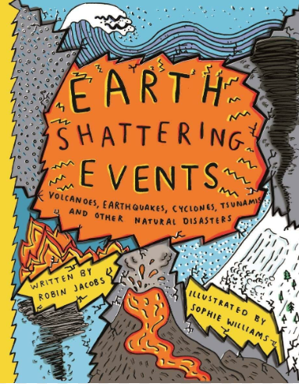  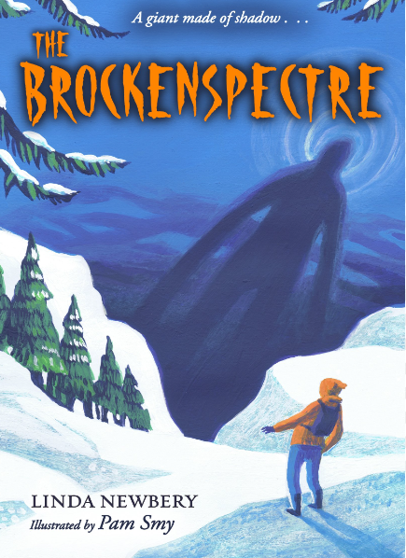  Mathematics – White Rose  Number – Decimals A and Decimals B  Measurement – Money and Time | P.E: Swimming  • Swim between 25 and 50 metres unaided.  • Use more than one stroke and coordinate breathing as appropriate for the stroke being used.  • Coordinate leg and arm movements.  • Swim at the surface and below the water  I.C.T: Information Technology  Computing Contexts  -I can develop camera skills and manipulation to create a trailer.  -I can create more complex video using a mixture of video and photo.  -I can use a variety of methods to create a news report with a replacement background.  RE: Religion: Hinduism.  Theme: Beliefs and Practices.  Key Question: What does it mean to be a Hindu in Britain today?  PSHE: Jigsaw Relationships.  Working towards building positive and healthy relationships.  Music: Music Express.  Learning the violin, reading music and preforming songs.  MFL: Spanish  At the café – En la Cafeteria.  -Remember and recall a wide variety of foods, snacks, and drinks (with their indefinite article/determiner) typically served in a Spanish cafetería.  • To understand better how to change a singular noun to plural form.  • Perform a short role-play ordering what they would like to eat and drink.
Art and Design: Pathway – Sculpture, Structure, Inventiveness and Determination.
Key Concepts:
-That artists can learn from the world around them. That artists can draw parallels with other beings/events to help us understand things about ourselves.
-That artists take creative risks. That artists try to say new things by manipulating and representing the materials of the world.
-DT: Food – Healthy Varied Diet

