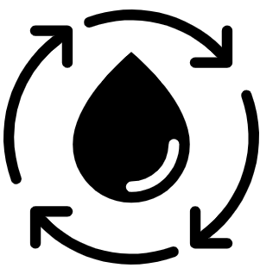  Geography Focus – How does the Earth shake, rattle and roll? | Year 4 – King of the Cloud Forests | The Curriculum – Threshold Concepts
Geography  Communicate geographically:  • To be able to describe and understand the key aspects of volcanoes and earthquakes.  • To know that earthquakes mostly occur at or near plate tectonic boundaries.  • To know the three major layers of the Earth.  Enquire Geographically:  • To understand that the distribution of earthquakes and volcanoes follows a pattern.  • To know there is an interdependence of the location of earthquakes and volcanoes and the boundaries of tectonic plates.  Study Location:  •To learn about the ‘Pacific Ring of Fire’  • To know that the Pacific Ring of Fire is a ring of plate boundaries circling the pacific ocean that is tectonically very active.  Mapping:  •To be introduced to plate tectonics.  • To understand the layers of the Earth and how plate tectonics move.  Science  Chemistry – States of Matter  • Compare and group materials together, according to whether they are solids, liquids or gases.  • Observe that some materials change state when heated or cooled, and measure and research the temperature at which this happens in degrees Celsius.  • Identify the part played by evaporation and condensation in the water cycle and associate the rate of evaporation with temperature. | 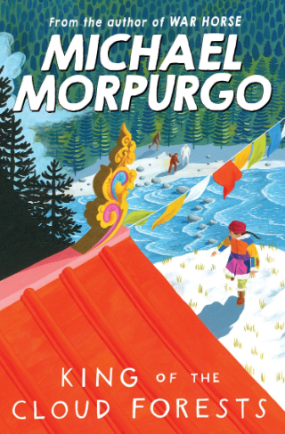  English focus text: King of the Cloud Forests by Michael Morpurgo  Extended writing outcomes:  Autobiography  Creating an autobiography writing as Ashley about his struggles and journey crossing the Himalayas whilst escaping China following Japan’s invasion leading up to Ashley’s capturing.  Link Reading:  Earthshattering Events – Sophie Williams (Non-Fiction)  The Brockenspectre – Linda Newberry (Fiction)  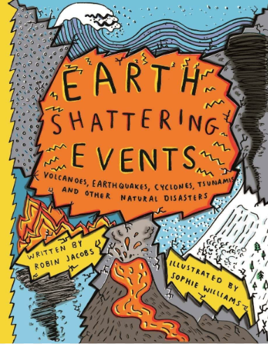  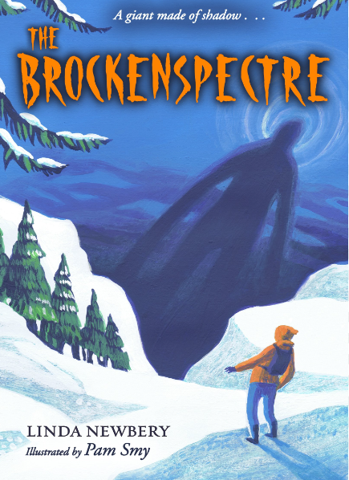  Mathematics – White Rose  Number – Decimals A and Decimals B  Measurement – Money and Time | P.E: Swimming  • Swim between 25 and 50 metres unaided.  • Use more than one stroke and coordinate breathing as appropriate for the stroke being used.  • Coordinate leg and arm movements.  • Swim at the surface and below the water  I.C.T: Information Technology  Computing Contexts  -I can develop camera skills and manipulation to create a trailer.  -I can create more complex video using a mixture of video and photo.  -I can use a variety of methods to create a news report with a replacement background.  RE: Religion: Judaism.  Theme: Beliefs and Practices.  Key Question: What is the best way for a Jew to show commitment to God?  PSHE: Jigsaw Relationships.  Working towards building positive and healthy relationships.  Music: Music Express.  Communication – musical focus: composition.  Time – musical focus: beat.  MFL: Spanish  Presenting Myself.
Art and Design: Pathway – Sculpture, Structure, Inventiveness and Determination.
Key Concepts:
-That artists can learn from the world around them. That artists can draw parallels with other beings/events to help us understand things about ourselves.
-That artists take creative risks. That artists try to say new things by manipulating and representing the materials of the world.
-That we can feel safe enough to take creative risks in our own work. That we can explore materials and ideas feeling free from criticism.
-That we can express our personality through the art we make.
DT: Food – Healthy Varied Diet

