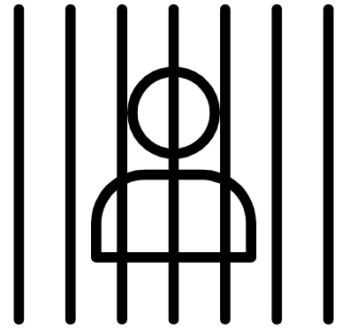  History Focus – Crime and Punishment  How has Crime and Punishment changed over time? | Year 4 English Focus  Oliver Twist by Charles Dickens | The Curriculum – Threshold Concepts
History:  Communicate historically:  • Establish clear narratives over periods of study.  • Note connections, contrasts and trends over time  and develop the use of historical terms.  • Construct informed responses that involve  thoughtful selection and organisation of relevant  historical information.  Historical enquiry:  • Address historically valid questions about  continuity, and change and cause.  • Address and devise historically valid questions  about continuity and change, similarity and  difference, and significance.  Understanding chronology:  • Develop a chronologically secure knowledge and understanding of British history.  Interpret historically:  • Understand how our knowledge of the past is  constructed from a range of sources.  Science  Biology – Animals including humans.  • Describe the simple functions of the basic parts of the digestive system in humans.  • Identify the different types of teeth in humans and their simple functions.  • Construct and interpret a variety of food chains, identifying producers, predators and prey  P.E:  Swimming.  • Swim between 25 and 50 metres unaided.  • Use more than one stroke and coordinate breathing as appropriate for the stroke being used.  • Coordinate leg and arm movements.  • Swim at the surface and below the water. | 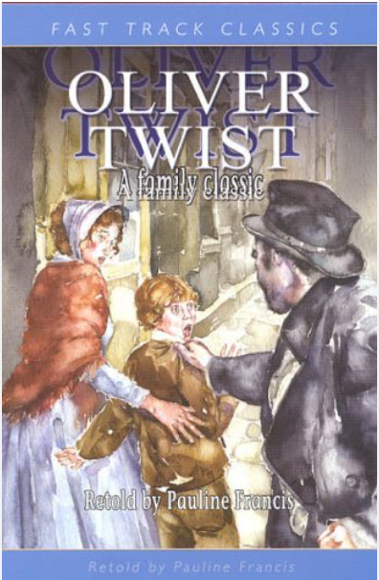  English focus text: Oliver Twist by Charles Dickens retold by Pauline Francis (Fast Track Classics)  Extended writing outcomes: Newspaper Report.  Using chapter five ‘The Robbery’ as the basis for our newspaper report we will explore the writing genre, identifying the grammatical and language features as well as the layout to create our own newspaper report, reporting on the events in the chapter as the purpose of our writing.  Link Reading:  Street Child by Berlie Doherty (Fiction)  The Vile Victorians by Terry Dean (Non-Fiction)  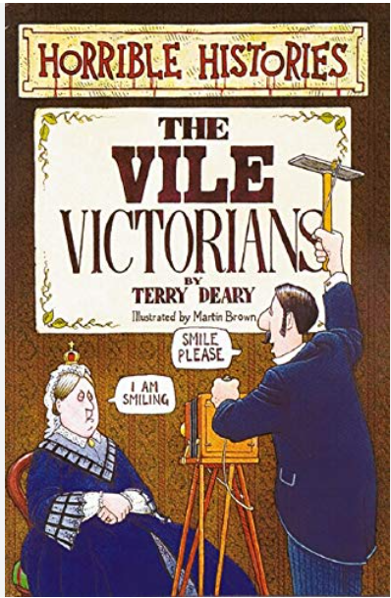  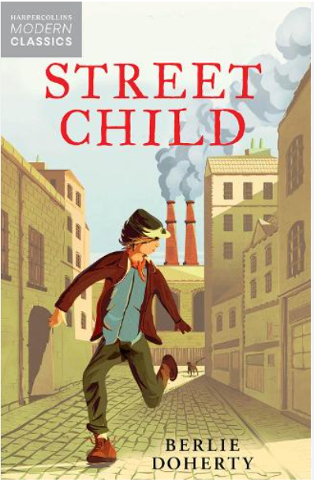  Mathematics – White Rose  Measurement – Money  Measurement – Time  Geometry – Shape  Geometry – Position and Direction. | I.C.T: Computer Science.  Scratch Creation of controllable maze game.  • Develop an understanding of instructions, logic and sequences by using IF and THEN conditions to control events or objects.  RE: Buddhism.  Theme: Beliefs and Practices.  Key Question: What is the best way for a Buddhist to lead a good life?  • Present the key teachings and beliefs of a religion.  • Refer to religious figures and holy books to explain answers.  PSHE: Jigsaw. Changing Me.  Puzzle Outcome: Looking at what makes us all unique and the changes that happen to our bodies as we get older.  Music: Unit: In the past.  Musical Focus: Notation.  • Use more than one stroke and coordinate breathing as appropriate for the stroke being used.  • Coordinate leg and arm movements.  • Swim at the surface and below the water.  MFL: Spanish  Language Angels Unit: Family.  • Ask and answer simple questions and talk about interests.  • Take part in discussions and tasks.  • Demonstrate a growing vocabulary
Art and Design: Pathway – Exploring Still Life
Key Concepts:
- That we can respond to a creative stimulus through lots of different media (paper, pen, paint, modelling materials and fabric) to work towards drawing, painting, collage, and sculpture.
- That we can use our knowledge and curiosity of line, shape, colour and form to make playful and inventive art.
- That we can make an individual artwork which contributes to a larger shared piece, or we can work on a shared artwork.
- That making art can be fun and joyful, and that we can find subject matter which inspires us all and brings us together.

