History – The Anglo Saxons  Enquiry Question:   | Year 5 | The Curriculum – Threshold Concepts
          Working Historically to:  -To be able to construct informed responses to historical questions about Anglo-Saxons.  -To be able to select and organise relevant historical information on Anglo-Saxons  -To be able to recognise how and why life changed in Britain during these periods  -To be able to describe the cultural/religious differences as they appeared during this time period.  -To be able to identify the significant events that brought about the most change during this period.  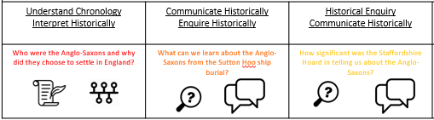  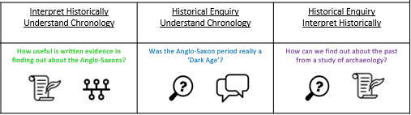  Science  Unit: Properties and changes of materials Chemistry  Compare and group together everyday materials based on their properties, including their hardness, solubility, transparency, conductivity (electrical and thermal), and response to magnets.  comparative and fair tests, for the uses of everyday materials, including wood, metals and plastic.  Demonstrate that dissolving, mixing and changes of state are reversible changes.  Explain that some changes result in the formation of new materials, and this kind of change is usually not reversible, including changes associated with burning and the action of acid on bicarbonate of soda  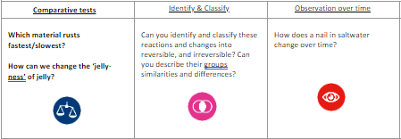  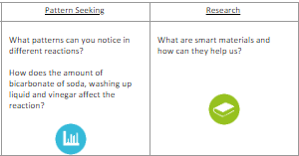 | English Focus text: Anglo-Saxon Boy  Link Reading: King Arthur and the knights of the round table  Writing Outcomes:  - Diary entry (changing the POV) describing the events at the court from a secondary character’s point of view  - Balanced argument Was it a good idea to be a warrior in the Anglo-Saxon times?  Reading Outcomes:  Reading skills: predicting, clarifying, questioning and summarising.  Grammatical Skills:  Subject related vocabulary (incl. old English)  Basic punctuation (Capital letters, full stops and commas etc.)  Present Tense (for stage directions)  Word classes (Verbs, adjectives and nouns)  Adverbs (character’s actions)  Pronouns  Determiners  Prepositions (scene description)  Contextual Knowledge:  -To understand differences between the current and Anglo-Saxon ways of life (incl. language used)  -To understand the universal values of courage, bravery and love  -To understand there may be many versions of the same story (to be able to compare them)  Maths – White Rose  Place Value  -Read Roman numerals to 1,000 (M) and recognise years written in Roman numerals.  -Count forwards or backwards in steps of powers of 10 for any given number up to 1,000,000  -Read, write, order and compare numbers to at least 1,000,000 and determine the value of each digit  -Solve number problems and practical problems involving the above  Addition and Subtraction  -Round any number up to 1,000,000 to the nearest 10, 100, 1,000, 10,000 and 100,000  Addition and Subtraction  -Add and subtract numbers mentally with increasingly large numbers  -Solve addition and subtraction multi-step problems in contexts, deciding which operations and methods to use and why  -Add and subtract whole numbers with more than four digits, including using formal written methods (columnar addition and subtraction)  -Round any number up to 1,000,000 to the nearest 10, 100, 1,000, 10,000 and 100,000  -Add and subtract numbers mentally with increasingly large numbers  -Use rounding to check answers to calculations and determine, in the context of a problem, levels of accuracy  DT  Unit Focus: Structures and Frame Structures  -To understand that structures can be large (e.g. buildings and bridges) or small (e.g. chairs and tables)  -To understand that freestanding structures are structures that can stand up without being attached to something else.  -To understand that freestanding structures need to support their own weight and also the weight of the things/people using them.  -Use designing, making and evaluating skills to create a bridge strong enough to transport a vehicle over water. (Use historical evidence of bridges being used in the past to support the movement of goods/ people) | P.E  Unit: Gymnastics 1  -To be able to develop flexibility, strength, technique, control and balance  Computer Science  Digital Literacy: E-Safety, Self-image and identity.  Online relationships, copyright and ownership, and I.T cloud and shared documents.  Information Technology: Plan an event, design a logo and create a digital flyer.  PSHE  Unit: Being me in my world.  I will learn…  -How to face challenges positively.  -What it means to have rights and responsibilities.  -How everyone has the right to learn.  -The affect that choices can have upon rewards and consequences.  R.E  Enquiry Questions: What does it mean if Christians believe that God is Holy and loving?  Religion: Christianity  -Learn about what Christians believe their God is like, exploring key texts from the Bible.  -Study passages from the book of Isaiah and Psalm 103 (Old Testament) and the book of 1 John (New Testament) to work out some ways the Bible says that God is both holy and loving.  MUSIC  Unit: Our Community  - Learning to sing a song  -Understanding metre through singing.  -Conducting a metre of four.  - To be able to develop accompaniments using ostinato and invented or improvised rhythms  -To Rehearse for a performance.  MFL  Unit: Phonics: Do you have a pet? (¿Tienes una mascota?)  -Learn the nouns and indefinite articles for 8 common pets.  -Ask somebody if they have a pet and give an answer back  -Say in Spanish what pet we have/do not have and give our pet’s name.  -Start to use the simple conjunctions 'y' (and) and 'pero' (but).  Art  Pathway: Typography and Maps  Disciplines  -To understand that when designers work with fonts and layout it is called Typography.  -To understand that we can use the way words look to help us communicate ideas and emotions.  -To understand that we can create our own typography and combine it with other visual elements to make artwork about chosen themes.

