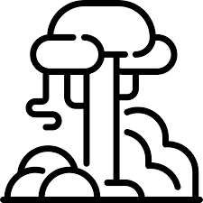  Geography Focus – South America - The Amazon | Year 6  Key Questions: What is life like in the Amazon? | The Curriculum – Threshold Concepts
Geography  Communicate geographically:  - Describe and understand key aspects of physical and human geography.  Enquire Geographically:  - Develop use of geographical knowledge, understanding and skills to enhance their locational and place knowledge.  - Extend knowledge and understanding beyond their local area to include South America.  Study Location:  - Understand geographical similarities and differences through the study of human and physical geography of a region of South America  Mapping:  - Use maps, atlases, globes and digital/computer mapping to locate countries and describe features.  Science  Physics – Light  - Understand that light appears to travel in straight lines.  - Use the idea that light travels in straight lines to explain that objects are seen because they give out or reflect light into the eyes.  - Use the idea that light travels in straight lines to explain why shadows have the same shape as the objects that cast them, and to predict the size of shadows when the position of the light source changes.  - Explain that we see things because light travels from light sources to our eyes or from light sources to objects and then to our eyes | 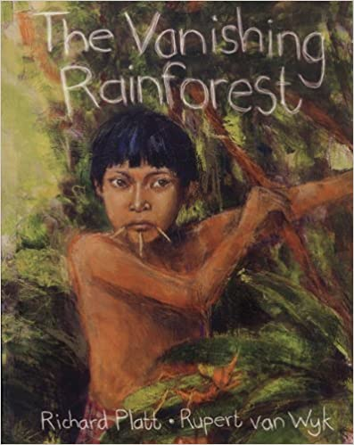  English focus text:  The Vanishing Rainforest  The children will compose a balanced argument relating to the deforestation of the Amazon, representing for and against viewpoints that affect the region locally and globally. They will use skills learnt in SPaG to enhance their writing including causual conjunctions and write using the point, evidence, explanation structure.  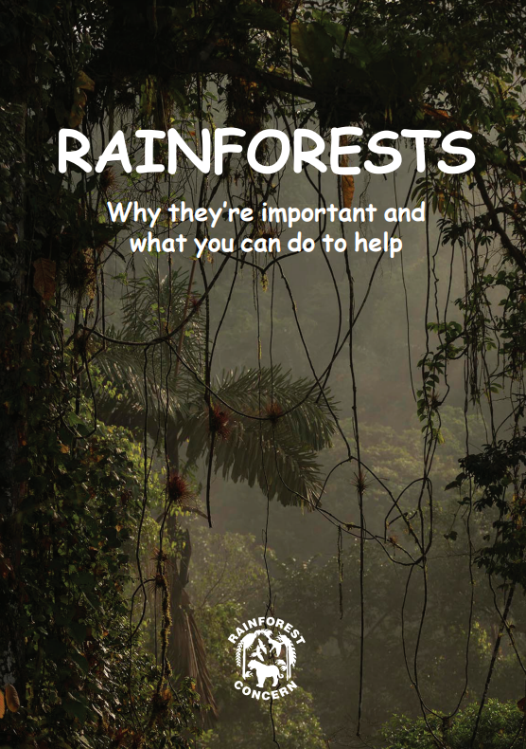  English Linked text:  Rainforests: Why they’re important and what you can do to help  The children will write a setting description of the Amazon jungle using their knowledge from our geography theme alongside the focus text and depictions of the jungle environment. They will use figurative language to create vivid images for the reader.  Maths – White Rose  Place Value  - Numbers to 1,000,000  - Number to 10,000,000  - Read and write numbers to 10,000,000  - Power of 10  - Number line to 10,000,000  - Compare and order any integers  - Round any integer  - Negative numbers | P.E: Gymnastics (Twist and Flip)  - Explore balances, rolls on/off apparatus  - Perform handstands and into a forward roll; cartwheels; perform rotation and balances.  - Combine balance & travel to produce a routine.  I.C.T: Digital Literacy  - E-Safety; Project Evolve  - Self-image and identify  - Online relationships  RE: Religion: Islam  Theme: Beliefs and Practices  Key Question: What is the best way for a Muslim to show commitment to God?  PSHE: Jigsaw Being Me In My World.  - Help others to feel welcome  - Try to make our school community a better place  - Think about everyone’s right to learn  Music: Music Express.  - World Unite – Step Dance Performance.  - Journeys - Song Cycle Performance.  MFL: Language Angels  - Phonics 4  - Habitats  - At school  Art: Access Art  - Explore the idea that drawing as a 2 dimensional activity can be manipulated into a 3 dimensional object.  - Explore mark making, line, tonal value, colour, shape, and composition to inform a final piece.  DT: Textiles  - Join textiles with a combination of stitching techniques  - Use the qualities of materials to create suitable visual and tactile effects in the decoration of textiles

