Geography Focus – South America - The Amazon  Enquiry Question: What is life like in the Amazon? | Year 6 – The Vanishing Rainforest | The Curriculum – Threshold Concepts
Geography  Communicate geographically:  • Describe and understand key aspects of physical and human geography.  Enquire Geographically:  • Develop use of geographical knowledge, understanding and skills to enhance their locational and place knowledge.  • Extend knowledge and understanding beyond their local area to include South America.  Study Location:  • Understand geographical similarities and differences through the study of human and physical geography of a region of South America  Mapping:  • Use maps, atlases, globes and digital/computer mapping to locate countries and describe features.  Science  Physics – Light  • Understand that light appears to travel in straight lines.  • Use the idea that light travels in straight lines to explain that objects are seen because they give out or reflect light into the eyes.  • Use the idea that light travels in straight lines to explain why shadows have the same shape as the objects that cast them, and to predict the size of shadows when the position of the light source changes.  • Explain that we see things because light travels from light sources to our eyes or from light sources to objects and then to our eyes | 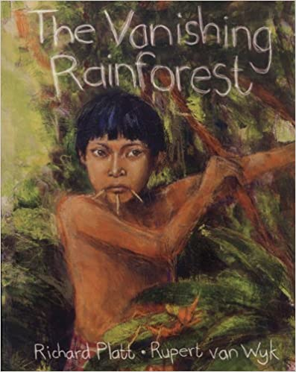  English focus text: The Vanishing Rainforest  -Balanced argument relating to the deforestation of the Amazon, representing for and against viewpoints that affect the region locally and globally.  Short writing outcomes:  -Setting description of the Amazon jungle based on the illustrations from the story and the contextual information learnt from the linked text and our geographical knowledge.  Link Reading:  Alone in the Amazon Forest – wordpress.com earth2mother (poetry)  Mapping South America – Paul Rockett (Non-Fiction)  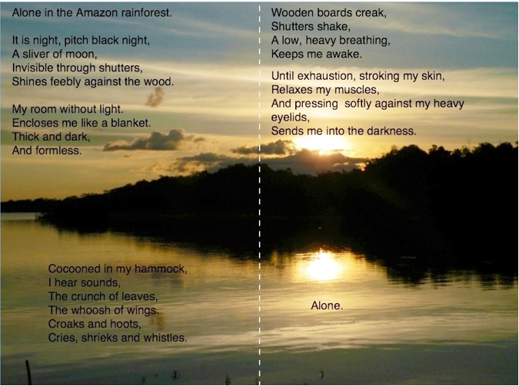  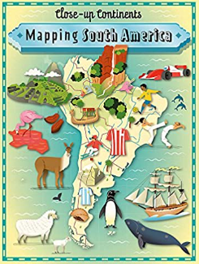  Maths – White Rose  Place Value  Addition, Subtraction, Multiplication and, Division. | P.E: Basketball.  • To pass and dribble with the ball.  • To develop the skills for shooting.  • To defend and mark an opponent  • To apply learnt skills to a game  I.C.T: Digital Literacy  - Understand, prevent, and respond to Cyberbullying threats.  - Is discerning in evaluating digital content  RE: Religion: Islam  Theme: Beliefs and Practices  Key Question: What is the best way for a Muslim to show commitment to God?  • learn to understand some of the ways Muslims show  commitment to God and to evaluate whether there is a  best way.  PSHE: Jigsaw Being Me In My World.  Music: Music Express.  World Unite – Musical Focus: Step Dance Performance.  Journeys - Musical Focus: Song Cycle Performance.  MFL:
The Curriculum:
Art and Design: 2D drawing to 3D making
xplore how 2D drawings can be transformed to 3D objects. Work towards a sculptural outcome or a graphic design outcome.
DT:
Textiles

