History Focus – Enquiry Question:  Why should we remember the Maya? | Year 6 – The Maya Civilisation | The Curriculum – Threshold Concepts
History  Historical Enquiry  - Use sources of evidence to deduce information about the past, refining lines of enquiry as appropriate.  - Seek out and analyse a wide range of evidence in order to justify claims about the past.  - Understand that no single source of evidence gives the full answer to questions about the past.  Interpret Historically  - Describe the social, ethnic, cultural or religious diversity of past society.  - Describe the characteristic features of the past, including ideas, beliefs, attitudes and experiences of men, women and children.  Communicate Historically  - Use appropriate historical vocabulary to communicate, including: dates, time period, era, chronology, continuity, change, century, decade, legacy.  - Use literacy, numeracy and computing skills to an exceptional standard in order to communicate information about the past.  Understand Chronology  - Describe the main changes in a period of history (using terms such as: social, religious, political, technological and cultural).  - Understand the concepts of continuity and change over time, representing them, along with evidence, on a time line.  Science  Physics – Light  - Understand that light appears to travel in straight lines.  - Use the idea that light travels in straight lines to explain that objects are seen because they give out or reflect light into the eyes.  - Use the idea that light travels in straight lines to explain why shadows have the same shape as the objects that cast them, and to predict the size of shadows when the position of the light source changes.  - Explain that we see things because light travels from light sources to our eyes or from light sources to objects and then to our eyes | 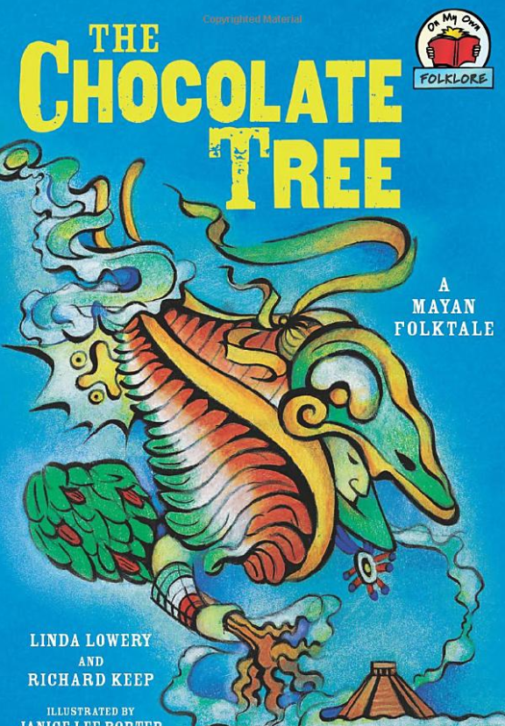  English focus text: The Chocolate Tree  Travel Guide to Maya – A (back in time) guide for visitors to the Maya civilisations, including places to visit, what to eat, Maya folklore, how to get there and where to stay.  Short writing outcomes:  Instruction text – An instruction text on how to make chocolate from cocoa similar to Mayan tradition.  Link Reading:  Mayan Civilisation –  The History Detective Investigates – Claire Hibbert  In Lak ‘ech  Luis Valdez  Mayan inspired poem  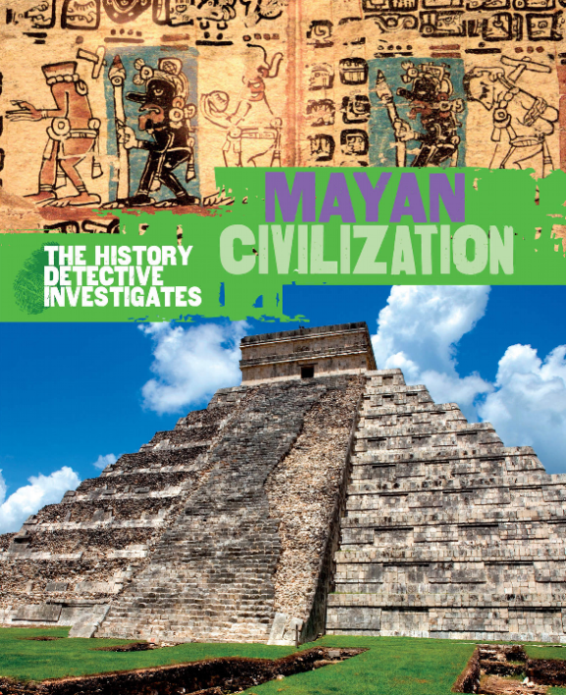  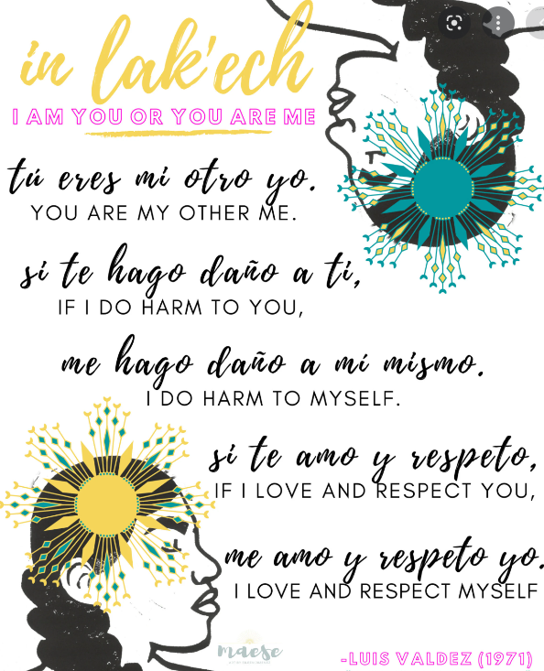  Maths – White Rose  - Addition, Subtraction, Multiplication and, Division.  - Fractions – Equivalent fractions, compare and order fractions, add and subtract fractions, multiply fractions, divide fractions, fractions of amounts.  - Measurement – converting units – metric, miles and kilometres, imperial. | P.E: Dance  - Perform expressively and hold a precise and strong body posture.  - Plan to perform with high energy, slow grace or other themes and maintain this throughout a piece.  - Perform and create complex sequences.  ICT  Digital Literacy – Sketch-Up – 3D Modelling  RE: Religion: Christianity  Theme: Christmas  Key Question: How significant is it that Mary was Jesus’ mother?  • Learn to analyse the Christian belief in the Virgin Birth and to assess the significance of this to Christians.  PSHE: Jigsaw – Celebrating Difference  - Learn how to respect for similarity and difference.  - Learn about Anti-bullying and being unique  Music: Music Express.  World Unite – Musical Focus: Step Dance Performance.  Journeys - Musical Focus: Song Cycle Performance.  MFL: Language Angels  - Phonetics 1&2  - Musical Instruments
The Curriculum:
Art and Design: 2D drawing to 3D making - Explore how 2D drawings can be transformed to 3D objects. Work towards a sculptural outcome.
DT:
Textiles
- Create objects (such as a cushion) that employ a seam allowance.
- Join textiles with a combination of stitching techniques (such as back stitch for seams and running stitch to attach decoration).
- Use the qualities of materials to create suitable visual and tactile effects in the decoration of textiles (such as a soft decoration for comfort on a cushion).

