Geography Focus – Enquiry Question:  Are we damaging our world? | Year 6 – Are we damaging our world?  Global Warming and Climate Change | The Curriculum – Threshold Concepts
Geography  Enquire Geographically  - Use sources to provide increasingly compelling evidence of environmental change.  - Research the key aspects of the distribution of natural resources including energy, minerals and water.  Mapping  - Use maps, atlases, and globes to locate countries and regions affected by environmental change.  Communicate Geographically  - Describe that the carbon cycle is the biogeochemical cycle by which carbon is exchanged among the biosphere, pedosphere, geosphere, hydrosphere, and atmosphere of the Earth. And that along with the nitrogen cycle and the water cycle, the carbon cycle comprises a sequence of events that are key to make Earth capable of sustaining life.  - Define ‘Sustainable Development’ as described by the UN World Commission on Environment and Development.  Study Location  - To be able to use fieldwork to observe, measure, record and present the physical features of an area using a range of methods, including sketch maps, plans and graphs, and digital technologies.  - Identify a Marine Protected Area and its purpose.  Science  Physics – Electricity  - Explore that batteries are a store of energy which pushes electricity round the circuit and when the battery’s energy is gone it stops pushing.  - Understand that voltage measures the ‘push’ of energy round a circuit.  - Know that the greater the current flowing through a device the harder it works.  - Understand that a ‘current’ is how much electricity is flowing round a circuit.  - Know that when a ‘current’ flows through wires heat is released. The greater the current, the more heat is released. | 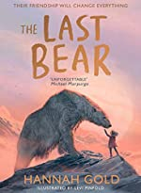  English focus text: The Last Bear  Biography – A biography of climate activist David Attenborough. Children to study and write a biography based on the life of naturalist David Attenborough.  Short writing outcome:  Explanation text – A written explanation of the carbon cycle and how Global Warming affects the planet.  Link Reading:  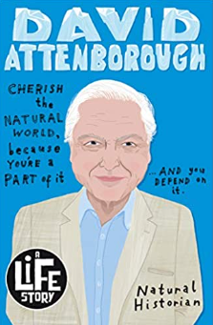  Sir David Attenborough:  (A Life Story) – Lizzie  Brian Moses  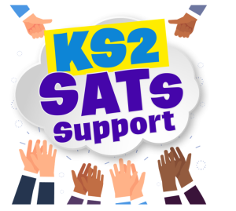  Huxley-Jones  Maths: White Rose  - Decimals, fractions, percentages.  - Algebra  - Ratio | P.E:  Dance:  - Perform dances using a range of movement patterns.  - Perform choreographed dance narrative, improving movement, developing timing and space.  ICT  - Digital Literacy: E-Safety – Online Reputations.  - Information Technology: Making Videos  - Computer Science: App Design  RE:  Religion: Christianity  Concept: Salvation  Theme: Beliefs and Meaning  Key Question: Is anything ever eternal?  PSHE:  Jigsaw – Dreams and Goals  - Learn about aspirations, how to achieve goals and understanding the emotions that go with this.  Music:  Y6 Leavers Performance – Farewell Concert.  - ‘The Island that Rocks’  MFL:  Language Angels  - At school  Art:  Brave Colour  Theme: Create a design proposal for a colourful architectural installation exploring colour and form.  DT  - Convert rotary motion to linear using cams.  - Use innovative combinations of electronics (or computing) and mechanics in product designs.

