Geography Focus  Sustainability | Year 6 – Are we damaging our world?  Global Warming and Climate Change | The Curriculum – Threshold Concepts
Geography  We will learn what plastic is and its uses, as well as the problems associated with plastic. We will investigate ways to reduce plastic waste in school and conduct fieldwork before recording, presenting and evaluating the collected data.  Key questions:  - What is plastic waste?  - What can our school do to reduce plastic waste?  - How can we plan and carry out effective ways to reduce plastic waste in school?  - How can we record and evaluate the effectiveness of reducing plastic waste in school?  Geographical Knowledge  - Place Knowledge,  - Human and Physical Geography  - Geography Skills and fieldwork  Concepts  - Interdependence,  - Physical and Human Processes,  - Environmental Impact  - Sustainable Development  Science  Physics – Electricity  - Explore that batteries are a store of energy which pushes electricity round the circuit and when the battery’s energy is gone it stops pushing.  - Understand that voltage measures the ‘push’ of energy round a circuit.  - Know that the greater the current flowing through a device the harder it works.  - Understand that a ‘current’ is how much electricity is flowing round a circuit.  - Know that when a ‘current’ flows through wires heat is released. The greater the current, the more heat is released.   | 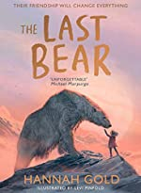  English focus text: The Last Bear  Biography – A biography of climate activist David Attenborough. Children to study and write a biography based on the life of naturalist David Attenborough.  Short writing outcome:  Explanation text – A non-chronological report on polar bears and the effects of plastic waste and climate change on their habitat.  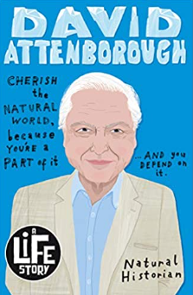  Link Reading:  Sir David Attenborough:  (A Life Story) – Lizzie Huxley-Jones  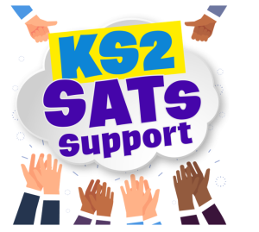  Brian Moses  Maths: White Rose  - Measurement – converting units  - Decimals, fractions, percentages.  - Algebra  - Ratio   | P.E: Dance:  - Perform dances using a range of movement patterns.  - Perform choreographed dance narrative, improving movement, developing timing and space.  ICT: Computer Science: Micro:Bit:  - I can create a program that accomplishes a specific goal.  - I can use the Micro:bit pins as an input and output.  - I can use while do loops, selection and variables in my algorithm.  RE: Religion: Hinduism  Key Question: Why do Hindus want to be good?  - I can interpret the story of the man in the well form the  - Mahabharata.  - I will investigate the key concepts of Karma, Dharma and samsara.  PSHE: Jigsaw – Celebrating Difference  - Learn how to respect similarity and difference.  - Learn about Anti-bullying and being unique  Music: Musical focus: Street dance performance - Growth  - I can explore Ravel’s Bolero through rhythmical mine.  - I can create a dance to build into a thrilling street performance.  MFL: Planets:  - I can name and label a map of the Solar System  - I can describe the Solar System in Spanish.  - I can ask key questions in Spanish to conduct an interview with an astronaut and present myself as an astronaut.  Art: Brave Colour:  - I can respond to creative challenges or stimulus, research the area, and make a creative response.  - I can use a sketchbook to focus my exploration of colour, taking time to record thoughts, test ideas and reflect.  - I can create a 3d model or 2d artwork which shares my vision with others.  DT  - Convert rotary motion to linear using cams.  - Use innovative combinations of electronics (or computing) and mechanics in product designs.

