Geography Focus – Enquiry Question:  Are we damaging our world? | Year 6 – Are we damaging our world?  Global Warming and Climate Change | The Curriculum – Threshold Concepts
Geography  Enquire Geographically  - Use sources to provide increasingly compelling evidence of environmental change.  - Research the key aspects of the distribution of natural resources including energy, minerals and water.  Mapping  - Use maps, atlases and globes to locate countries and regions affected by environmental change.  Communicate Geographically  - Describe that the carbon cycle is the biogeochemical cycle by which carbon is exchanged among the biosphere, pedosphere, geosphere, hydrosphere, and atmosphere of the Earth. And that along with the nitrogen cycle and the water cycle, the carbon cycle comprises a sequence of events that are key to make Earth capable of sustaining life.  - Define ‘Sustainable Development’ as described by the UN World Commission on Environment and Development.  Study Location  - To be able to use fieldwork to observe, measure, record and present the physical features of an area using a range of methods, including sketch maps, plans and graphs, and digital technologies.  - Identify a Marine Protected Area and its purpose.  Science  Physics – Electricity  - Explore that batteries are a store of energy which pushes electricity round the circuit and when the battery’s energy is gone it stops pushing.  - Understand that voltage measures the ‘push’ of energy round a circuit.  - Know that the greater the current flowing through a device the harder it works.  - Understand that a ‘current’ is how much electricity is flowing round a circuit.  - Know that when a ‘current’ flows through wires heat is released. The greater the current, the more heat is released. | 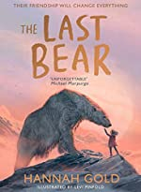  English focus text: The Last Bear  Biography – A biography of climate activist David Attenborough. Children to study and write a biography based on the life of naturalist David Attenborough.  Short writing outcome:  Explanation text – A written explanation of the carbon cycle and how Global Waring affects the planet.  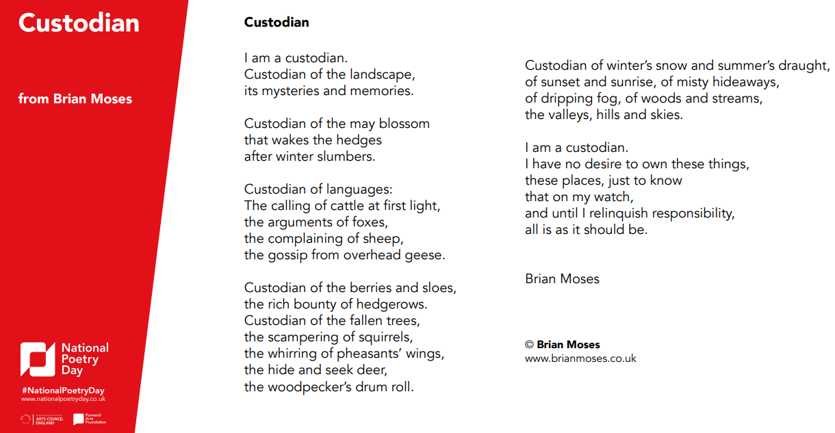  Link Reading:  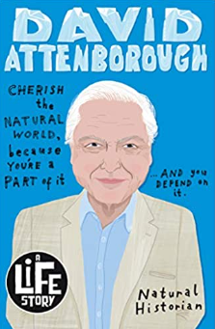  Sir David Attenborough: Custodian:  1 (A Life Story) – Lizzie Brian Moses  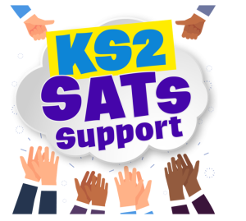  Huxley-Jones  Maths: White Rose  - Decimals, fractions, percentages.  - Algebra  - Ratio | P.E:  Gymnastics  - To perform counter balances  - Explore a range of rolls with a partner, on and off apparatus and within routines.  - To perform shoulder and headstands and incorporate into a performance.  ICT  - Digital Literacy: E-Safety – Online Reputations.  - Information Technology: Making Videos  - Computer Science: App Design  RE:  Religion: Christianity - Theme: Beliefs and Meaning  Key Question: Is anything ever eternal?  - Explore funeral and mourning rituals and what they tell you about what a religion believes and about what happens after death.  PSHE:  Jigsaw – Dreams and Goals  - Learn about aspirations, how to achieve goals and understanding the emotions that go with this.  Music:  Music Express.  - Growth – Musical Focus: Street Dance Performance.  - Roots - Musical Focus: Mini Musical Performance.  MFL:  Language Angels  - Ancient Britain and Presenting Myself  Art:  Print and Activism  - Create a poster on global warming / climate change using stencil or collage on canvas.  DT  - Convert rotary motion to linear using cams.  - Use innovative combinations of electronics (or computing) and mechanics in product designs.

