History Focus – Enquiry Question:  What did the Ancient Greeks do for us? | Year 6  What did the Ancient Greeks do for us? | The Curriculum – Threshold Concepts
History  Understand Chronology  To be able to place the time of Ancient Greek civilisation on to a timeline with Ancient Egyptians and Mayan civilisation  To be able to identify the main lasting achievements of Ancient Greek culture that can still be seen in Britain today  Historical Enquiry  To be able to ask and answer historically valid questions about the life and events of Ancient Greece  To be able to identify main sources of evidence about Ancient Greeks  Interpret Historically  To be able to recognise how and why Ancient Greeks have influenced modern life  Communicate Historically  To be able to describe the cultural differences during Ancient Greek civilisation  To be able to give reasons for historical change in Britain and wider world brought about by Ancient Greeks  Science  Physics – Electricity  - Explore that batteries are a store of energy which pushes electricity round the circuit and when the battery’s energy is gone it stops pushing.  - Understand that voltage measures the ‘push’ of energy round a circuit.  - Know that the greater the current flowing through a device the harder it works.  - Understand that a ‘current’ is how much electricity is flowing round a circuit.  - Know that when a ‘current’ flows through wires heat is released. The greater the current, the more heat is released. | 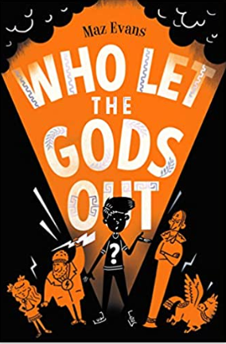  English focus text: Who Let the Gods out  Narrative – Children will recreate a classic Greek myth by interweaving descriptions of characters, settings and atmosphere with dialogue to help develop action and plot.  Character description – A character description of an ancient Greek god creating vivid images by using alliteration, similes, metaphors, and personification.  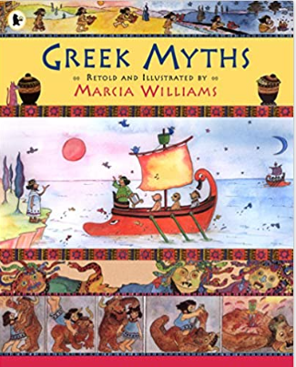  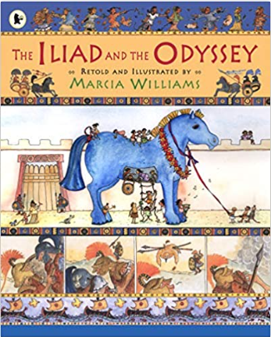  Link Reading:  Greek Myths – Marcia Williams  Maths: White Rose  - Algebra  - Measurement  - Statistics  - Shape  - Position and direction  The Iliad and The Odyssey – Marcia Williams  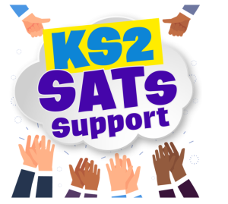 | P.E:  Tennis  - Control the ball and develop a cooperative rally.  - Develop underarm serve.  - Develop footwork and return serve.  - Develop serve and recognise how to score a point.  ICT  - Digital Literacy: E-Safety – Online Reputations.  - Information Technology: Making Videos  - Computer Science: App Design  RE:  Religion: Christianity - Theme: Easter, salvation, gospel.  Key Question: Is Christianity still a strong religion  2000 years after Jesus was on  Earth?  - Is Christianity still a strong religion  - 2000 years after Jesus was on  - Earth?  PSHE:  Jigsaw – Healthy Me  - Being and keeping safe and healthy.  Music:  Music Express.  - Growth – Musical Focus: Street Dance Performance.  - Roots - Musical Focus: Mini Musical Performance.  MFL:  Language Angels  - The Classroom  Art:  Exploring Identify  - Discover how artists use layers and juxtaposition to create artwork which explores identity. Make your own layered portrait.  DT  - Convert rotary motion to linear using cams.  - Use innovative combinations of electronics (or computing) and mechanics in product designs.

