      History Focus – Enquiry Question:  What did the Ancient Greeks do for us? | Year 6  What did the Ancient Greeks do for us? | The Curriculum – Threshold Concepts
Theme and concept:  Society and Community  Substantive concepts explicitly taught:  Civilisation, Trade, Settlement, Empire, Monarchy  Historical skill:  Evidence and Interpretation  What was life like in early Greece?  How did the Minoans trade in early Greece?  Historical skill:  Similarity and difference – cause and consequence  What was life like in Athens and Sparta?  How did the city-states overcome the Persian Invasion?  Historical skill:  Historical significance.  Who was Alexander the Great and what made him a significant leader?  What were the greatest acheivements of Ancient Greece?  Science  Physics – Electricity  - Explore that batteries are a store of energy which pushes electricity round the circuit and when the battery’s energy is gone it stops pushing.  - Understand that voltage measures the ‘push’ of energy round a circuit.  - Know that the greater the current flowing through a device the harder it works.  - Understand that a ‘current’ is how much electricity is flowing round a circuit.  - Know that when a ‘current’ flows through wires heat is released. The greater the current, the more heat is released.   | 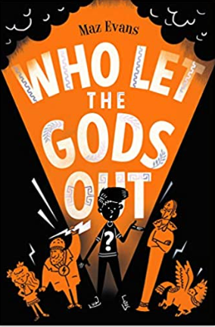  English focus text: Who Let the Gods out  Narrative – Children will recreate a part of a classic Greek myth by interweaving descriptions of characters, settings and atmosphere with dialogue to help develop action and plot.  Character description – A character description of an ancient Greek god creating vivid images by using alliteration, similes, metaphors, and personification.  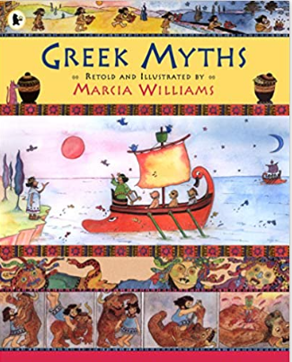  Link Reading:  Greek Myths – Marcia Williams  Maths: White Rose  - Fractions Decimals Percentages  - Measurement  - Statistics  - Shape  - Position and direction  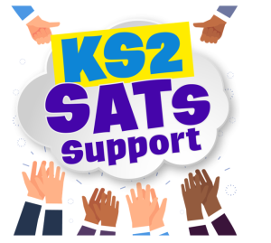 | P.E: Gymnastics – Lincs Inspire  - Support ourselves and partners with balances.  - Combine balancing and travelling  - Perform routines on apparatus.  ICT: Data Loggers  - Create algorithms using Microbit and Python  - Create and log an algorithm independently  - Debug a program  RE: Christianity: What difference does the resurrection make to Christians?  - Recognise the significance of the three days after the crucifixion.  - Recognise Christian beliefs in the resurrection.  PSHE: Jigsaw – Dreams and Goals  - Knowing the difference between a dream and a goal.  - Setting realistic learning steps to achieve a goal.  - Recognise emotions  Music: Music Express.  - Growth – Musical Focus: Street Dance Performance.  - Roots - Musical Focus: Mini Musical Performance.  MFL: Language Angels - El fin de semana (The weekend)  - Learn the time in Spanish  - Recognise, recall and spell 10 activities  - Integrate ‘at’ into spoken and written work.  Art: Exploring Identify  - Discover how artists use layers and juxtaposition to create artwork which explores identity. Make your own layered portrait.  DT: Mechanism  - Convert rotary motion to linear using cams.  - Use innovative combinations of electronics (or computing) and mechanics in product designs.

