Geography Focus – People and their communities. | Year 1 – City Shapes. | The Curriculum – Threshold Concepts
Geography:  Place knowledge - Understand geographical similarities and differences through studying the human and physical geography of a small area of the United Kingdom, and of a small area in a contrasting non-European country.  Human and physical geography - use basic geographical vocabulary to refer to: key physical features, including beach, cliff, coast, forest, hill, mountain, sea, ocean, river, soil, valley, vegetation, season and weather § key human features, including; city, town, village, factory, farm, house, office, port, harbour and shop.  Geographical skills and fieldwork - use aerial photographs and plan perspectives to recognise landmarks and basic human and physical features; devise a simple map; and use and construct basic symbols in a key.  Science- Chemistry: Everyday Materials.  · Distinguish between and object and the material from which it is made.  · Identify and name a variety of everyday materials,  including wood, metal, plastic, glass, water and rock,  · Describe the simple physical properties of a variety of  everyday materials.  · Compare and group together a variety of everyday            materials based on their simple properties. | 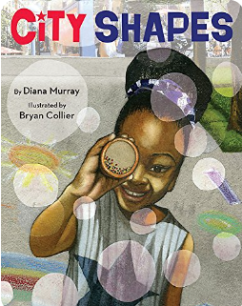  English focus text: City shapes.  Extended writing outcomes:  Story Re-write -  - To write a description of the actions.  - To sequence events that take place.  - To use word types to enhance sentences.  Link Reading:  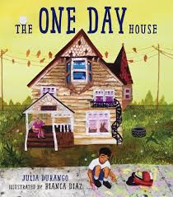  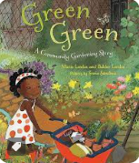  Maths – White Rose  Place value and Addition and Subtraction (within 20) | P.E: Striver - Dance.  I.C.T:  - E Safety Using the Internet Safely.  - Understanding algorithms .  RE: Religion: Judaism.  Theme: Jewish ways of life.  Key Question: Who is Jewish and how do they live?  PSHE: Jigsaw: Dreams and Goals.  Music: Music Express- Machines and Seasons.  MFL: Language Angels: Under the Sea.  DT: Mechanisms – sliders and levers  Access Art  Art and Design: Playful Making.  In this pathway children are introduced to what sculpture can be and invited to explore the work of other sculptors whilst taking a playful and inventive approach to making their own sculptures.

