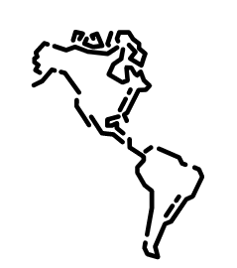  History Focus – The Greatest Explorers  Enquiry Question: Who were the greatest explorers? | Year 1– Tom Crean’s Rabbit | The Curriculum – Threshold Concepts
  History  Investigate and interpret the past.  This concept involves our understanding that the past comes from an interpretation of the available evidence.  Build an overview of world history.    - This concept involves an appreciation of the characteristic features of the past and an understanding that life is different for different sections of society.  - Describe significant people from the past such as: Ibn Battuta, Captain Cook, Roald Amundsen, Captain Robert Falcon Scott and Sunita Williams.  Understand chronology.    - This concept involves an understanding of how to chart the passing of time and how some aspects of history studied were happening at similar times in different places.  Communicate historically.  - This concept involves using historical vocabulary and techniques to convey information about the past.  Science  Work Scientifically  - To perform simple tests  - Ask simple questions  - Observe closely, using simple equipment  - Gather and record data  Understanding the Earth’s movement in Space  - To observe changes across the 4 seasons           | 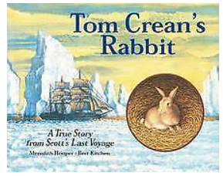  English focus text: Tom Crean’s Rabbit by Meredith Hooper  Short writing outcomes:  Write a recount of events in the story.  Extended writing outcome:  To write a letter to Tom Crean about a journey you have taken.  Link Reading:  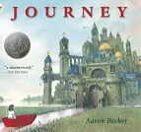  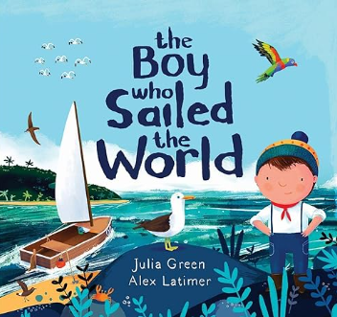  Maths – White Rose  Place Value – within 50  Length and Height  Mass and Volume | P.E: Gymnastics – moving and balancing  I.C.T:  Programming animations  Making, joining, changing, designing, showing.  RE:  Religion: Christianity – Unit 10.  Key Question: What do Christians believe God is like?  - Find out what Parables are.  - What it means to ask for forgiveness.  PSHE: Jigsaw - Healthy Me  Music: Music Express:  Our School  Pattern  MFL: Language Angels: Superheros.
The Curriculum:

Art and Design: Exploring watercolour
We are going to enjoy a freeing exploration of watercolour, building our understanding of the properties of the medium, and opening our minds as to how imagery can be created.

DT: Sliders and Levers.

