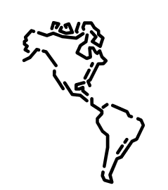  Geography Focus – Animals and their habitats. Where do animals live. | Year 1– One Day on our Blue Planet… in the Savannah | The Curriculum – Threshold Concepts
Geography  Investigate places  - Ask and answer geographical questions about the physical and human characteristics of a landscape.  - Explain own views about locations, giving reasons.  - Use maps, atlases, globes and digital/computer mapping to identify countries, continents and oceans.  - To name and locate the world’s 7 continents and 5 oceans.  - To know that some of the continents have significant hot and cold areas.  - To use specific place knowledge to describe the habitat of a significant animal.  Investigate patterns  - Understand geographical similarities and differences through studying the human and physical geography of their local area and 5 different World continents.  Communicate geographically  - Use appropriate geographical vocabulary to communicate key physical and human features.  - Use simple fieldwork and observational skills.  Science  Work Scientifically  - To perform simple tests  - Ask simple questions  - Observe closely, using simple equipment  - Gather and record data  Understanding animals and humans            Identify and name a variety of common animals that are birds, fish, amphibians, reptiles, mammals and invertebrates. | 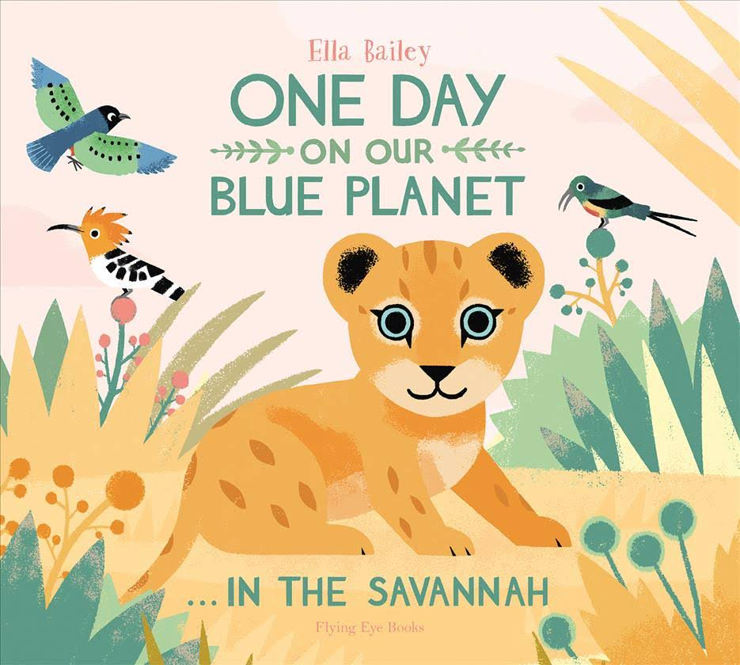  English focus text: One Day on our Blue Planet…in the Savannah  Extended writing outcomes:  To write an acrostic poem about the Savannah.  Short writing outcomes:  To write a setting description of the focus text.  Link Reading:  Listen to our World The Dandelion Seed  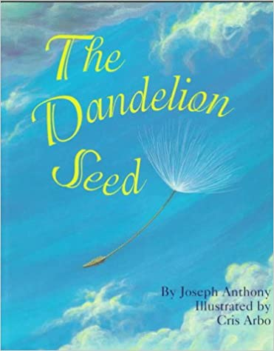  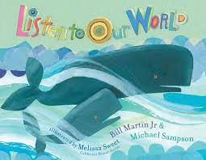  Maths – White Rose  Multiplication and Division  Fractions  Position and Direction | P.E: Athletics – Running, Jumping, Throwing and Catching.  I.C.T: E-Safety Managing Online Information I/T Digital Art and design  RE:  Religion: Christianity – Unit 10.  Key Question: What do Christians believe God is like?  - Find out what Parables are.  - What it means to ask for forgiveness.  PSHE: Jigsaw - Relationships  Music: Music Express:  Story Time  Our Bodies  MFL: Language Angels: Teddy bear picnic
The Curriculum:

Art and Design: Making Birds

This pathway aims to help children begin to understand the relationship between drawing and making, 2D and 3D. Pupils explore how to transform materials into sculpture, moving away from mark making to balance and structure.

DT: Food Preparation – fruit and vegetables.
To make a fruit kebab.

