  Geography Focus – South America - The Amazon | Year 6  Key Questions: What is life like in the Amazon? | The Curriculum – Threshold Concepts
Geography    Communicate geographically:  - Describe and understand key aspects of physical and human geography.  Enquire Geographically:    - Develop use of geographical knowledge, understanding and skills to enhance their locational and place knowledge.  - Extend knowledge and understanding beyond their local area to include South America.  Study Location:    - Understand geographical similarities and differences through the study of human and physical geography of a region of South America  Mapping:    - Use maps, atlases, globes and digital/computer mapping to locate countries and describe features.  Science  Physics – Light  - Understand that light appears to travel in straight lines.  - Use the idea that light travels in straight lines to explain that objects are seen because they give out or reflect light into the eyes.  - Use the idea that light travels in straight lines to explain why shadows have the same shape as the objects that cast them, and to predict the size of shadows when the position of the light source changes.  Maths – White Rose  Place Value  - Numbers to 1,000,000  - Number to 10,000,000  - Read and write numbers to 10,000,000  - Power of 10  - Number line to 10,000,000  - Compare and order any integers  - Round any integer  - Negative numbers  - Explain that we see things because light travels from light sources to our eyes or from light sources to objects and then to our eyes           | English focus text:  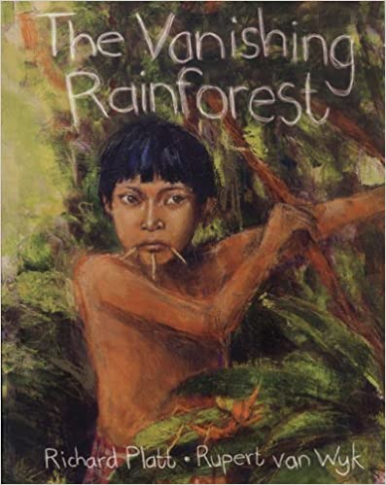  The Vanishing Rainforest  The children will compose a balanced argument relating to the deforestation of the Amazon, representing for and against viewpoints that affect the region locally and globally. They will use skills learnt in GPS to enhance their writing including causal conjunctions and write using the point, evidence, explanation structure.  English Linked text:  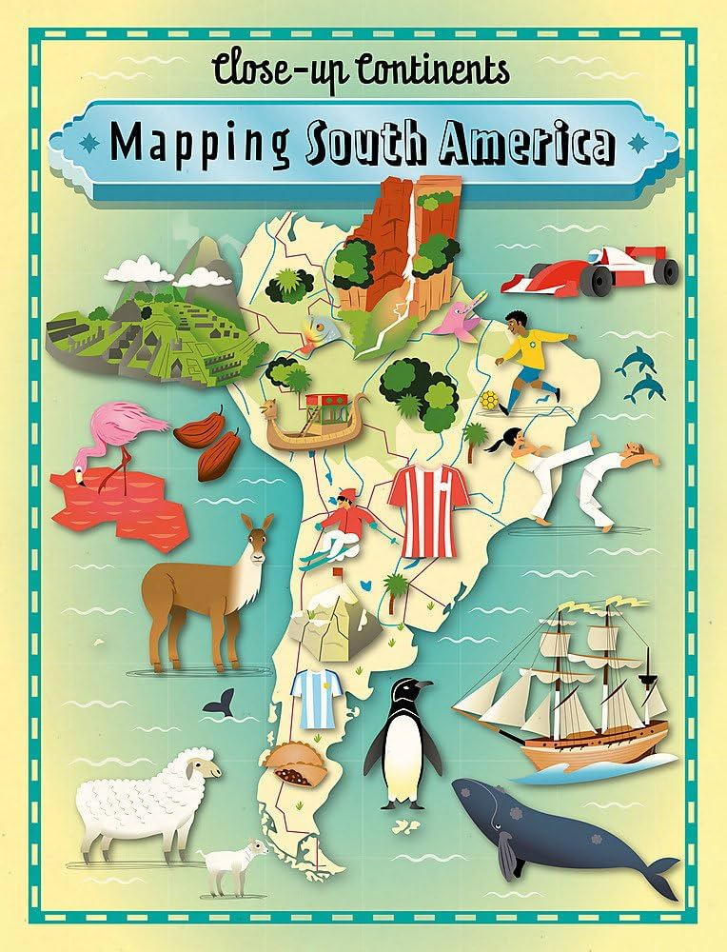  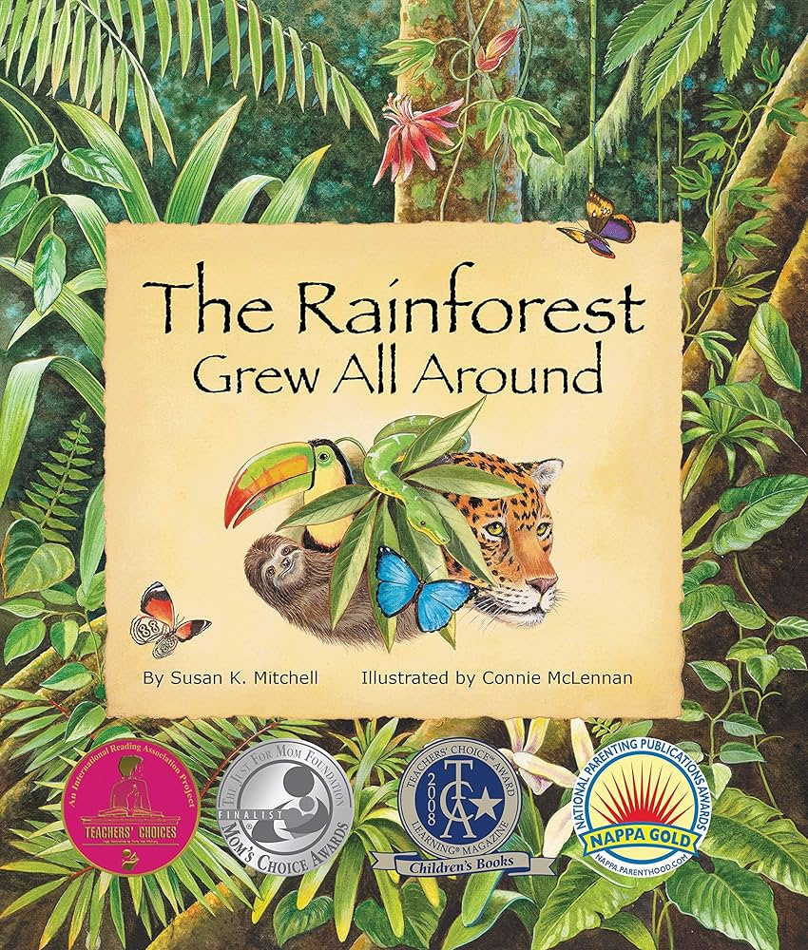   | P.E: Strivr: Basketball.  • Choose and combine techniques in game situations (running, throwing, catching, passing, jumping and kicking, etc.).  • Work alone, or with teammates in order to gain points or possession.  • Choose the most appropriate tactics for a game.  • Uphold the spirit of fair play and respect in all competitive situations.  I.C.T: Digital Literacy  - Self-Image and Identity.  - Online Relationships.  - Copyright and Ownership.  - Privacy and Security.  - Online Bullying.  RE: Religion: Christianity  Theme: Christians and how to live.  Key Question: What would Jesus do? (Gospel)  PSHE: Jigsaw: Being Me In My World.  - Help others to feel welcome  - Try to make our school community a better place  - Think about everyone’s right to learn  Music: Music Express.  - World Unite – Step Dance Performance.  - Journeys - Song Cycle Performance.  MFL: Language Angels - Spanish  - Phonics 4  - At school  Art: Access Art – 2D Drawing to 3D Making.  - That drawing can be used to transform a two dimensional surface, which can be manipulated to make a three dimensional object.  - That when we transform two dimensional surfaces we can use line, mark making, value, shape, colour, pattern and composition to help us create our artwork.  - That we can use methods such as the grid method and looking at negative space to help us draw.  DT: Textiles  - Join textiles with a combination of stitching techniques  - Use the qualities of materials to create suitable visual and tactile effects in the decoration of textiles.

