Geography | Y1 Our Local Area (Class Text) | Art and Design/DT – At the seaside
Geography  Investigate places  This concept involves understanding the geographical location of places and their physical and human features.  - Ask and answer geographical questions about the physical and human characteristics of a landscape  - Explain own views about locations, giving reasons.  - Use maps, atlases, globes and digital/computer mapping to identify countries, continents and oceans.  - To know that some of the continents have significant hot and cold areas.  Investigate patterns  This concept involves an appreciation of the characteristic features of maps.  - Understand geographical similarities and differences through studying the human and physical geography of their local area.  Communicate geographically  This concept involves using geographical vocabulary and techniques to convey information about the environment.  - Use appropriate geographical vocabulary to communicate key physical and human features.  - Use simple fieldwork and observational skills.  Science  Work Scientifically  This concept involves learning the methodologies of the discipline of science  - To perform simple tests  - Ask simple questions  - Observe closely, using simple equipment  - Gather and record data  Investigate materials  This concept involves becoming familiar with different types of plants, their structure and reproduction.  - Identify and name a variety of common plants.  - Identify and describe the basic structure of a plant.  - Observe and describe how seeds grow and what plants need to survive. | 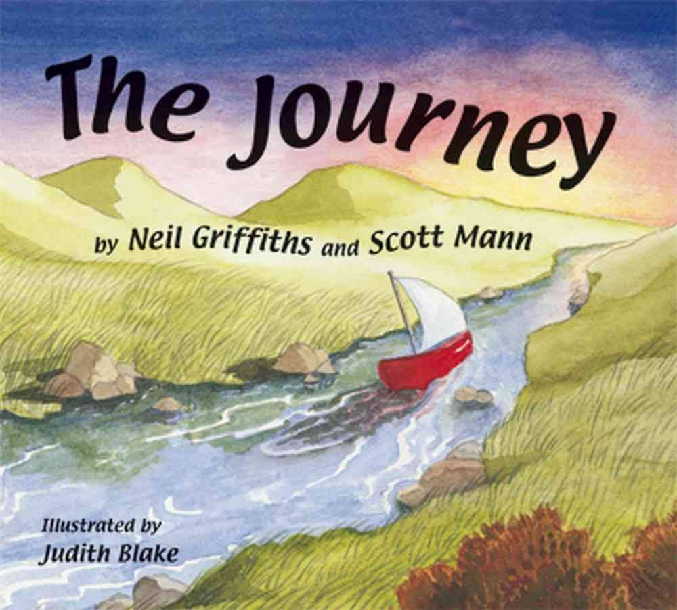  English: To be able to present neatly  This concept involves developing an understanding of handwriting and clear punctuation  To be able to spell correctly (CW words)  The concept involves understanding the need for accuracy. Spell by segmenting words into phonemes and represent them with the correct grapheme.  To be able to punctuate accurately  This concept involves understanding that punctuation adds clarity to writing. Emphasis on capital letters and full stops.  Writing – intended outcome:  The children will write a series of sentences, punctuated appropriately to retell several of the main events in the story, The Journey. | To develop ideas  This concept involves understanding how ideas develop through an artistic process  - Explore ideas and collect visual information  - Explore different methods and materials as ideas develop  To master techniques  This concept involves developing a skill set so that ideas may be communicated  - Use thick and thin paint brushes  - To make warm and cool colours  - To add sand to create texture (beach)  To take inspiration from the greats  This concept involves learning from both the artistic process and techniques of great artists and artisans throughout history  - Describe the work of notable artists  - Use some of the ideas of Claude Monet to create a piece of art work
Maths:
To know and use numbers
This concept involves understanding the number system and how they are used in a wide variety of mathematical ways.
To add and subtract
This concept involves understanding both the concepts and processes of addition and subtraction.

PSHE: Being me In My World

R.E:
Theme: The Creation Story
Concept: God/Creation
Key Question: Does God want Christians to look after the World?
Religion: Christianity (Humanism)

