History and Geography- Threshold Concepts | Y1 My family history (Class Texts) | Art and Design/DT - Threshold Concepts
History  Investigate and interpret the past  This concept involves understanding that our understanding of the past comes from an interpretation of the available evidence.  Build an overview of world history  This concept involves an appreciation of the characteristic features of the past and an understanding that life is different for different sections of society.  - Describe the social, ethnic, cultural or religious diversity of past society.  - Describe the characteristic features of the past, including ideas, beliefs, attitudes and experiences of men, women and children.  Build an overview of world history  - This concept involves an appreciation of the characteristic features of the past and an understanding that life is different for different sections of society.  Understand chronology  - This concept involves an understanding of how to chart the passing of time and how some aspects of history studied were happening at similar times in different places.  Communicate historically  - This concept involves using historical vocabulary and techniques to convey information about the past.  Geography  Communicate geographically  This concept involves using geographical vocabulary and techniques to convey information about the environment.  - Use appropriate geographical vocabulary to communicate key physical and human features.  - To compare the changes over time using maps and photographs. | SMSC and PSHE: Looking at me, looking at you. What makes us special?  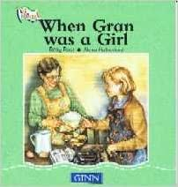  Cross curricular  Maths: Shapes, space and measure  - 2D and 3D Shapes in the environment  - Identify the properties of shapes  English: Spoken language  - Story maps  - Conducting interviews  - Vocabulary  - Explanations, reasoning and predictions | To develop ideas  To respond to ideas and starting points  - Explore ideas and collect visual information  - Explore different methods and materials as ideas develop  To master techniques  - Use thick and thin brushes; Mix primary colours to make secondary; Add white to colours to make tints and black colours to make tones; Create colour wheels.  Look at Gainsborough’s ‘The Blue Boy’ and recreate.  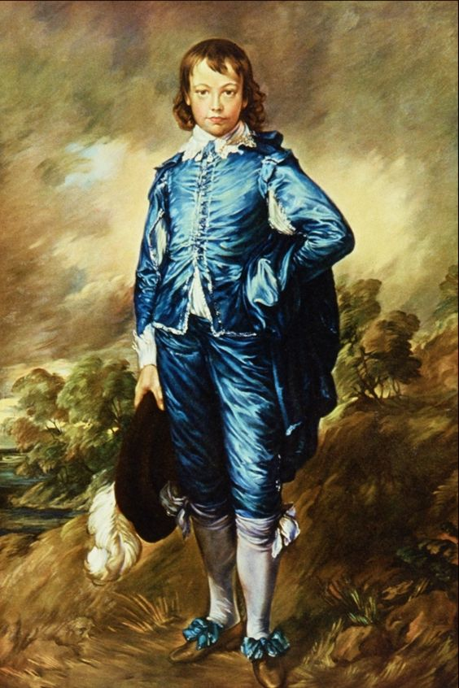  - Use a combination of shapes; Include lines and texture; Use rolled up paper, straws, paper, card and clay as materials; Use techniques such as rolling, cutting, moulding and carving  Look at structure of Dock Tower and its architect – James William Wild.  Take inspiration from the greats.  To learn from both the artistic process and techniques of great artists and artisans throughout history.
 |  | Science
To understand the Earth’s movement in Space
Observe changes across the four seasons.
• Observe and describe weather associated with the seasons and how day length varies.

