Early Years –FS2 | FS2 Great Inventors- Transport (Class Texts)
Understanding the World  To be able to name and describe people who are familiar to them.  - To identify people and their roles in the community  - To identify how these roles have changed  - To discuss who they have had experience with/of  To talk about member of the community  - To identify those in the community who help transport us  - Bus drivers, taxi drivers, train drivers, pilots, captains  - Identify which type of transport they operate  - Discuss using pictures of their jobs now and in the past  To be able to comment on familiar situations in the past  - Look at images of transport – past and present  - Identify the first types of each transport  - School trip- A ride on a steam train  - Talk about their present day experiences on transport and look at how this was different in the past  - Organise the history of a type of transport in a simple chronological order- support children to understand that things happened before they/staff were born  Materials  To explore the natural world around them- Observe and interact with natural processes  - Boat floating on water  - Sound causing a vibration  - Gravity – how things float in the air- hot air balloons – helium filled balloons – weight in basket  - Up, up and Away song about hot air balloon- scenes around the world  - Recognise some environments are different from the ones they live in  Seasonal change  This concept involves developing an understanding of change.  - To observe and explain why certain things may occur (eg. Leaves covering the trees, flowers in full bloom, days being hotter)  - Comment and question about the place they live or the natural world  - Changes in the materials/clothes we wear and why  - Changes in food available and what we eat | 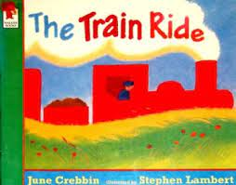  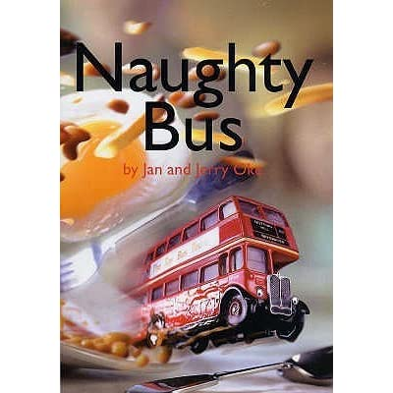  PSHE:  - Jigsaw- Changing Me  R.E –Christianity, Judaism and Islam  EYFS: Our Special Places  - To use the senses to explore different artefcats from different religions  - To investigate how these artefacts are used by religious people in their places of worship  P.E- Striver | Expressive Arts and Design  Understanding Identity and exploring Relationships  To develop the ability to explore who we are and how we connect to those around us  - Making Finger Puppets  - Self-Portraiture Photography  The themes will help:  • Develops dexterity and making skills  • Explores using drawing, colouring and collage  • Promotes conversations about character and identity  • Promotes ideas about story, narrative and dialogue  • Enables children to work alone and then contribute their work to shared experience  • Helps children explore their sense of self, likes & dislikes, personality etc  • Explores and connects drama, photography, drawing, collage… • Promotes sharing and conversation  • Encourages children to recognize and appreciate the things we have in common and the things which make us special
Maths: Exploring shape, pattern and measure
Children will practice the skills during the activities
- Spatial reasoning skills
- Composing and decomposing shapes and amounts
- Compare and using informal units of measure
English: To be able to present neatly
This concept involves developing an understanding of forming letters
To be able to use phonics to build words
To be able to segment words and identify the phonics in order within the words. To find the letter/s to represent each sound in the correct order.
To be able to say a sentence to write
This concept involves saying a sentence, counting the words and writing these with finger spaces. To begin to write several sentences

