History- Threshold Concepts | Y1 The Greatest Explorers (Class Texts) | Art and Design - Threshold Concepts
History  Investigate and interpret the past  This concept involves understanding that our understanding of the past comes from an interpretation of the available evidence.  Build an overview of world history  - This concept involves an appreciation of the characteristic features of the past and an understanding that life is different for different sections of society.  - Describe significant people from the past such as: Ibn Battuta, Captain Cook, Roald Amundsen, Captain Robert Falcon Scott and Sunita Williams.  Understand chronology  - This concept involves an understanding of how to chart the passing of time and how some aspects of history studied were happening at similar times in different places.  Communicate historically  - This concept involves using historical vocabulary and techniques to convey information about the past.  Science: To understand the Earth’s Movement in Space  Observe changes across the four seasons.  • Observe and describe weather associated with the seasons and how day length varies. | 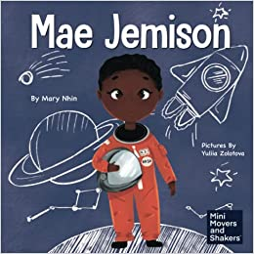  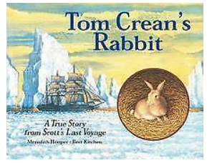  PSHE: Healthy Me (Jigsaw SoW)  R.E.:  Theme: Easter – Palm Sunday  Key Question: Why was Jesus welcomed like a king or celebrity by the crowds on Palm Sunday?  Religion: Christainity (Concept: Salvation)  Music: Charanga Round and Round  P.E. To develop practical skills in order to participate, compete and lead a healthy lifestyle.  - Gymnastics 2  ICT: Information Technology:  Bug Hunters  Finding, saving, organising, sending, and presenting  D&T: To create products using levers, wheels and winding mechanisms. | WEATHER - Artist Spotlight: J.M.W. Turner  We will be covering: colour theory, effects, emotions, techniques and vocabulary  To develop ideas  This concept involves understanding how ideas develop through an artistic process  - Explore ideas and collect visual information  - Explore different methods and materials as ideas develop  To master techniques  This concept involves developing a skill set so that ideas may be communicated  - Use thick and thin paint brushes  - Mix primary colours to make secondary  - Add white to colours to make tints and black to colours to make tones  To take inspiration from the greats  This concept involves learning from both the artistic process and techniques of great artists and artisans throughout history  - Describe the work of notable artists  Use some of the ideas of George Seurat to create a piece of art work
Maths: To understand the properties of shapes
- Addition and subtraction (within 20)
- Place value (within 50)
- Height and length
- Weight and volume

English: To be able to present neatly
This concept involves developing an understanding of handwriting and clear punctuation (through daily/weekly handwriting sessions)
To be able to spell correctly ( CEW and harder to read and spell words)
The concept involves understanding the need for accuracy Children will be continuing to learn the phase 5 graphemes and phonemes covered in ELS
To be able to punctuate accurately
This concept involves understanding that punctuation adds clarity to writing.

