History - Threshold Concepts | Y1 Great Inventions: Transport (Class Texts) | Art
History  Investigate and interpret the past  This concept involves understanding that our understanding of the past comes from an interpretation of the available evidence.  Build an overview of world history  - This concept involves an appreciation of the characteristic features of the past and an understanding that life is different for different sections of society.  - Describe historical events. The children will explore the stories of 2 significant events in history: the first aeroplane flight and the Rainhill Trials of Stephenson’s Rocket.  Understand chronology  - This concept involves an understanding of how to chart the passing of time and how some aspects of history studied were happening at similar times in different places.  Communicate historically  - This concept involves using historical vocabulary and techniques to convey information about the past.  Science: To understand the Earth’s Movement in Space  Work Scientifically  This concept involves learning the methodologies of the discipline of science  - To perform simple tests  - Ask simple questions  - Observe closely, using simple equipment  - Gather and record data  Observe changes across the four seasons.  • Observe and describe weather associated with the seasons and how day length varies. | 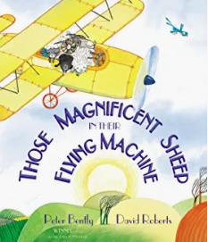  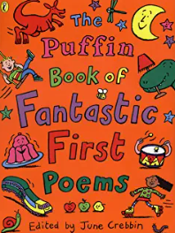  English: To be able to present neatly  This concept involves developing an understanding of handwriting and clear punctuation  To be able to spell correctly (CW words)  The concept involves understanding the need for accuracy  To be able to punctuate accurately  To understand that punctuation adds clarity to writing.  To retell the story Those Magnificent Sheep in their Flying Machines.  To be able to explore, interpret and respond to poetry.  SMSC and PSHE:  Changing Me  R.E.:  Religion: Judaism  Theme: Rosh Hashanah and Yom Kippur  Key Question: Are Rosh Hashanah and Yom Kippur important to Jewish children?  D.T. Food Preparing fruit and vegetables.  Make a fruit and vegetable smoothie  Music: Charanga Reflect, Rewind, Replay  Computing: To introduce and use Scratch Junior | 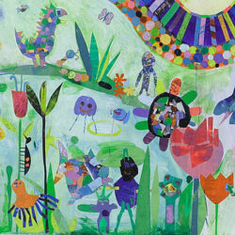  Inspired by Flora and Fauna  Children are introduced to the idea that many artists use flora and fauna to inspire their work. They will look at artists who used drawing as a way to accurately capture the way plants and insects look, and artists who use their imagination to create their own versions of flora and fauna. Children will spend time engaged in close looking as a way to build drawing skills. They will also experiment with new materials. They will practice cutting and collage skills and explore shape and colour to build images. There is also the opportunity for children to work collaboratively on a shared background for the artwork, and pupils can see how their individual efforts are valued as part of a larger class artwork.
Maths: Fractions
This concept involves understanding the concept of part and whole and ways of calculating using it.

Recognise, find and name a half as one of two equal parts of an object, shape or quantity.
Recognise, find and name a quarter as one of four equal parts of an object, shape or quantity.
Recognise, find, name and write fractions 1/2, 1/4, 2/4 and 3/4 of a length, shape, set of objects or quantity.
- To recognise the value of coins and notes. To recognise and use language relating to dates.
- To tell the time to the hour, half hour and draw the hands on a clock face to show these times.

