History - Threshold Concepts Great Inventions – Transport. How did the first flight change the world? | Y1 Great Inventions: Transport (Class Texts) | Threshold Concepts - Foundation Subjects and Maths
History  Investigate and interpret the past  This concept involves understanding that our understanding of the past comes from an interpretation of the available evidence.  Build an overview of world history  - This concept involves an appreciation of the characteristic features of the past and an understanding that life is different for different sections of society.  - Describe historical events. The children will explore the stories of 2 significant events in history: the first aeroplane flight and the Rainhill Trials of Stephenson’s Rocket.  Understand chronology  - This concept involves an understanding of how to chart the passing of time and how some aspects of history studied were happening at similar times in different places.  Communicate historically  - This concept involves using historical vocabulary and techniques to convey information about the past.  Science: To understand the Earth’s Movement in Space  Work Scientifically  - To perform simple tests  - Ask simple questions  - Observe closely, using simple equipment  - Gather and record data  Observe changes across the four seasons. Observe and describe weather associated with the seasons and how day length varies. | 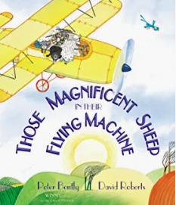  English focus text: Those Magnificent Sheep in Their Flying Machine  Extended writing outcomes:  Rewrite the story  Short writing outcomes:  To be able to explore, interpret and respond to poetry.  To write a description of one of the settings.  To write a list of all the places visited with the story and the people they met.  To develop the children’s letter formation.  Reading: Inference questions  Answer questions relating to clues in the story  Link Reading:  Rosie Revere Engineer – Andrea Beatty  The Puffin Book of Fantastic First Poems. -  Edited by June Crebbin  Picture Book  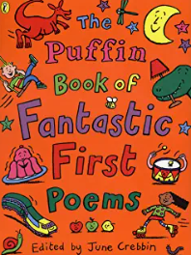  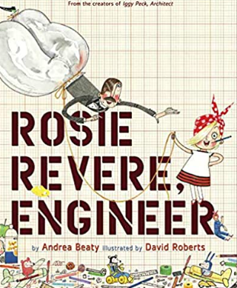 | Access Art:  Flora and Fauna  In this pathway children are introduced to the idea that many artists use flora and fauna to inspire their work. We look at artists who used drawing as a way to accurately capture the way plants and insects look, and artists who use their imagination to create their own versions of flora and fauna.Children spend time engaged in close looking as a way to build drawing skills. They also experiment with new materials. They practice cutting and collage skills and explore shape and colour to build images.
Maths:
Fractions
Position and Direction
Place Value (within 100)
Money
Time
SMSC and PSHE:
Changing Me
R.E.:
Religion: Judaism
Theme: Rosh Hashanah and Yom Kippur
Key Question: Are Rosh Hashanah and Yom Kippur important to Jewish children?
D.T. Food Preparing fruit and vegetables.
Make a fruit and vegetable smoothie
Music: Music Express
Travel
Water
Computing: Scratch Jnr – Introduction and Fundamental

