Knowledge and understanding | Foundation – Fun at the Seaside! | The curriculum – Threshold concepts
History  In history we will be comparing the experiences of going to the seaside in the past and present day.  We will also be learning about the key historical figure, Mary Anning, who is famous for her discovery of fossils along the Dorset coast.  We will be developing the key historical skills of:  Chronological understanding  Understanding that there are differences between past and present and that there are events which occurred before we were born.  Historical enquiry  Ask and answer historical questions such as why? and how? In relation to artefacts.  Continuity and change between periods  Identifying some similarities/differences between the past and now.  Significance of events and people  Discussing historical figures through storytelling.  Science  As scientists this half term, we will learning about materials and exploring their properties.  *Explore a variety of materials  *Explore the natural world around them, making observations.  • Know some similarities and differences between the natural world around them and contrasting environments, drawing on their experiences and what has been read in class  • Understand some important processes and changes in the natural world around them | 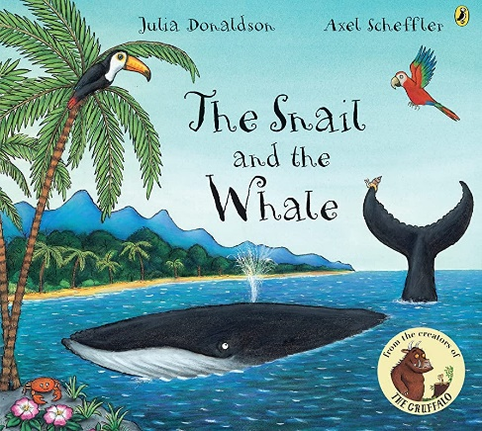  Reading and writing outcomes  During this half term, we will be exploring the theme of fun at the seaside. We will be learning about life under the sea and fossils as part of this topic.  We will be reading ‘The snail and the whale’ by Julia Donaldson and writing a postcard about what the snail has seen on their adventure around the world.  We will also be looking at the non-fiction text ‘Big blue whale’ by Nicola Davies and creating our own fact files about whales.  This half term we will be bringing the seaside to our outdoor area and will be writing diaries about our seaside day.  We will continue to work on using our phonic skills to write sentences that include tricky words, independently. Our sentences will include finger spaces and full stops.  Link Reading:  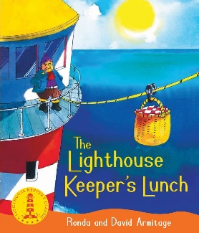  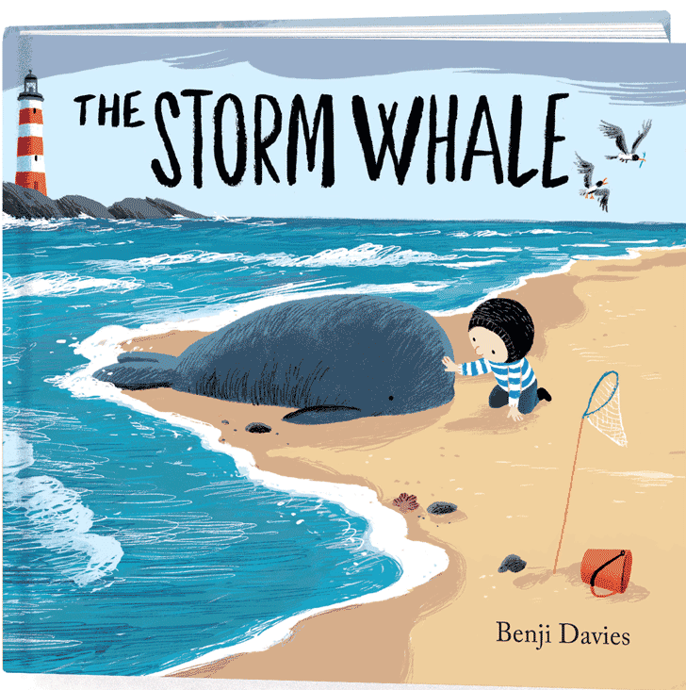  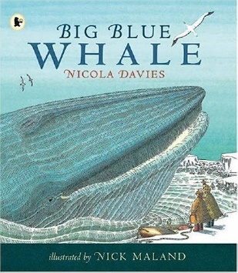 | P.E:  This half term we will be getting ready for our sports day.  PSHE  Jigsaw – Changing me  Circle time themes:  Understand that everyone is unique and special  Can express how they feel when change happens  Understand and respect the changes they see in themselves  Understand and respect the changes they see in others  Know who to ask for help when they are worried about change  Are looking forward to change  R.E.  Theme – Special places  Key question – What makes places special?  Religions: Christianity, Islam, Judaism  Music:  ‘Under the sea’  We will be discovering life under the sea.  We will explore this through:  - Singing  - Playing  - Listening and responding to the music  - Moving to the music  This half term we will be revisiting pitch, pulse, beat and rhythm during our music lessons.  MFL  Bajo el mar – Under the sea.  DT:  This half term we will be using different materials to construct houses, make 3D sea creatures for our art project and form our own salt dough fossils.  Art: Wildflower Meadow  During this half term, we will be designing and creating under the sea murals. We will be using newspaper and paint to create 3D fish. We will be planning these 3D models by first tracing our designs on paper. To inspire our artwork we will be reading rainbow fish and commotion in the ocean.  This unit will explore:  - Colour and mark making  - Developing 3D experiences  - Links to drama and storytelling
Maths
Find my pattern
*Doubling *Sharing and grouping *Even and odd *Spatial reasoning 3 *Visualise and build
On the move
*Deepening understanding *Patterns and relationships *Spatial mapping(4) *Mapping

