Anti - Bullying Policy

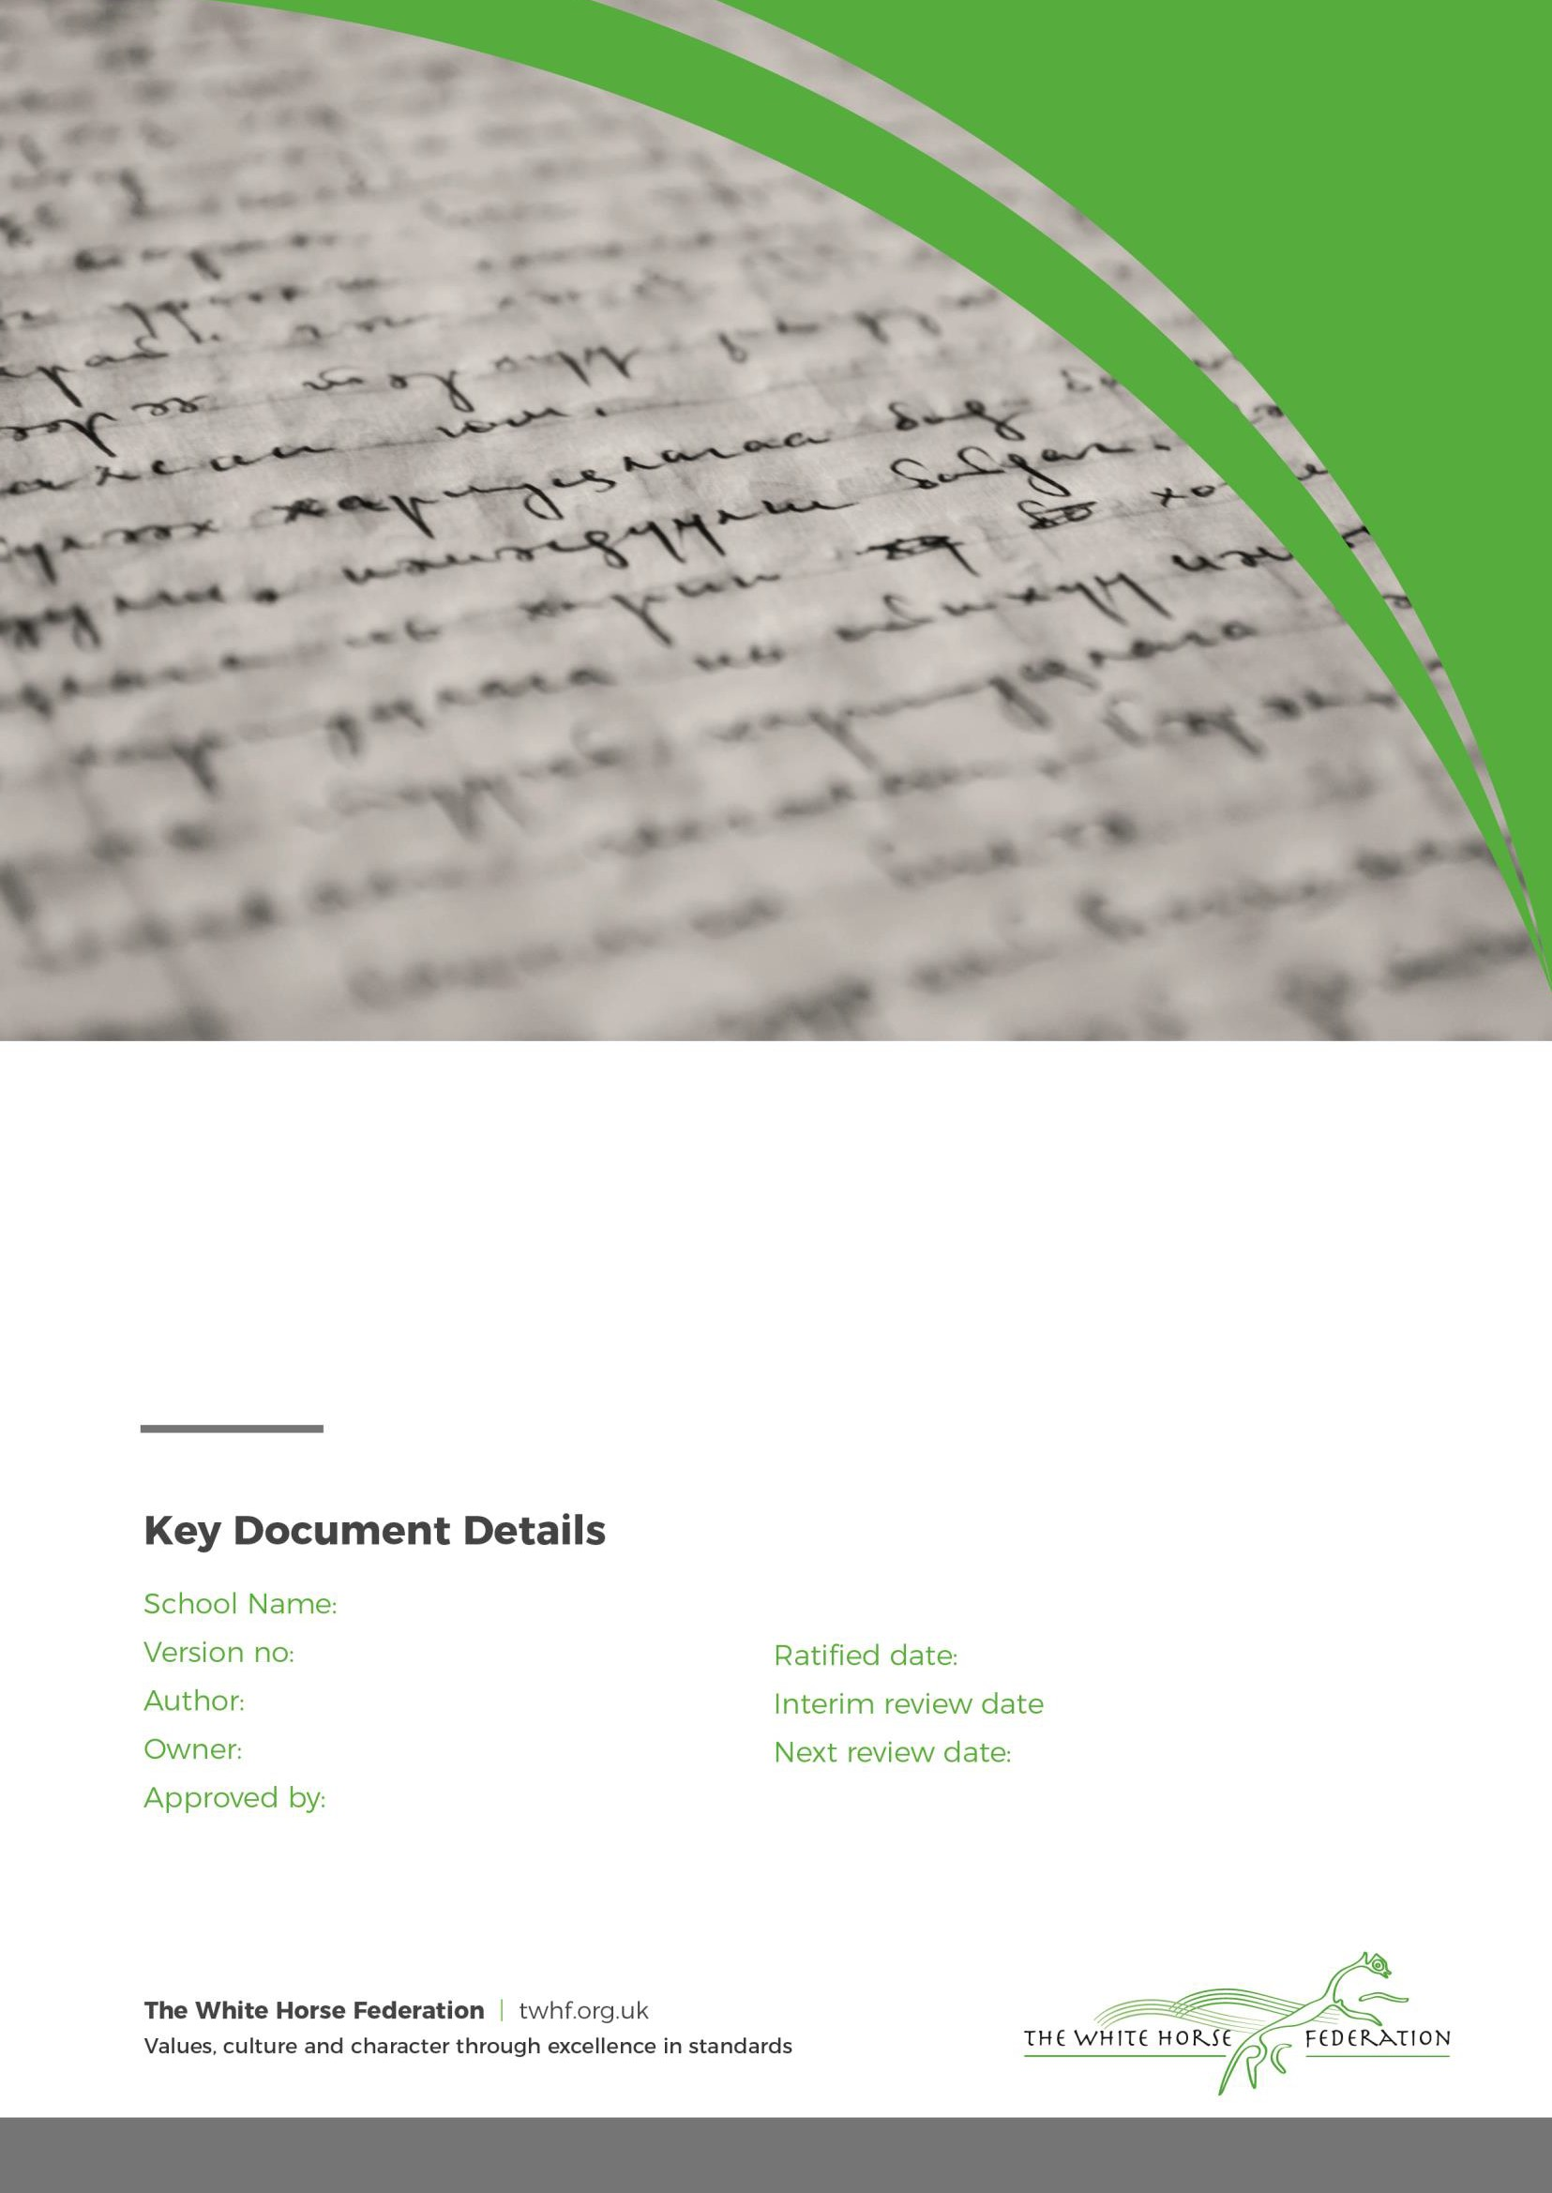
Larkhill Primary School 3
F Jenkins
FJenkins LGB

09/09/2025
n/a 09/2026

Statement of Intent:
At Larkhill Primary we are committed to providing a warm, caring and safe environment for all our children so that they can learn and play in a relaxed and secure environment. Bullying of any kind is unacceptable and will not be tolerated in our school. We take all incidents of bullying seriously.
Bullying hurts. No-one deserves to be a victim of bullying. Everybody has the right to be treated with
respect and pupils who are bullying others need to learn different ways of behaving.

At Larkhill Primary, we acknowledge that bullying does happen from time to time – it would be unrealistic to claim that it does not. When bullying does occur, everyone should be able to tell and know that incidents will be dealt with promptly and effectively in accordance with our anti- bullying policy. We are a TELLING school. This means that anyone who knows that bullying is happening is expected to tell the staff.

Aims and Objectives
The aim of this policy is to try and prevent and deal with any behaviour deemed as bullying. The implementation of this policy will create an ethos where bullying is regarded as unacceptable so that a safe and secure environment is created for everyone to learn and work in. All members of the school have a responsibility to recognise bullying when it occurs and take appropriate action in accordance with the school policy. This will happen in the following ways:
- The school will meet the legal requirement for all schools to have an anti-bullying policy in place.
- All governors, teaching and non-teaching staff, pupils and parents/carers will have an understanding of what bullying is.
- All governors, teaching and non-teaching staff will know what the school policy is on bullying and will consistently and swiftly follow it when bullying is reported.
- All pupils and parents/carers will know what the school policy is on bullying and what they can do if bullying occurs.
- Pupils and parents/carers will be assured that they will be supported when bullying is reported.
- Whole school initiatives (staff training, celebration assemblies etc) and proactive teaching strategies (PHSE [Personal, Health & Social Education] lessons, circle time etc) will be used throughout the school to reduce the opportunities for bullying to occur.
- A positive, caring ethos will be created within the school environment where everyone can work, play and express themselves, free from the fear of being bullied.

Definition – What is bullying?

At Larkhill we have used the Stop Bullying website (StopBullying.gov) to define bullying as unwanted, aggressive behavior that involves a real or perceived power imbalance. The behavior is repeated, or has the potential to be repeated, over time.
In order to be considered bullying, the behavior must be aggressive and include:
- An Imbalance of Power: Kids who bully use their power—such as physical strength, access to embarrassing information, or popularity—to control or harm others. Power imbalances can change over time and in different situations, even if they involve the same people.
- Repetition: Bullying behaviors happen more than once or have the potential to happen more than once.

Types of Bullying:
- Verbal bullying is saying or writing mean things. Verbal bullying includes:
  - Teasing
  - Name-calling
  - Inappropriate sexual comments
  - Taunting
  - Threatening to cause harm
- Social bullying, sometimes referred to as relational bullying, involves hurting someone’s reputation or relationships. Social bullying includes:
  - Leaving someone out on purpose
  - Telling other children not to be friends with someone
  - Spreading rumors about someone
  - Embarrassing someone in public
- Physical bullying involves hurting a person’s body or possessions. Physical bullying includes:
  - Hitting/kicking/pinching
  - Spitting
  - Tripping/pushing
  - Taking or breaking someone’s things
  - Making mean or rude hand gestures

With younger children there must be a distinction made between bullying and bossiness and between bullying and boisterous play. Most young children grow out of bossiness as they become more self controlled and learn the social skills of negotiation and compromise.
Bullying: ‘’All children make friends, break friends, say horrible things to each other, are spiteful, tease and jostle for places in the pecking order of school and family. Bullying is something beyond that.” Keith Sullivan: The Anti-Bullying Handbook: 2001

Bullying is not:

It is important to understand that bullying is not the odd occasion of falling out with friends, name calling, arguments or when the occasional trick or joke is played on someone. It is bullying if it is done several times on purpose. Children sometimes fall out or say things because they are upset. When occasional problems of this kind arise it is not classed as bullying. It is an important part of children’s development to learn how to deal with friendship breakdowns, the odd name calling or childish prank. We all have to learn how to deal with these situations and develop social skills to repair relationships.
Identification

Where does Bullying happen?

It can happen anywhere. Bullying may also happen on the way to and from school. In such cases, the Headteacher is empowered by law to deal with such incidents but must do so in accordance with the school’s policy.

At Larkhill Primary, we are concerned with our children’s conduct and welfare outside, as well as inside school, and we will do what we can to address any bullying issues that occur off the school premises. The following steps may be taken:

  - Talk to the local Community Police Officer about problems on the streets
  - Talk to the transport companies about bullying on school buses and in school taxis
  - Talk to the Headteachers of other schools whose children may be involved in bullying off the premises
  - Discuss coping strategies with parents
  - Talk to the children about how to handle or avoid bullying outside the school premises

Signs and Symptoms
A child may indicate, by different signs or behaviour, that he or she is being bullied. Adults should be aware of these possible signs and investigate further if a child:
- is frightened of walking to or from school
- changes their usual routine/route to school
- begins truanting
- becomes withdrawn, anxious or lacking in confidence
- starts stammering
- attempts or threatens suicide or runs away
- cries themselves to sleep at night or has nightmares
- feels ill in the morning
- begins to under-perform in school work
- comes home with clothes torn or books damaged
- has possessions go “missing”
- asks for money or starts stealing money (to pay the bully)
- has dinner or other monies continually “lost”
- has unexplained cuts or bruises
- comes home starving (money/snack/sandwiches have been stolen)
- becomes aggressive, disruptive or unreasonable
- starts swearing or using aggressive language for no apparent reason
- is bullying other children or siblings
- stops eating
- is frightened to say what’s wrong
- gives improbable excuses for any of the above

These signs and behaviours could indicate other problems, but bullying should be considered a possibility and should be taken seriously and investigated as soon as possible.

What can you do if you are being bullied?
Wherever you are in school, you have the right to feel safe. Nobody has the right to make you feel unhappy. If someone is bullying you, it is important to remember that it is not your fault and there are people who can help you.
The children were all asked this question and we have included some of their strategies in the list below:
  - Tell an adult in school
  - Try not to let the bully know that he/she is making you feel upset.
  - Try to ignore them.
  - Be assertive – stand up to them, look at them directly in the eye, tell them to stop and mean it.
  - Stay in a group, bullies usually pick on individuals.
  - Get away as quickly as you can.
  - Tell someone you can trust – it can be a teacher, a teaching assistant, a midday supervisor, a parent, a friend, a brother, a sister or a relative.
  - If you are scared, ask a friend to go with you when you tell someone.
  - If you don’t feel you can talk to someone about it, write it down and post it in the ‘Worry’ box.
  - When you tell an adult about the bullying give them as many facts as you can (What? Who? Where? When? Why? How?).
  - Keep a diary of what’s been happening and refer to it when you tell someone (see Appendix 1).
  - Keep on speaking out until someone listens and helps you.
  - Never be afraid to do something about it and quick.
  - Don’t suffer in silence.
  - Don’t blame yourself for what is happening.

What can you do if you see someone else being bullied? (The role of the bystander) Ignoring bullying is cowardly and unfair to the victim. Staying silent means the bully has won and gives them more power. There are ways you can help without putting yourself in danger. The children have also discussed this question in class and some of the strategies they suggested are listed below:
  - Don’t smile or laugh at the situation.
  - Don’t rush over and take the bully on yours
  - Don’t be made to join in.
  - If safe to do so, encourage the bully to stop bullying.
  - If you can, let the bully know you do not like his or her behaviour.
  - Shout for help.
  - Let the victim(s) know that you are going to get help. + Tell a member of staff as soon as you can.
  - Try and befriend the person being bullied.
  - Encourage the person to talk to someone and get help.
  - Ask someone you trust about what to do.
  - If you don’t feel you can talk to someone about it, write it down and post it in the ‘Worry’ box.
  - Call a helpline for some advice.

Bullying of Children with Special Educational Needs
Larkhill Primary is an inclusive school. We provide a secure, accepting, safe and stimulating environment where everyone is valued for who they are.

Procedures for reporting and responding to bullying incidents - strategies for the prevention and reduction of bullying
All staff will respond calmly and consistently to all allegations and incidents of bullying at Larkhill Primary. They will be taken seriously by all staff and dealt with impartially and promptly. All those involved will have the opportunity to be heard. Staff will protect and support all children involved whilst allegations and incidents are investigated and resolved. The following step-by-step procedure will be used for reporting and responding to bullying allegations or incidents:
- Report all bullying allegations and incidents to staff.
- Staff will make sure the victim(s) is ok and feels safe.
- Appropriate advice will be given to help the victim(s).
- Staff will listen and speak to all children involved about the incident separately.
- The problem will be identified and possible solutions suggested.
- Staff will attempt to adopt a problem-solving approach which will move children on from them having to justify their behaviour.
- Appropriate action will be taken quickly to end the bullying behaviour or threats of bullying.
- Staff will reinforce to the bully that their behaviour is unacceptable.
- The bully (bullies) may be asked to genuinely apologise. Other consequences may take place and appropriate sanctions applied (see next section).
- If possible, the pupils will be reconciled.
- An attempt will be made, and support given, to help the bully (bullies) understand and change his/her/their behaviour.
- In all cases of bullying, the incidents will be recorded by staff on the Bullying Incident Report Sheet. All reports will be kept in the Headteacher’s office.
- In serious cases parents will be informed and will be invited to come into school for a meeting to discuss the problem.
- After the incident has been investigated and dealt with, each case will be monitored to ensure repeated bullying does not take place. Bullying incidents will be discussed regularly at staff meetings.
- If necessary and appropriate, the Child Protection Officer in school, Social Services or police will be consulted.

The following sanctions may be used:
The children have also discussed this question in their classes and some of the sanctions they suggested are included in the list below:

  - Apologise to the victim(s) verbally or in writing
  - Lose playtimes (stay with class teacher)
  - Spend playtimes and lunchtimes with an adult
  - Parents will be invited in to school
  - Be removed from class and work in isolation
  - Report to the Headteacher or Deputy Headteacher
  - Be withdrawn from participation in school visit, clubs and events not essential to the curriculum
  - Fixed term exclusion
  - Permanent exclusion

All incidents of online bullying should be logged and recorded in line with our safeguarding protocol. Any incident should be reported to a member of the Senior Leadership team. A written record of the incident should be made and then monitored by the Online Safety co-ordinator of the school. The Headteacher will consider the context, intention and impact of the incident, in order to determine the level of sanction put in place.
Parents and carers from both parties must be informed and advised of any action that takes place. The Headteacher will decide on a sanction which is proportionate to the incident.

Whole school initiatives and proactive teaching strategies will be used throughout the school to develop a positive learning environment with the aim of reducing the opportunities for bullying to occur. These include:

- Involving the whole school community in writing and reviewing the policy
- Undertaking regular questionnaires and surveys to monitor the extent of bullying in the school and the effectiveness of the anti-bullying policy
- Each class agreeing on their own set of class rules
- PHSE (Personal, Health & Social Education) scheme of work from Reception to Year 6 used to support this policy
- Circle time on bullying issues
- Setting up of a circle of friends support network where a small group of children volunteer to help and support an individual experiencing difficulty if needed
- Children writing stories and poems and drawing pictures about bullying
- Children being read stories about bullying
- Using drama activities and role-plays to help children be more assertive and teach them strategies to help them deal with bullying situations
- Introduction of a confidential ‘Worry’ box where children and parents/carers can write and post their concerns and ideas
- Introducing playground improvements and initiatives
- Anti – Bullying monitors in KS2
- Playground Leaders in Year 2 – Year 6
- Implementation of the Kindness Curriculum
- Using praise and rewards to reinforce good behaviour
- Encouraging the whole school community to model appropriate behaviour towards one another
- Organising regular anti‐bullying training for all staff

Roles and Responsibilities The Role of Governors
- The Local Governing Body supports the Principal in all attempts to eliminate bullying from our school.
- The local board of governors will not condone any bullying at all in our school, and any incidents of bullying that do occur will be taken very seriously, and dealt with appropriately.
- The Local Governing Body will monitor incidents of bullying that do occur, and reviews the effectiveness of this policy regularly. The governors require the Principal to keep records of all incidents of bullying, and to report to the governors on request about the effectiveness of school anti-bullying strategies.
- A parent who is dissatisfied with the way the school has dealt with a bullying incident can ask the Chair of the Local Governing Body to look into the matter. They will respond within ten days to any request from a parent to investigate incidents of bullying. In all cases, the Local Governing Body notifies the Principal, and asks her to conduct an investigation into the case, and to report back to a representative of the Local Governing Body.

The Role of the Principal
- Principals have a legal duty under the School Standards and Framework Act 1998 to draw up procedures to prevent bullying among pupils and to bring these procedures to the attention of staff, parents and pupils.
- The Principal reports to the Local Governing Body about the effectiveness of the Anti-Bullying Policy on request.
- The Principal ensures that all children know that bullying is wrong, and that it is unacceptable behaviour in this school. The Principal draws the attention of children to this fact at suitable moments.
- The Principal ensures that all staff, including lunchtime staff, receive sufficient training to be

Monitoring and evaluation of the policy
To ensure this policy is effective, it will be regularly monitored and evaluated.
Questionnaires completed by the whole school community, together with surveys, children’s and parents’/carers’ comments posted in the ‘Worry’ box and bullying incident forms will be used to gauge the effectiveness of the policy.

Following an annual review any amendments will be made to the policy and everyone informed. An annual report will then be issued to governors and parents and the policy will be distributed to all parents.

Appendix A - HELP ORGANISATIONS:

General advice on bullying/sources of help Anti-bullying Alliance www.anti- bullyingalliance.org.uk
Anti-Bullying Network www.antibullying.net

Beat Bullying www.beatbullying.org Email: hello@beatbullying.org Tel: 0208 771 3377 Bully Online www.bullyonline.org Bully.org www.bully.org
Kidscape www.kidscape.org.uk
Beyond Bullying (Leicestershire Ant—Bullying Team) www.beyondbullying.com Bullying UK www.bullying.co.uk
- Onlinebullying Chatdanger www.chatdanger.com
Childnet International www.childnet.com Email: info@childnet.com Tel: 020 7639 6967 Dot Com Children’s Foundation http://dotcomcf.org

Think U Know www.thinkuknow.co.uk/
Hector’s World www.thinkuknow.co.uk/5_7/hectorsworld/

