Anti Bullying policy

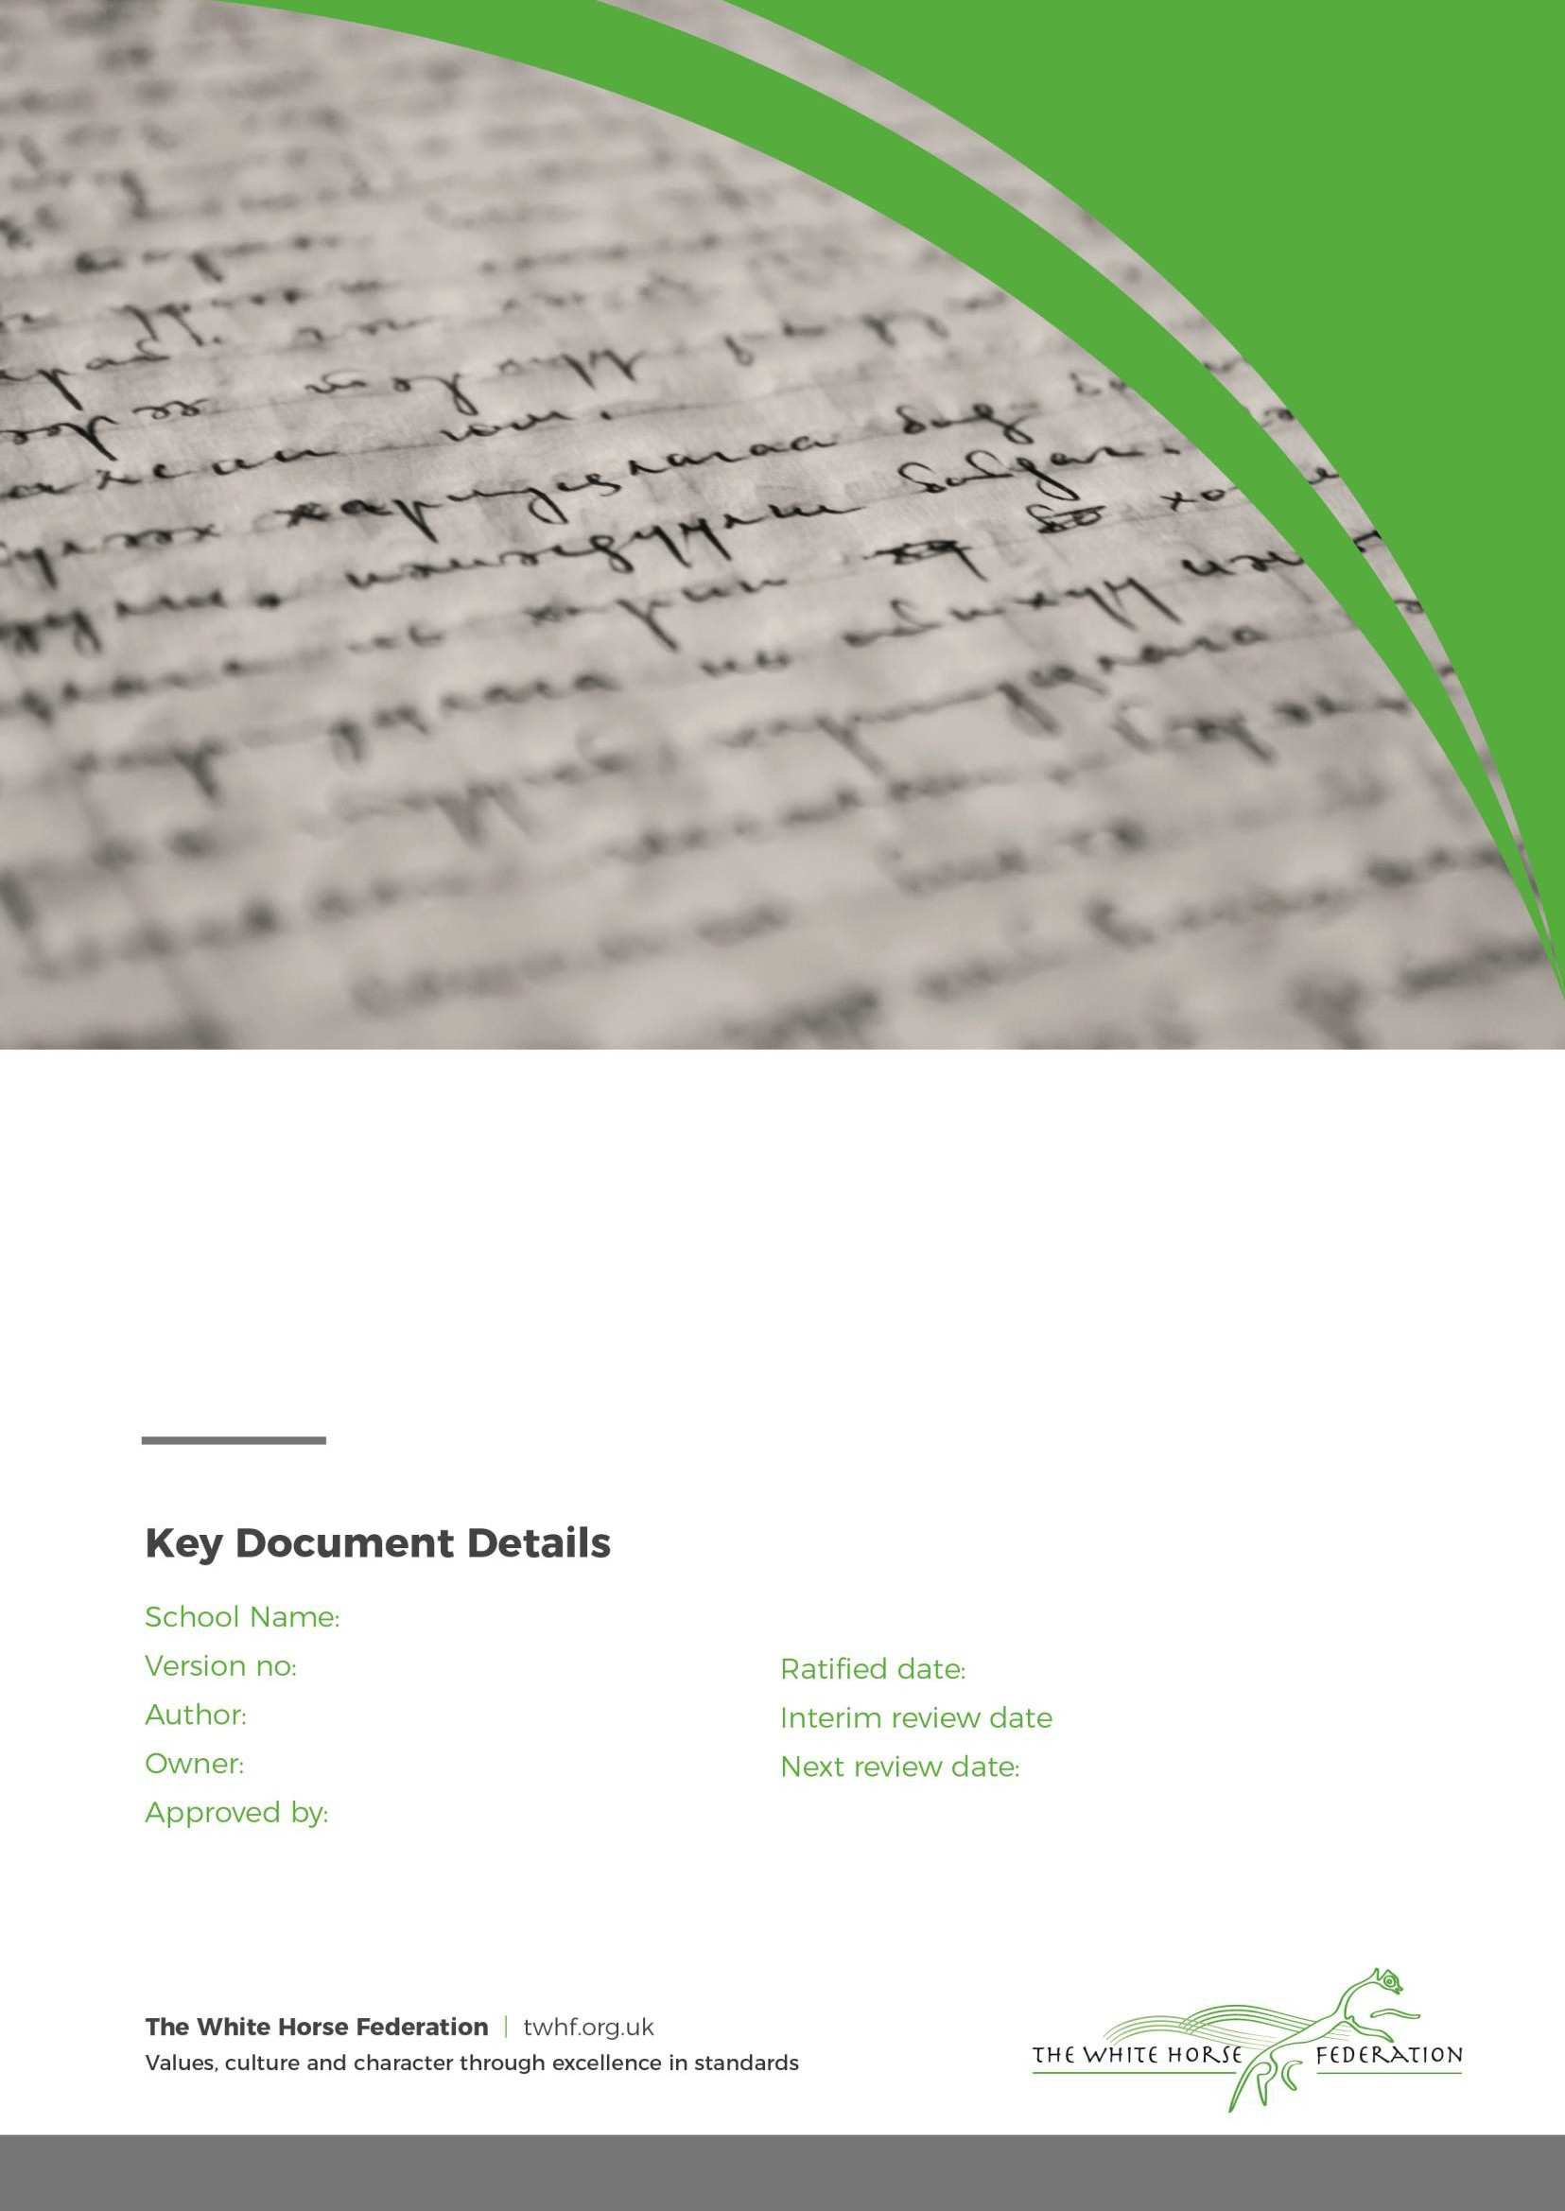Larkhill Primary School 2

C.Harmer C.Harmer LGB

4.9.24

n/a 1.9.25

# Introduction

The aim of the Anti-Bullying Policy is to ensure that all members of our school community learn and work in a supportive, caring and safe environment without fear of being bullied. Bullying is antisocial behaviour and can affect anyone; it is unacceptable and will not be tolerated. A person has the right to be treated with respect and has the responsibility to treat others in the same way.

This Anti-Bullying Policy is concerned with the way in which pupils conduct themselves and interact with adults and their peers around the school. It was drawn up in consultation with staff, children, governors and parents. It should be read in conjunction with the Equality Policy, the Safeguarding Policy, the Behaviour Policy and the On-line Safety Policy.

# Definition

In our school, we define bullying as any unkind, threatening or hurtful behaviour that is deliberate and persistent. With the children we use the expression ‘several times on purpose’. The four main types of bullying are:

* Physical (e.g. fighting, hitting, kicking, theft)
* Verbal (e.g. name calling, racist remarks)
* Indirect (e.g. spreading rumours, excluding someone from social groups
* Online (e.g. verbal or indirect by means of internet, mobile phone etc)

With younger children there must be a distinction made between bullying and bossiness and between bullying and boisterous play. Most young children grow out of bossiness as they become more self controlled and learn the social skills of negotiation and compromise.

Bullying: ‘’All children make friends, break friends, say horrible things to each other, are spiteful, tease and jostle for places in the pecking order of school and family. Bullying is something beyond that.” Keith Sullivan: The Anti-Bullying Handbook: 2001

# Bullying is not:

It is important to understand that bullying is not the odd occasion of falling out with friends, name calling, arguments or when the occasional trick or joke is played on someone. It is bullying if it is done several times on purpose. Children sometimes fall out or say things because they are upset. When occasional problems of this kind arise it is not classed as bullying. It is an important part of children’s development to learn how to deal with friendship breakdowns, the odd name calling or childish prank. We all have to learn how to deal with these situations and develop social skills to repair relationships.

Identification

Our school staff must be alert to the signs of bullying and act promptly and firmly against it in accordance with this policy. Pupils are encouraged always to show courage in reporting instances of bullying.

Signs of bullying may include:

* Reluctance to go out to play
* Reluctance to come to school
* Lack of concentration
* Drop in standard of work
* Physical injuries
* Withdrawn personality
* Possessions regularly going missing
* Becoming nervous and shy
* Clinging to adults
* Exhibiting atypical aggressive behaviour

Page 2 of 7

# Our strategies for preventing bullying:

Pupil well-being has a high profile in our school, and the following measures are taken to create an inclusive and compassionate environment:

**School ethos and values** - Our school ethos focuses on providing a safe, secure, happy and caring environment which aims to foster children’s respect for themselves and others. Our 11 school values also aid pupils in their development of life long skills built around our core value of respect. We build successful relationships with families and the community who all work together to identify and address any issues of potential bullying or communicate an anti-bullying message to the children. All adults in the school model respect for each other and for the children.

**Curriculum -** Through various curriculum activities and behaviour system, children will be taught about their responsibilities and the consequences of their behaviour. They will be taught to understand their own and other people’s feelings. They are taught about friendship and relationships, fairness and justice.

Issues such as prejudice against disabled people, sexism, racism and homophobia are discussed in a sensitive and age-appropriate manner. They are taught strategies for dealing with conflict with a view to preventing a situation escalating into bullying (see Appendix A).

We also run a yearly Anti-Bullying Week where the profile of the issue is raised and the children are encouraged to discuss the causes and prevention of bullying.

**Online Bullying** - In Computing, children are taught about responsible use of the internet, and approved websites support discussions. All use of the Internet is closely supervised, and is in line with our Acceptable Use Policy. Children’s mobile phones are not allowed in school. (Where mobile phones are brought to school they are handed into the office and retrieved at the end of the school day.) We teach the children to understand what constitutes online bullying and we give them the skills to deal with it. We access external sources to support with our teaching of online bullying and all other areas of bullying (see Appendix B).

**Assemblies and PSHE lessons** ensure that the focus on Anti Bullying and On-line Safety is maintained throughout the year. The On-line Safety Policy applies to all members of the school community who have access to and are users of the school ICT systems. Incidents of online bullying will be dealt with within the Anti Bullying Policy and the On-line Safety Policy.

**Anti Bullying posters**- We have posters in class and on the playground which encourage children to make informed decisions about whether or not they are being bullied.

**Personal Social and Health Education (PSHE)** – Curriculum time and resources are used for relevant units of work. Whole class interventions such as Circle Time are regularly used by teachers to enable children to explore issues and dilemmas. Children are taught that knowing about bullying by or to others and doing nothing, is unacceptable.

**Communication** – We publicise the fact that bullying is not acceptable in our school and that all allegations of bullying will be investigated. We use our prospectus, website and newsletters – as appropriate – to inform parents of our policy. All staff are made aware of the policy, and can access it in hard copy, on the school website and on the school ICT network.

**Supervision** – All staff are watchful and observe the social relationships developing in a class. We ensure that there are no ‘unsafe’ areas in the school and that supervisors are able to monitor areas where children play. We ensure that Teaching Assistants and Midday Supervisory Assistants are informed of any bullying incidents, and are advised how to identify any likely incidents that might occur in the hall or in the playground.

Our procedures for dealing with bullying

We have two main aims when reacting to bullying:

1: To make the child who has been bullied feel safe.

2: To encourage better behaviour from the child who has displayed bullying behaviours.

Page 3 of 7

The following steps should be taken when dealing with incidents:

* Incidents will be investigated immediately by the member of staff who has been approached
* If incident requires action, notes will be written on CPOM’s under ‘Bullying / Workshop related
* issues’ for following actions and tracking and monitoring.
* Meeting with SLT member, class teacher, parents and child carrying out the bullying (select as
* appropriate) to discuss and agree a plan – meeting documented on CPOM’s
* and a review meeting agreed.
* Day decided for weekly in school review meeting between child and member of staff to check
* progress against agreed actions
* Review meeting held with SLT member, class teacher, parents and child (decision made about need for a plan to continue or cease)
* Can be re-opened at any time as necessary if decision to cease is appropriate Pupils who have
* been bullied will be supported by:

offering an immediate opportunity to discuss the experience with their class teacher or member of staff of their choice ;reassuring the pupil; offering continuous support (e.g. through the buddy system with anti-bullying monitors); allocating a staff mentor of child’s choice.

Pupils who have displayed bullying behaviours will be helped to change these by:

* discussing what happened;
* discussing why they became involved;
* establishing the wrong doing and need to change;
* teaching of social skills;
* raising empathy for the victim, and promote friendship;
* After support from our THRIVE team/ELSA or class teacher, the following disciplinary steps can be taken:
* official warning by the Principal to cease offending;
* withdrawal of playtime/s;
* internal exclusion;
* exclusion from certain areas of school premises;
* fixed-term exclusion;
* permanent exclusion.
* ​

# Roles and Responsibilities The Role of Governors

* The Local Governing Body supports the Principal in all attempts to eliminate bullying from our school.
* The local board of governors will not condone any bullying at all in our school, and any incidents of bullying that do occur will be taken very seriously, and dealt with appropriately.
* The Local Governing Body will monitor incidents of bullying that do occur, and reviews the effectiveness of this policy regularly. The governors require the Principal to keep records of all incidents of bullying, and to report to the governors on request about the effectiveness of school anti-bullying strategies.
* A parent who is dissatisfied with the way the school has dealt with a bullying incident can ask the Chair of the Local Governing Body to look into the matter. They will respond within ten days to any request from a parent to investigate incidents of bullying. In all cases, the Local Governing Body notifies the Principal, and asks her to conduct an investigation into the case, and to report back to a representative of the Local Governing Body.

# The Role of the Principal

* Principals have a legal duty under the School Standards and Framework Act 1998 to draw up procedures to prevent bullying among pupils and to bring these procedures to the attention of staff, parents and pupils.
* The Principal reports to the Local Governing Body about the effectiveness of the Anti-Bullying Policy on request.
* The Principal ensures that all children know that bullying is wrong, and that it is unacceptable behaviour in this school. The Principal draws the attention of children to this fact at suitable moments.
* The Principal ensures that all staff, including lunchtime staff, receive sufficient training to be

Page 4 of 7

equipped to identify and deal with all incidents of bullying.

* The Principal sets the school climate of mutual support and praise for success, so making bullying less likely. When children feel they are important and belong to a friendly and welcoming school, bullying is far less likely to be part of their behaviour.

# The Role of the Teacher and Support Staff

* All the staff in our school take all forms of bullying seriously, and seek to prevent it from taking place.
* Teachers keep their own records of all incidents that happen in their class, and they are aware of in the school. If teachers witness an act of bullying, they will follow the steps outlined above.
* All members of staff routinely attend training, which equips them to identify bullying and to follow school policy and procedures with regard to behaviour management.
* Teachers use a range of methods to help prevent bullying and to establish a climate of trust and respect for all.
* Teachers will record any incidents of bullying on CPOM’s and alert the DSL/DDSLs.

# The Role of Parents

* Parents who are concerned that their child might be being bullied, or who suspect that their child
* may be the perpetrator of bullying, should contact their child's class teacher immediately.
* Parents have a responsibility to support the school's Anti-Bullying Policy, actively encouraging their child to be a positive member of the school. In this school, we actively discourage children from ‘fighting back’. We encourage parents to remember that they are role models for their children.
* We believe that if a child has a problem caused by someone else, then the correct way of dealing with it is to tell a grown-up. This is how the problem gets sorted out - not by retaliation or confrontation.
* Parents need to be aware of this policy in school and we ask for their support in reinforcing and implementing it.

# The Role of Pupils

* Pupils are encouraged to tell anybody they trust if they are being bullied, and if the bullying continues, they must keep on letting people know.
* Use information around you, like our posters to make informed decisions
* Pupils are also taught that, as members of our school community, they have responsibilities to each other, should make their own choices and should not ‘go along with the crowd’.

# Anti-Bullying Ambassadors

* Pupils from year 6 are elected as values ambassadors.
* They meet termly and liaise with the Pupil Parliament
* They attend assemblies to disseminate information
* They monitor the playgrounds for any signs of bullying or inappropriate actions.

# Monitoring, evaluation and review

This policy is monitored on a day-to-day basis by the Principal, who reports to governors on request about the effectiveness of the policy. The Anti-Bullying Policy is the Governors' responsibility, and they review its effectiveness annually. The Chair of Governors does this by examining the school's antibullying records, where incidents of bullying are recorded, and by discussion with the Principal. Governors analyse information for patterns of people, places or groups. They look out in particular for racist bullying, homophobic bullying or bullying directed at children with disabilities or special educational needs.

Supervision is held on a monthly basis where DSL/DDSL’s meet to monitor CPOM’s and discuss next steps for the cases we currently have open. We will know if this policy is working by:

Specifically: 1. The victim is no longer being bullied – as evidenced verbally i.e. able to articulate positive feelings, and by positive behaviour e.g. happy, smiling, willing to participate in activities, good attendance, self-esteem is high. 2. The bully is no longer bullying, self-esteem is high. Generally: 1. Children are tolerant and assertive and well informed as to strategies to combat bullying. 2. The incidents of bullying are being dealt with effectively, with parental satisfaction, and surveys, pupil voice and circle time discussions support this.

Page 5 of 7

# Appendix A Assertiveness Training for our children

We want to teach children positive ways of dealing with conflict situations which they are faced with in everyday life. In our school we teach these skills through role play from the point of view of the victim and the bully.

We teach them to….

* State clearly what we don’t like: “I don’t like it when you …. kick me …. Please stop.” “I don’t talk to you like that and I’d appreciate it if you’d stop talking to me like that, thanks very much.”
* Speak in a firm, not angry voice. Look in their eyes firmly (but not in a threatening way.)
* Stand tall – (body language is important).
* Stay in control of themselves.
* Walk away (not run) from the situation and towards an adult if necessary. Most children do not find this easy, so the skills do need to be taught and practised.

# Fogging

Fogging is when a person who is being bullied responds with neutral statements or is in agreement with what the bully says. The person being bullied does not deny what is being said and does not act aggressively. For example saying, “Thanks” or “That’s your opinion.” The idea is to show the bully that they are not succeeding in bothering you.

When people are horrible to us, we want to be horrible back. The trouble with this is that we might get hurt, they might be even more unkind and we might even get into trouble (which is really not fair, but it does happen! Fogging can give us a way to stop the things the people bullying us might say from hurting us, and can also stop us from ‘rising to the bait’ (which lets them win). Remember that the person bullying you is often saying things about you because of something that is wrong in their life. Or they may enjoy the fact that they can ‘wind you up’, especially in front of an audience. Often what people who bully like is the feeling of power they get when you react as they want you to. Fogging stops them from getting this pleasure, but doesn’t put you in danger.

# Fogging – How to do it

Remind yourself that:

* The person bullying you has said this to many other people – what they say tells us more about them than you.
* They want to see a good reaction – take away the satisfaction! Imagine a great fog around you which swallows up insults so they cannot get under your skin.
* Use a normal, bored-sounding voice and say something neutral (that doesn’t make them mad) ‘yeah, whatever’ ‘if you say so’ ‘well, you could be right’ ‘maybe’ ‘yes, that’s true (eg I do wear glasses)’
* Make sure your body language, tone of voice and the words you use all give the same message: ‘I’m really not bothered by anything you say or do.’
* Stick with it… It probably won’t work the first time.

Appendix B HELP ORGANISATIONS:

# General advice on bullying/sources of help Anti-bullying Alliance [www.anti-](http://www.anti-bullyingalliance.org.uk/) [bullyingalliance.org.uk](http://www.anti-bullyingalliance.org.uk/)

**Anti-Bullying Network** [**www.antibullying.net**](http://www.antibullying.net/)

Page 6 of 7

**Beat Bullying** [**www.beatbullying.org**](http://www.beatbullying.org/) **Email:** [**hello@beatbullying.org**](mailto:hello@beatbullying.org) **Tel: 0208 771 3377 Bully Online** [**www.bullyonline.org**](http://www.bullyonline.org/) **Bully.org** [**www.bully.org**](http://www.bully.org/)

**Kidscape** [**www.kidscape.org.uk**](http://www.kidscape.org.uk/)

**Beyond Bullying (Leicestershire Ant—Bullying Team)** [**www.beyondbullying.com**](http://www.beyondbullying.com/) **Bullying UK** [**www.bullying.co.uk**](http://www.bullying.co.uk/)

1. **Onlinebullying Chatdanger** [**www.chatdanger.com**](http://www.chatdanger.com/)

**Childnet International** [**www.childnet.com**](http://www.childnet.com/) **Email:** [**info@childnet.com**](mailto:info@childnet.com) **Tel: 020 7639 6967 Dot Com Children’s Foundation** [**http://dotcomcf.org**](http://dotcomcf.org/)

# Think U Know [www.thinkuknow.co.uk/](http://www.thinkuknow.co.uk/)

**Hector’s World** [**www.thinkuknow.co.uk/5_7/hectorsworld/**](http://www.thinkuknow.co.uk/5_7/hectorsworld/)

Page 7 of 7