Larkhill Primary School Code of Conduct for Visitors and Volunteers

Welcome to Larkhill Primary School.
We recognise that our purpose is to provide the very best quality learning experience for each child within a safe, secure and happy environment where mutual respect is paramount.
As a visitor to our school, we would ask that you support us to achieve our purpose and to this end would ask that you follow the guidance points below.

On arrival, please ensure that you:
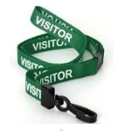
1. Report to reception and sign in using the iPad.
2. Wear the visitor’s lanyard and badge you are given.
3. Sign this document and read it along with our Safeguarding Leaflet.

Safeguarding Requirements for Visitors
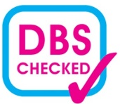
If you are going to be working unsupervised with pupils at any point during your visit, you must have an Enhanced DBS check and Children’s Barred List check.
Please provide this information to the office on arrival. If you do not have a DBS or barred list check then you must always be accompanied by a member of our staff.

Our Safeguarding Team:
The Designated Safeguarding Lead at Larkhill Primary School is our Head Teacher, Charlotte Harmer.
The Deputy Designated Safeguarding Lead at Larkhill Primary School is our Deputy Head Teacher, Fiona Jenkins.
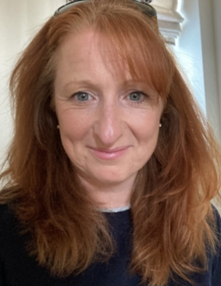

Charlotte Harmer Fiona Jenkins
Head Teacher and DSL Deputy Head Teacher and DDSL

If you notice worrying behaviour exhibited by an adult who is working or volunteering on site whilst you are visiting you should report this to the Head teacher immediately.

If a student shares sensitive information with you during your visit, or if you witness any worrying behaviours, you must report this to the Designated Safeguarding Lead or Deputy Designated Safeguarding Lead.

Confidentiality
- You must not give your personal contact details to children for example, e-mail address, home or mobile telephone numbers, details of web-based identities.
- You must not have pupils at the school as friends on any social networking site account.
- You should refrain from discussing/commenting on individual pupils, school information or staff outside of the school (including on social network site accounts).
- You should refrain from taking photographs of pupils (unless this has been agreed with the Head Teacher and is part of the purpose of your visit).

Use of personal mobile phones
All staff and adults working in / visiting the school are not permitted to use personal mobile phones in any areas of the school, with the exception of the staff room. We would ask that if at all possible phones are switched off or put on silent.

School Trips
If you are helping as a volunteer on a school trip, please refrain from taking photographs of the pupils on personal mobile phones. If the class teacher would like photographs taken, you will be supplied with a school camera for this purpose.

In the event of a fire
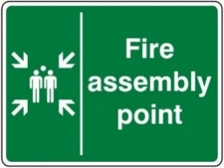
In the event of a fire please make your way to the fire evacuation point located on the school’s main playground.
If you are covering a class, please collect your fire register (located by the classroom door) and ensure that you leave the building via the nearest fire exit. Please then make your way to the fire evacuation point located on the main playground.
You will then be required to take the fire register to ensure you have all members of your class present. Fire marshals will continue to check break out zones and toilets for pupils.

Staff Toilets
Staff toilets are located by the office. These are the only toilets that visitors should use.

Code of Conduct for Visitors and Volunteers
I confirm that I have received the Code of Conduct for Visitors and External Staff.
I understand that it is my responsibility to read the above information and that I should ask for clarification of any points I am unsure about. I agree to follow the expectations laid out here.

Name: ……………………………………………………………………………………………………………………………………

Signed: …………………………….…………………………………………………………………………………………………….

Date………………………………………………

