Curriculum Intent
Computing at
Larkhill
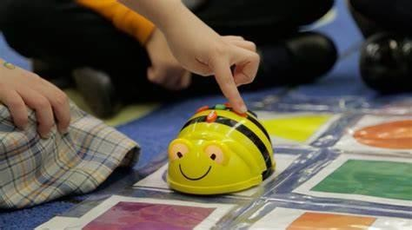

At Larkhill, we aim to prepare our learners for their future by giving them the opportunities to gain key vocabulary, knowledge and develop skills that will equip them for an ever changing digital world. Knowledge and understanding of IT is of increasing importance for the children’s future at home, school and for employment. Computing is part of our outer curriculum and focuses on a progression of skills in digital literacy, computer science, information technology and online safety. This ensures that our children become competent in safely using, as well as understanding, technology. Our intention is that Computing also supports children’s creativity and cross curricular learning to engage children and enrich their experiences and their learning.
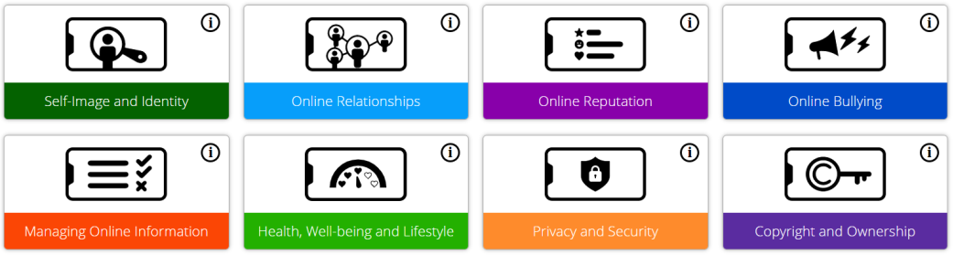
Online safety at Larkhill:

Assessment
Teachers will assess learning during each lesson and unit of work to build up accurate judgements of children’s attainment. Teachers record the progress of each child termly and use this to inform and adapt future planning.



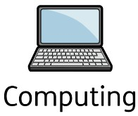
Curriculum Implementation
Our curriculum design for Computing is broken down into four key parts: knowledge, skills, understanding and vocabulary, covering the National Curriculum expectations. These areas have been sequenced in each year group ensuring they are progressive and everyone understands the intended end- points. Computing makes up part of our outer curriculum and reflects our embedded values including respect and responsibility, especially in regards to our online safety curriculum. Objectives are ambitious for all across the four strands of our computing curriculum: Computer Systems and Networks, Programming, Data and information and Creating Media.
These four strands build upon the three core aspects of Computing; Computer Science, Information Technology and Digital Literacy. As part of Information Technology, children learn to use and express themselves and develop their ideas through ICT. Within digital literacy, children develop practical skills in the safe use of ICT and the ability to apply these skills to solving relevant, worthwhile problems for example understanding safe use of internet, networks and email. In Computer Science we teach children to understand and apply the fundamental principles and concepts of abstraction, logic, algorithms and data representation.
Like other foundation subjects, Computing lessons have a clear process which involves retrieval of learning, exploring Computing as a subject, presenting a clear objective and key vocabulary as well as summarising the knowledge and skills the children will learn in each lesson/unit.

Curriculum Impact
The implementation of this curriculum, ensures that when all children leave
Larkhill, they are able:
- To navigate the online world safely and understand how to report concerns.
- To apply computational thinking to a range of contexts.
- To be passionate about the use of information technology.
- To demonstrate their skills and understanding of computing.

