Curriculum Intent
Geography at Larkhill

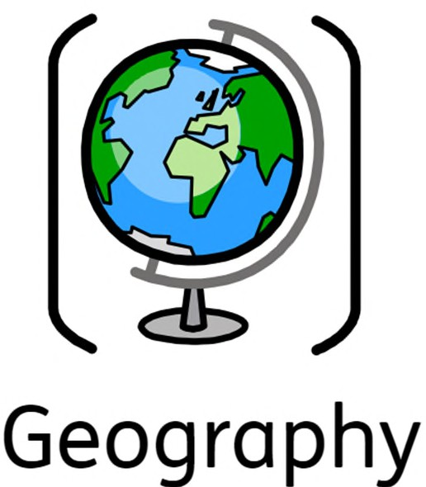
Our curriculum design for Geography forms part of the outer curriculum at Larkhill and is broken down into four key parts: knowledge, skills, understanding and vocabulary. These areas have been sequenced in each year group ensuring they are progressive and everyone understands the intended end-points. Our Geography curriculum intends to develop the children’s understanding of the world around them. It allows children to explore the physical and human environment on a spatial scale and the patterns and relationships between them. The children encounter both opportunities and challenges linked to geography, with a range of local, national and global themes.

Curriculum Impact
The implementation of this curriculum ensures that when all children leave Larkhill, they have gained a rich understanding of Primary Geography that they can draw upon in future learning. In addition, they will also be able to:
- Have a real sense of curiosity to find out about the world and the people who live there.
- Have an excellent base of geographical knowledge and vocabulary.


- Be confident using fieldwork and other geographical skills and techniques.
- Have the ability to express well-balanced opinions, rooted in very good knowledge and understanding.

Curriculum
Implementation
Starting in the Early Years, the children explore their immediate locality through termly welly walks where they develop a sense of place through their Understanding of the World. In Key Stages 1 and 2, bi-termly themes develop geographical knowledge and skills. These themes focus on particular localities relevant to the children such as Larkhill, Salisbury, London, countries in the commonwealth as well as geographical features such as mountains, volcanoes, rivers and islands. Trips and visitors also help to enhance this learning. Children are required to learn relevant geographical facts and develop key geographical skills in a progressive manner. Key to their understanding is the idea that geography is about people, places and environments and the links between these.

Assessment
Teachers will assess the Geographical knowledge and skills at the end of every Geography unit through a quiz. These assessments will inform a judgement on the child’s overall understanding of the geographical skills and knowledge taught.

