Curriculum Intent
History at Larkhill

At Larkhill, our History curriculum acknowledges that history is one of the richest mediums to teach children about life. By finding out about how life has developed over time, children understand how the past influences the present. They will explore the diversity of human experience, and begin to understand more about themselves as individuals as well as members of society.
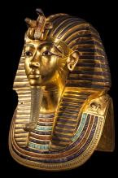
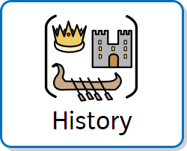
When learning about history, children have the opportunity to act as historians do, stimulating their curiosity about the past. We enable history to come to life through a wide range of active and cross-curricular activities, so children understand that they are learning about real people and real events locally, nationally and globally.
History makes up part of our outer curriculum and reflects our embedded values including respect, appreciation and understanding.

Curriculum Impact
By the time children leave Larkhill, the teaching and learning they will have received through history will
have developed:
- A secure knowledge and understanding of people, events and contexts from the range of historical
periods covered.
- The ability to think critically and reflectively about history and communicate confidently in styles
appropriate to a range of audiences.
- The ability to consistently support, evaluate and challenge their own and others’ views using detailed,
appropriate and accurate historical evidence derived from a range of sources.
- The ability to think about, reflect on, debate, discuss and evaluate the past, forming and refining
questions and lines of enquiry.
- An interest in history and an enthusiastic engagement in learning, which develops their sense of curiosity about the past and their understanding of how and why people interpret the past in different ways.
- A respect for historical evidence and the ability to make robust and critical use of it to support their
- explanations and judgements.
- A desire to embrace challenging activities, including opportunities to undertake high-quality research


across a range of history topics.

Curriculum Implementation
Starting in the Early Years, children begin to make sense of their own personal and family history through their Understanding of the World. In Key Stages 1 and 2, bi-termly themes enable children of all abilities and backgrounds to develop a wide range of knowledge, skills, understanding and vocabulary in a progressive manner.

Our history curriculum is designed to make full use of the rich local heritage surrounding our children. We place a strong emphasis on studying the Stone, Bronze and Iron Ages, bringing these periods to life through key local links such as Amesbury Archer, Stonehenge, and Danebury Hill Fort. Trips to Stonehenge throughout the year deepen understanding and provide meaningful, real-world connections.
To further engage, inspire and embed learning, we provide hands-on workshops and immersive experiences, including Viking and Egyptian themed days, as well as opportunities to handle real artefacts through visiting experts.
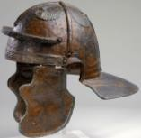
Like other foundation subjects, History lessons have a clear process which involves recapping prior learning to embed knowledge and understanding, exploring History as a subject, presenting a clear objective and key vocabulary as well as summarising the knowledge and skills the children will learn.

Assessment
Assessment in History is woven throughout each unit in the form of regular retrieval of previous learning, including through the use of entry and exit tickets within lessons. At the end of each unit of learning, children partake in a carefully-tailored multiple choice quiz to test the knowledge they have learnt. The aim of these assessments is to help children remember more so they can build a chronological awareness of History.

