Curriculum Intent
Physical Education at Larkhill
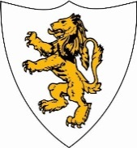
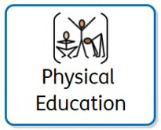
Our curriculum design for PE is broken down into four key parts: knowledge, skills, understanding and vocabulary. We aim to develop a fun, high- quality physical education curriculum that is progressive from EYFS, all the way through to Upper Key Stage 2, that inspires all pupils to succeed. We intend for our PE curriculum to give all children, including disadvantaged and children with SEN, alternative opportunities and experiences that they may never receive outside the school environment. PE makes up part of our outer curriculum and reflects our embedded values including respect and responsibility. We develop the knowledge, skills and capabilities necessary for mental, emotional, social and physical wellbeing in our children for both now, and for their future.

Curriculum Impact
The implementation of this curriculum, ensures that when all children leave Larkhill, they are able:
- Achieve well in Physical Education and apply a range of skills.
- Approach sports with resilience and show the value of sportsmanship.


- Understand how to play a range of sports and how to communicate as part of a team.

Curriculum Implementation
At Larkhill, Physical Education is a crucial part of the curriculum as it promotes a positive mind-set, perseverance, self-discipline, resilience and determination to believe that anything can be achieved. Our PE curriculum includes all children and is taught by highly skilled adults, including specialist coaches and a professional dance teacher. It is essential to us that pupils fulfil their sporting potential, but also do so in line with our values and showing sportsmanship at all times. These areas have been sequenced in each year group ensuring they are progressive and everyone understands the intended end-points. As a school, we offer sport focused after school clubs and take part in local tournaments.

Assessment
PE is assessed by four main pointers. The children are assessed on their sport-specific skill, their general sport skills, their teamwork and their values. This is assessed on a term-by-term basis for each new unit.

