Curriculum Intent
Reading at Larkhill

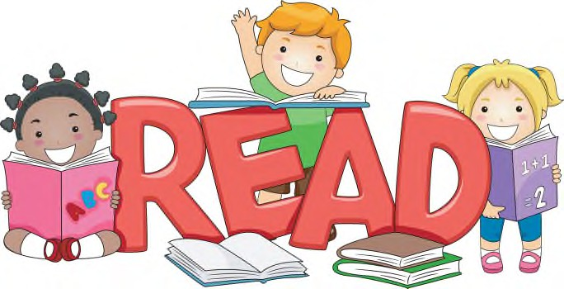
Our reading curriculum aims to prepare and provide our children with a solid understanding of literature and have the skills needed to read confidently and fluently. We aim to inspire our children to be enthusiastic readers who read for pleasure and develop their knowledge. In addition, we ensure our children are exposed to and understand a wide range of vocabulary. We are passionate about promoting reading for pleasure to our children on a daily basis. The overarching aim for English in our curriculum is to promote high standards of language and literacy by equipping pupils with a strong command of the spoken and written word, and to develop their love of literature through widespread reading for pleasure.
Reading makes up part of our outer curriculum and reflects our embedded values, resilience, responsibility and independence.

Curriculum Impact

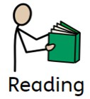
We believe our effective teaching, regular assessment and rigorous intervention have a lasting impact on developing our children’s ability to read. Objectives within reading are ambitious for all, to enable children to reach the highest standards, and these objectives are adapted to meet the needs of children with SEND and those who are disadvantaged. We have also supported other colleagues in the WHF MAT by collaboratively developing areas of the new curriculum and providing training on how to implement and teach reading across the curriculum.
Reading sequence

The sequence is repeated weekly for years 2-6
Skills for reading - These are taught throughout the week. Children are taught to read for comprehension through skimming and scanning, they are taught to answer retrieval questions, predict and make inferences based on what they have read.
Developing vocabulary- Lesson 1 is focused around teaching vocabulary. When a child accesses the text for the first time, vocabulary is discussed, defined and a word of the week is focused on to provide a deeper understanding. Children are taught skills for how to read around a word for meaning.

Readers Theatre – Each week, children are given a new piece of text. Through a series of daily modelled reads, echo reads, partner reads and independent reads, children are taught to build fluency, accurately read words and read with pace, pitch, expression and intonation. This begins every Reading lesson.

Assessment
The children are assessed at regular points throughout the year using summative assessments. We also formatively assess the children when we read 1:1 with them or in a small group, on a weekly basis.
Curriculum Implementation
Our curriculum design for Reading includes these four parts: knowledge, skills, understanding and vocabulary. These areas have been sequenced in each year group ensuring they are progressive and everyone understands the intended end-points. Reading for pleasure is promoted through story times, Stay and Read sessions with parents, our reading vending machine for celebrating reading and through a range of events across the year. EYFS and Year 1, teaching reading is structured around rhyme time and book talk using high quality selected texts. Our teaching of reading prepares our children for their future selves by teaching them the skills that they need to be fluent, accurate word readers and to have strong comprehension skills. We recognise the importance of reading across the whole curriculum and incorporate reading in all subjects. Our reading curriculum enables our children to acquire a wide vocabulary, an understanding of grammar and knowledge of linguistic conventions for reading. High quality texts are selected to develop this level of comprehension where children are explicitly taught language comprehension skills and strategies enabling them to understand and explore the level of text they are required to read for their age. To support children who fall behind, additional “accelerated” catchup interventions are put in place.

