**Larkhill Primary School**

**The Inclusive Classroom**

How we support our learners?

At Larkhill Primary we are an inclusive school and strive to be able to be able to make reasonable adaptations to our curriculum and provision within our mainstream setting.

# What is inclusive practice?

Inclusive practice is a teaching approach that recognises the differences between students and uses this to ensure that all students can access educational content and participate fully in their learning. It understands that no two pupils are the same and ensures that lessons and activities accommodate this.

# Benefits of inclusive practice

* Teaching pupils about diversity and equality.
* Developing student empathy and sensitivity to people who are different from themselves.
* Improving friendships, confidence, and self-image.
* Providing teachers with additional ways to incorporate problem-solving, teamwork, and collaboration into their lessons.
* Promoting parental confidence that their children are being accepted and can be successful in the school setting

(Plan Bee)

# Differentiation; Equity vs equality

Differentiation is how we adjust our teaching and learning to ensure everyone can be successful. This may mean that we offer more to some children. (equity)

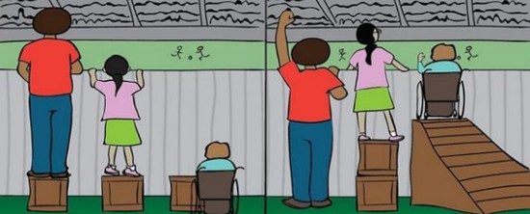

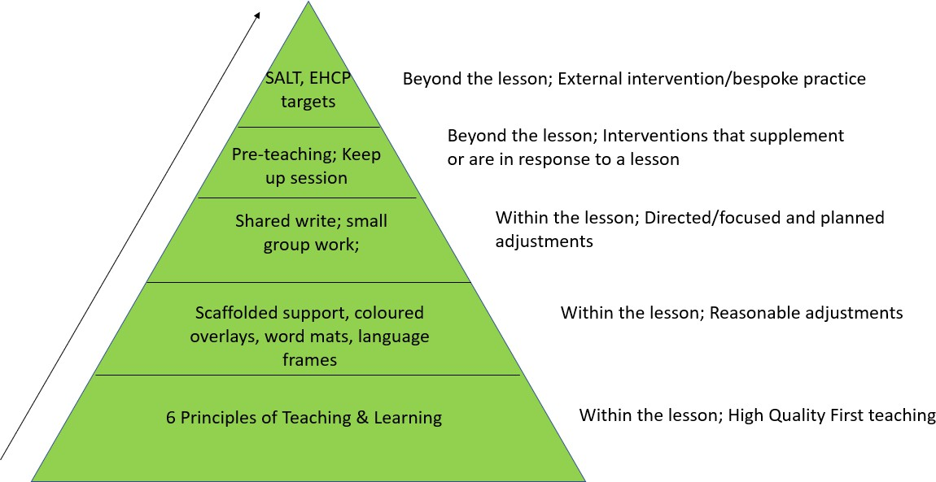**Inclusive Practice at F&S**

**Inclusive classroom; 5**

**phases of the lesson**

* Phase 1 – Transition; entering the classroom and preparing to learn
* Phase 2 – Delivering and receiving instructions and whole-class engagement.
* Phase 3 – Individuals working as a class
* Phase 4 – Individuals fitting into a group of learners
* Phase 5 – The “last 5 minutes”.

# PHASE 1: Transition, entering the classroom and preparing to learn

What happens before the children enter, including the attitude of the teacher: ‘supporting’ rather than penalising children and starting on a positive note.

Seating plans and starting routines: being simple and clear, removing uncertainty, and use of visual timetables.

# Strategies for Setting pupils up for lesson success

* Task management boards
* Modelled outcomes
* Children to feel success early in the lesson/task
* Staggered starts to learning
* Pre-learning – children have opportunities to learn language or concepts prior to the lesson
* Over-learning – children have opportunities to repeat learning
* Scaffolding – support pupils to plan how to approach a task, problem solve as they go and review how they approached a task. Building to teach children to self-scaffold.
* Widgit - a visual resource to support language

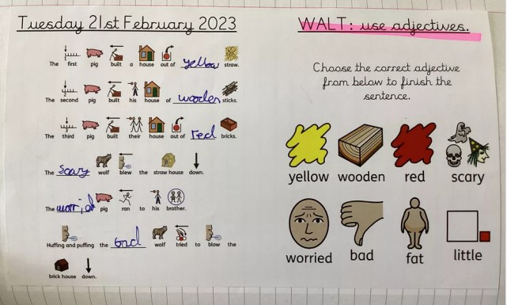

# Starting the lesson

* Don’t set impossible expectations
* Keep children in mind – 5 and I’ll be back
* Allow movement breaks when needed
* Classrooms to have clear walls and use calming colours
* Ensure children are comfortable when sitting, whilst still being able to access learning and listen
* Consider possible distractions and remove where possible
* Seat children in a place that will best support their learning and social development

# PHASE 2: Delivering and receiving instructions and whole-class management

Making sure the message you communicate is understood by giving effective instructions that reduce barriers of misunderstanding, for example providing visual or written as well as verbal instructions.

Using prompt questions effectively to avoid confusion, for example avoiding vague, unclear statements that are open to interpretation and confusion.

# Delivering and receiving instructions

* Use visual prompts to support verbal instructions
* Point to or hold up resources when talking about them
* Show numbers of fingers, cards, number line or 100 square
* Have symbols for books or resources on slides, worksheets or tables
* Pause between instructions and make sure they are clear and concise

# Questioning and increasing engagement

* Use randomisers (e.g., children’s names on lolly sticks) to choose different children
* Allow thinking time and opportunity to talk to a partner
* Share questions you want the children to be able to answer by the end of the input/lesson
* Use visuals for children to show their confidence levels



# PHASE 3: Individuals working as a class

Making writing and production of ‘work’ more accessible and avoiding the dreaded ‘boredom by worksheet’.

Managing the distractions and interruptions, including working silently versus self-talk.

# Individuals working as a class

* Pre-learning sessions for targeted children
* Personalised visual images and prompts
* Regular adult check-ins
* Support for part of lesson
* Quick additional explanations
* Working in a group with an adult to go through extra examples
* Differentiation by process e.g., asking different and directed questions, using apparatus to support their understanding
* Different ways of recording - Consider IT, pictures, visuals, photos of work, recording their responses, making a transcription



# PHASE 4: Individuals fitting into a group of learners

1. Balancing groups of students, considering the demands of social and academic skills and guided by the explicit roles and rules for working together.
2. Managing sensory and concentration level issues and their impact, for example is this group too loud or not loud enough for the child?

# Group work strategies

* Consider the pros and cons of children working in groups depending on the learning process and outcome
* Give the children roles within their groups
* Those supported by visual aids still be given them within the group setting
* Manage the movement of furniture and create direct working spaces
* Reinforce expectations of behaviour prior to group work.
* Keep group sizes small enough for success and put children in groups before the task starts
* Create a class checklist of how to be successful within the group for the task at hand
* Sentence starters and visuals to prompt with group work can help with confidence and building teamwork skills
* Deploy an adult to observe SEND children rather than work alongside
* Give adequate time for group work.
* Allow children to problem solve before you step in
* Create an exhibition to celebrate group work

# PHASE 5: The last five minutes

1. Enabling the child to identify learning through self- and peer- assessment and to clarify understanding through over-learning.
2. Providing a clear end to the lesson with pre-warning and clear routines and leaving the room calmy with praise and positivity.

* Give children warnings so they know the lesson or task is coming to an end. Visual aids can be used such as sand timers
* Where possible use peer marking work 'swap with a friend'
* Use a now and next approach to support with transition between tasks
* When teaching children to edit, focus on one skill
* Ask children to share their 'best bits' from the lesson
* Verbal feedback 'What do you know now?'. Supports children to explain what they have 'learned' rather than just what they 'did'
* Quiet or soft closes to the lesson

Please note that the lists above are not used for every child and are not used in every lesson. Teachers and teaching assistants will use a mixture of strategies for different pupils and in different lessons.