Curriculum Intent
Spelling, punctuation and grammar at Larkhill

As stated within the overall English Writing Intent statement, our spelling, punctuation and grammar (SPaG) curriculum aims to empower all children to acquire the vocabulary, skills, knowledge and understanding necessary for confident and effective written communication both now and in the future.
Our SPaG curriculum - is broad and balanced to cover a range of
skills such as spelling, handwriting, grammar, vocabulary, syntax,
composition and creativity; these skills are then applied across
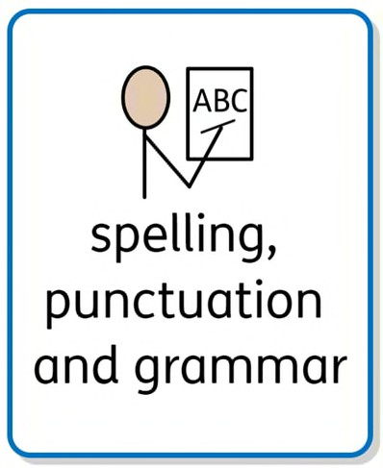
all other subjects.
We therefore intend for every child to accurately spell high frequency and common exception words and to understand the key patterns, rules and etymology of spelling as well as understanding the key rules of English grammar and punctuation, applying these accurately in their writing.

Curriculum Impact
The implementation of this curriculum ensures that when all children leave Larkhill, they will have acquired the skills to utilise the spelling, grammar and punctuation knowledge taught to them within their writing independently. This will enable the children to express themselves through their writing and therefore write effectively for a range of purposes.

Assessment


Teachers will assess the children’s spelling, grammar and punctuation understanding through a variety of summative and formative assessment. We will assess through: regular spelling tests based on their spelling learning; end of Autumn, Spring and Summer term teacher assessments; end of KS2 SATs - spelling, punctuation and grammar results; end of Autumn, Spring and Summer term grammar assessments and evidence of spelling application in writing will be identified through book scrutiny.

Curriculum Implementation
Spelling: In KS1 and KS2, the use of spelling progression grids have been designed – using the national curriculum - for each term that highlights the spelling rules and common exception words.
In both KS1 and KS2, a ‘phonics first’ approach will be used, wherein the primary method for spelling words should be to segment and blend the individual phonemes in words. Where this is not suitable, further morphemic or graphic approaches will be introduced.
Spelling in KS2 is taught whole class and we use the Read Write Inc programme to ensure progression across year groups. The complexity of the words increases with the year group. In addition, words from the explicit Year 3/4 and Year 5/6 statutory common exception word lists will be covered. These are assessed termly in Year 5 and Year 6.
Punctuation and grammar: In KS1 and KS2, punctuation and grammar skills will be taught daily at the beginning of each English lesson.
To ensure an even coverage of the punctuation and grammar objectives for each year group, our teachers follow the TWHF English planning which ensures coverage and progression. Teachers also have the flexibility to adapt objectives and teach catch up and keep up interventions as and when needed. This ensures that we are responding to the needs of the children as a result of daily formative assessment.

