Curriculum Intent
Science at
Larkhill
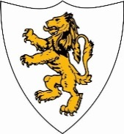
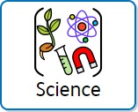
At Larkhill, we immerse our children in a Science curriculum that combines knowledge and vocabulary with practical Science skills to enable them to be curious and gain a detailed understanding about the scientific world around them. Children have the opportunity to learn in a series of ways to nurture our diverse range of learners and promote independent scientific thinking. This includes through practical investigations and exploration, undertaking varied research and observation of the environment and of key Scientific phenomena occurring (such as materials changing states).
Our teaching is intended to ensure that children are provided with a variety of skills to help structure their understanding of the key areas of the Science Curriculum: chemistry, biology and physics for years 1-6 and Understanding the World for EYFS.

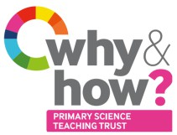


Curriculum Impact

Assessment
Teachers will assess Science skills using the Teacher Assessment of Primary Science (TAPS) framework once termly and via end of unit glossary to assess knowledge and vocabulary. Together, these assessments will inform a judgement on the child’s overall understanding of a unit of Science. This is reported to parents at the end of the year and at the end of Key Stages as part of the Statutory Assessment process.

The implementation of this curriculum ensures that when all children leave Larkhill, they have gained a rich understanding of Primary Science that they can draw upon in future learning. In addition, they will also be able to:
- Think scientifically by finding different ways to answer questions
- Generate their own ideas on how best to answer Scientific enquiries
- Gather and record their own evidence from practical Science opportunities
- Ask meaningful questions to further their own understanding of Science as a core subject.

Curriculum Implementation

Science forms part of our outer curriculum at Larkhill. At Larkhill, we ensure our teaching follows a purposeful progression through the careful sequencing of Science units to allow our learners to draw on their knowledge across the curriculum. Where appropriate, Science learning is matched and complemented by the knowledge of other curriculum areas to allow this to further support children.

Throughout the course of their learning, children will be immersed in a range of Scientific vocabulary to help build oracy within and across their year groups. Children will be taught with a focus on both subject-specific vocabulary that links to each module of learning and vocabulary that structures a framework for their skills of Working Scientifically.
Our model of teaching encourages children to revisit and build upon previous learning to help embed and extend their understanding across the Science curriculum.

