Collective Worship Policy

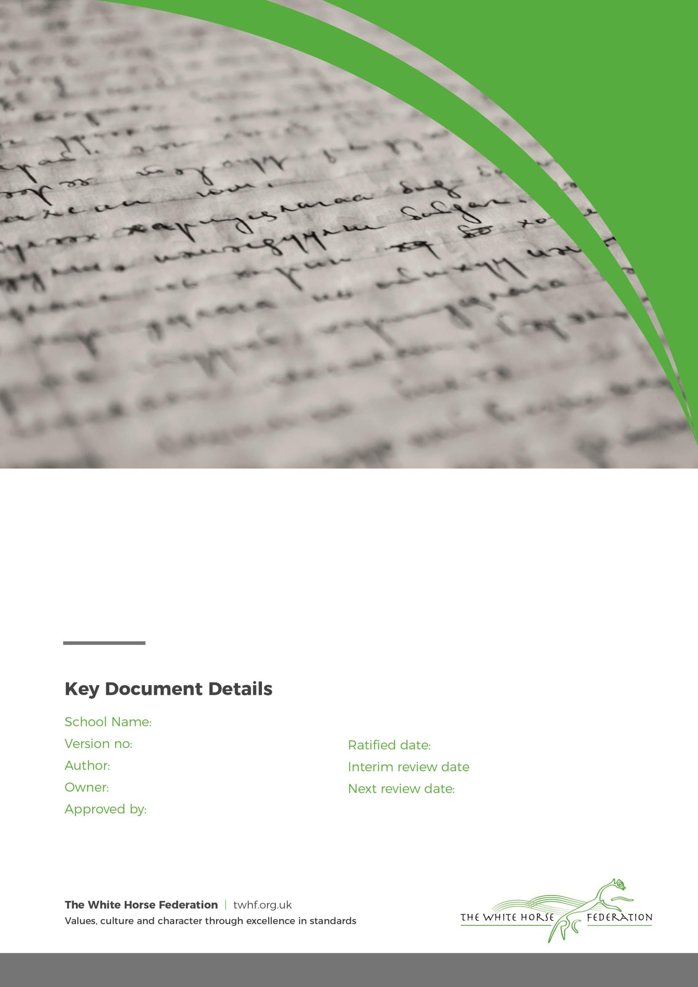School Name 1

Simon Cowley C. Harmer

LGB

14.9.24

n/a

1 September 2026

# Collective Worship Policy

The Collective Worship at Larkhill Primary School pays due regard to statutory requirements, and

has taken account of the guidance offered by the LA through its SACRE. In line with the 1988 Education Reform Act, which states that collective worship should be ‘wholly or mainly of a broadly Christian character’, and in recognition of the fact that the majority of our pupils are practising members of other faiths we base our assemblies on those aspects of Christian teaching that are shared with other faiths.

The Collective Worship Policy of Larkhill Primary School is consistent with the philosophy and aims

of our school as a Values Based school. Assemblies are conducted in a manner that is sensitive to the individual faiths and beliefs of all members of the school community.

# Definition of Collective Worship

Collective Worship is a time when the whole school, or groups within the school meet together in order to consider and reflect on common concerns, issues and interests. It offers all pupils an opportunity to worship through engaging in relevant, meaningful experiences and provides opportunities for the pupils’ spiritual, moral, social and cultural development.

# Aims of Collective Worship

For the School:

Collective Worship contributes significantly to the ethos of Larkhill Primary School and it is our aim that it is a time when the school community can:

* Share common aims and values
* Celebrate achievement and special times
* Explore together the world in which we live
* Develop a community spirit

For the pupils:

We also intend that collective Worship contributes to the development of the pupil as a ‘whole’ person by providing opportunities to:

* Consider spiritual and moral issues
* Explore their own beliefs
* Develop their own spirituality
* Reinforce common ethos and values
* Reinforce positive attitudes
* Develop a sense of community spirit
* Encourage participation and response
* Reflect on that which is considered worthy

# The Organisation of Collective Worship

At Larkhill Primary School we hold regular acts of Collective Worship in our school. This forms part

of our morning assembly programme, which may be a whole school assembly, a singing assembly or class assembly. The assembly on each Monday is a Values Assembly in which children have the opportunity to discuss and learn about our core values and wider community or global issues.

We conduct assemblies in a dignified and respectful way. Children are expected to behave

Page 2 of 3

in an appropriate way as this time is a period of calm reflection.

* The Principal or other members of staff normally lead assembly, but sometimes local clergy or other representatives of local religious groups are invited into the school.
* We take themes of our assemblies from our school values and from the traditions of the Christian and other faiths and we often reflect the festivals and events of the religious calendars.
* Sometimes the themes of our assembly reflect and build on topics that we teach as part of the school curriculum, such as the Social and Emotional Aspects of Learning.
* We welcome parents and Governors to attend our assemblies at certain points in the year, as this promotes the community spirit of the school and is a practical demonstration of the way the home and the school work together to support the achievements of our children in all aspects of their lives.

# Right of withdrawal

At Larkhill Primary School, assemblies are conducted in a manner as sensitive and inclusive as to ensure that all children feel comfortable to attend the assembly.

However, parents/ carers have the right to withdraw their child from any act or acts of Collective Worship. Those wishing to make such a request are encouraged to discuss with the Principal the concerns they may have as well as the practical arrangements for the withdrawal.

Page 3 of 3