EYFS Policy

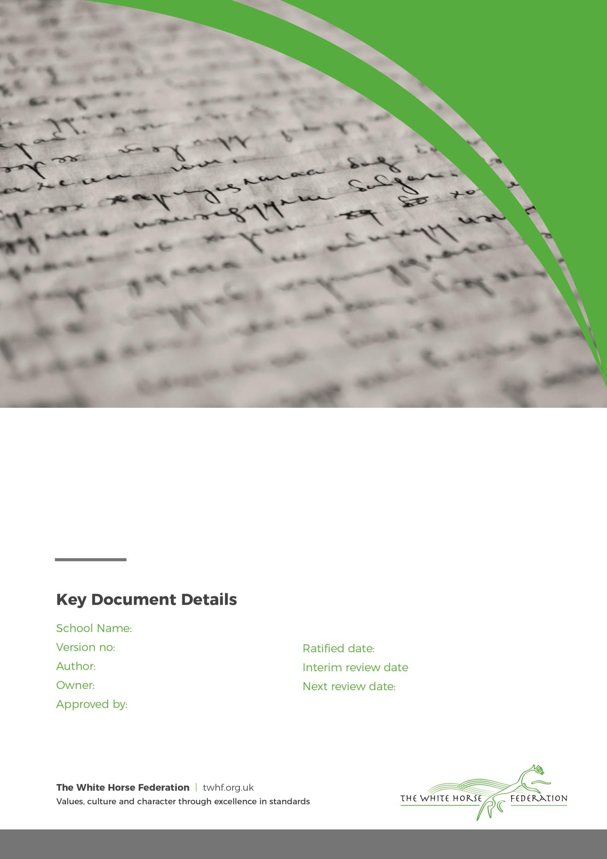Larkhill Primary 2

Charlotte Harmer Simon Cowley Governing Body

June 2023 n/a

Sept 2026

# Policy Front Template2Aims

It is our intent that children who enter our Early Years Foundation Stage (EYFS) begin their lifelong learning journey by making progress physically, verbally, cognitively, and emotionally in all areas of learning, from their individual starting points whilst developing a love of learning. At Larkhill Primary our aim is to create high quality learning environments which inspire, support and enhance every child’s curiosity and imagination, making learning irresistible. We strive to work collaboratively with parents and carers to encourage independent and enthusiastic learners who thrive and reach their full potential. Every child has access to a broad, balanced and differentiated curriculum that reflects our community. Our curriculum offer prepares them for the present and for the future in terms of opportunities, experiences, knowledge and skills. Through a language rich environment, all children are supported and given opportunities to become skilful communicators who connect with others through language and play so that all children achieve at least the expected standard at the end of the EYFS.

# Play and Active learning

At Larkhill Primary we believe play to be the means through which young children learn. It is through play that children have the opportunity to explore, develop and act out experiences, helping them make sense of the world. Play helps children shape their own ideas, to overcome challenges, to regulate their emotions and develop a positive sense of self. We understand the need for children to investigate and solve problems through collaborative and individual play. Children work at their highest cognitive level in self-chosen play.

We provide the children with a safe and secure physical and emotional learning environment. We aim to develop good relationships with all children; interacting positively with them and taking time to listen. All staff model behaviours founded on our values and support children in forming positive relationships and friendships with one another. It is the role of all adults within the environments to engage in high quality interactions with all children and scaffold children’s learning to enable them to make progress.

At Larkhill Primary we recognise and value the fundamental role the learning environment plays in supporting and extending the children’s development. The reception classrooms, which incorporate the indoor and outdoor areas are well organised to allow children to explore and learn securely and safely. There are areas where the children can be active and can be quiet.

The environments are organised into areas where the children are able to access resources and equipment independently. Play opportunities are available in our reception classrooms both indoors and outdoors, where the three prime areas and four specific areas of learning are offered with equal importance. Due to the range of adult led activities and child-initiated time we provide; we give plenty of time for play opportunities to arise. High quality, active learning occurs when children are motivated and interested.

Children need to have some independence and control over their learning. As children develop their confidence, they learn to make decisions. It provides children with a sense of satisfaction as they take ownership of their learning. Young children can engage in a wide range of activities that develop their metacognition and self- regulation.

‘Play is the highest form of research’ (Albert Einstein).

Page **2** of **4**

# Policy Front Template2Planning

The planning within the Foundation Stage allows the children to explore key themes from our curriculum overview. Our weekly plans take into account our theme and are also supported by observations carried out of child-initiated learning from the previous week. This enables children’s interests, achievements, and next steps to be addressed. Our curriculum coverage is based upon the Educational Programmes outlined in the reformed Early Years Foundation Stage Framework.

We plan themes throughout the year to ensure every child is given a variety of different provocations and experiences. The themes are also supplemented by the children’s interests which helps to keep the children engaged and allows them to take ownership of their learning. We offer a broad and balanced curriculum, which is supported by using the ‘Development Matters’ and ‘Statutory Framework’. This enables staff to incorporate the seven areas of learning and development into a stimulating, creative, cross curricular approach, ensuring breadth.

Staff have an in-depth knowledge of children’s individual starting points, have a clear understanding of skills and knowledge progression and a thorough understanding of child development which informs planning to ensure children reach their full potential by the end of the EYFS.

# Assessment and observation

Before children begin in our Reception class all parents are invited into school for a stay and play session to enable us to meet the families. Parents and carers are asked to fill in key information about their child so that we can gather key information which supports the settling in process. In addition, all children are visited in their current setting. Where this is not possible, a home visit or teams call is arranged. On transition into reception, discussions take place with the child’s key worker in their current setting. From September 2021 all children in reception have undertaken the RBA baseline assessment from the DfE. In addition to the RBA baseline, practitioners within reception will carry out an in-house baseline assessment to create a secure judgement of each child’s starting points.

Throughout the year our nursery and reception staff carry out observations of children and record their observations and photographs as a learning journey. This, along with pieces of work and creations the children have produced, contributes to the child’s Learning Journey. Although adult led activities can offer insight into children’s attainment by making sure all children have had the opportunity to learn new knowledge and skills, our primary source of assessment judgement evidence is gathered through observing and interacting with children through their child-initiated time when they apply their knowledge and skills independently.

We collate our observations and assessments three times a year which are recorded on our tracking system to create a judgment of ‘on track’ or ‘not on track’ for their end of year expectations. For those

children judged as not being on track to meet the end of year expectations, next steps will be planned for them based on their gaps in learning.

At the end of reception, the level of development children should be expected to have attained is defined by the Early Learning Goals (ELGs). The ELGs support staff to make a holistic, best-fit judgment about each child’s development. Parents will receive a written report which summarise the child’s Characteristics of Effective Teaching and Learning and will state their progress against the ELGs.

Moderation takes place within Larkhill Primary and across the WHF.

Page **3** of **4**

# Policy Front Template2Working in partnership with Parents/Carers

We recognise that parents/carers are children’s first and enduring educators and we value the contribution they make. We appreciate the role that parents have played and their future role in educating the children. We do this through:

* Talking to parents about their child before they start school.
* The teachers visit all children in their home setting prior to starting school in nursery.
* The children have the opportunity to come into school to spend time in the environment and get to know their teacher. They are invited to a transition morning or afternoon for a stay and play session in June/July before starting school.
* We invite all parents to an induction meeting in the term before their child starts school.
* We offer parents regular opportunities to discuss their child’s development and progress. This might be an informal meeting before or after school. We also hold 2 parents’ evenings throughout the year.
* We invite all parents to a variety of ‘workshops’ and stay and play sessions each term, including early reading sessions, early mathematics and phonics.

Page **4** of **4**